WBS 1.6 Software

- Reconstruction Software/Offline Chain
  - A draft of the quantities to be monitored offline for this Run’s data was discussed. Examples include hit distributions, per event, sensor etc, track and vertex reconstruction and quality.
  - A PXL cluster-based event vertex finder is being developed as an extra tool to obtain event vertex information without the use of tracking information.
  - A first version of a PXL Slow Simulator, based on DIGMAPS, has been released. It needs testing in the simulation chain. It will provide valuable input to check the functionality of the PXL cluster/hit finders. First tests show a possible z-coordinate determination of the vertex with an accuracy of about 100 microns (see figure).
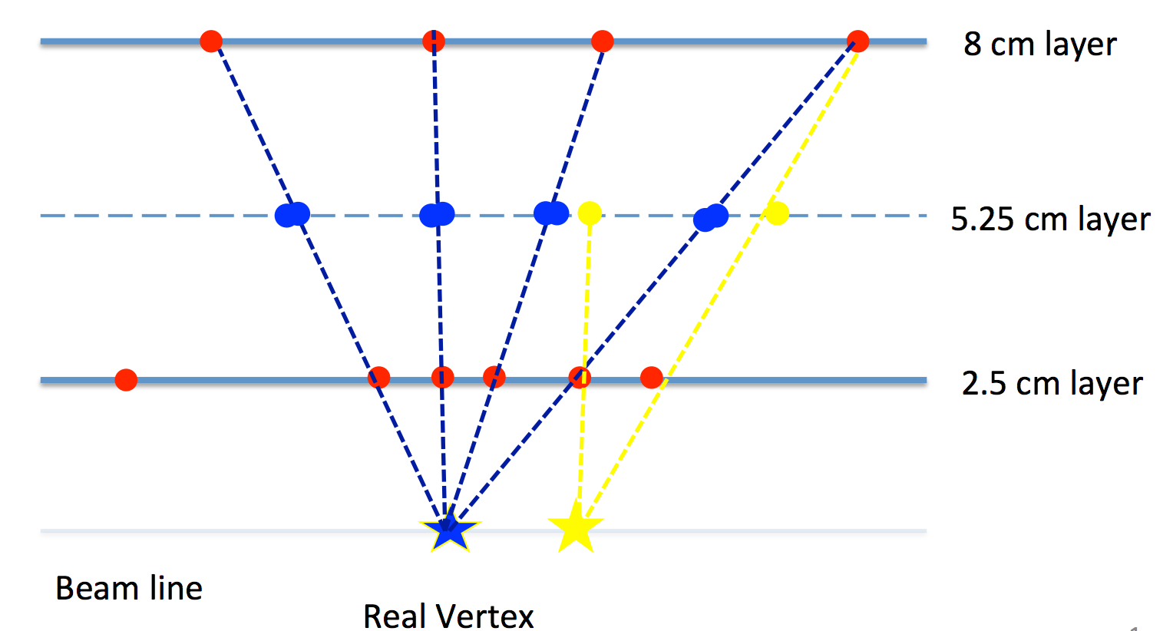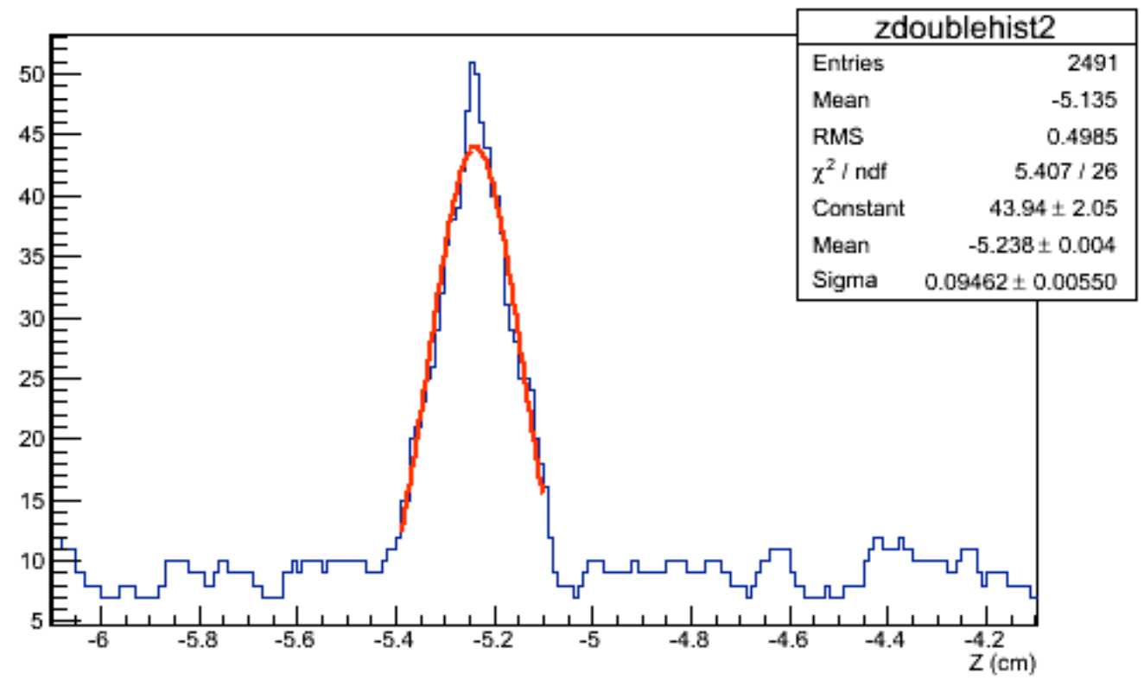
Figure 1 (left panel): The hit-mapping method of the cluster-based vertex finder. When the seed vertex approaches the correct position the mapped hits of the two PXL layers cluster as doublets on the reference surface. (right panel): The number of doublets versus the seed position of the vertex. In this event the z position of the vertex was reconstructed with an 80 micron accuracy.
  - The first version of PXL Db maker, the software that provides the geometry (local to master) transforms is completed and ready to be peer reviewed.
  - Further work on IST offline software was reported and discussed.

- PXL Survey and Calibrations
  - The three sector survey information is in the STAR Db and it is been debugged and tested.
  - We begun work on setting up detailed, blind tests of the alignment methods and software.

- Geometry modeling
  - A major wave of updates to PXL geometry started this month and it is about to be implemented. These include precision, configuration, material and shape of active elements updates. The figure below shows the redefinition of the active silicon in the PXL sensors (left panel) and the shape update of two supporting structures.
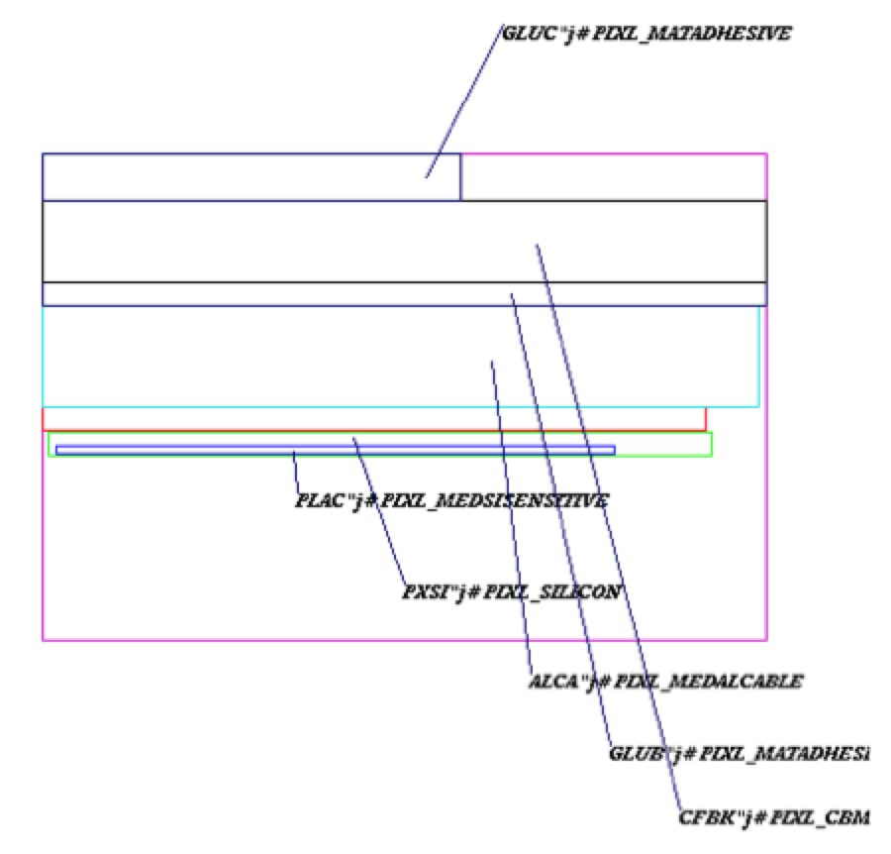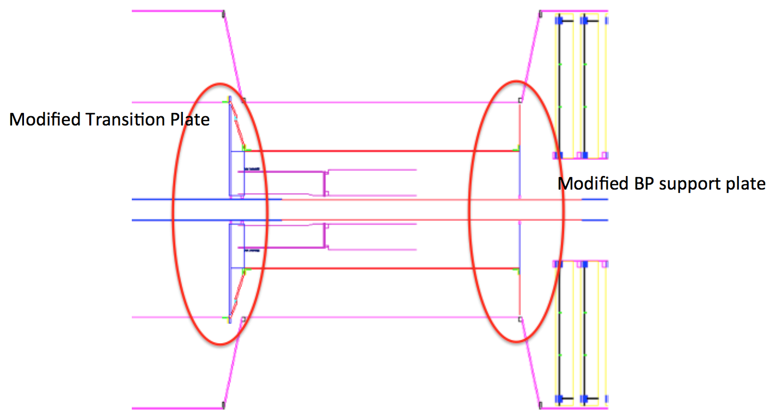
- AOB
  - The BUR draft of the HFT estimates for Run14 and Run15 has been updated with data based rates from the current run.
  - A simulation production of p-p collisions was set up and under way. Its main purpose is to refine the reconstruction efficiencies of D⁰s for better data sample estimates for Run14 etc.

