Working with macros the API. Can create, run and edit .SWP files with

Using Seth’s proton code developed example for putting points in a 3D sketch from a file of coordinates:
C:\Documents and Settings\Howard Wieman\My Documents\aps project\mechanical\macro API play\3D with segments.swp

One can record macro’s and edit them or can also get .swp files from web – whatever

Example with 3D sketch:
C:\Documents and Settings\Howard Wieman\My Documents\aps project\mechanical\macro API play\macro assembly API play.SLDASM

7/29/2009
ran into problem with above
In view select Immediate
to display debug messages

finally got 3D sketch working again see:
3D with segments july d009 works.swp in above directory

have a working example that won’t change:
C:\Documents and Settings\Howard Wieman\My Documents\aps project\mechanical\macro API play\sector_scan_raw_vert_no_wt_some.SLDASM
in same directory used:
sector_scan_raw_vert_no_wt_some.swp
V_no_W_some.txt
This was with just part of the scan and it used funny indexing because don’t know how to us the Split() routine in Visual basic. Will now continue with full data set, but will change file names to preserve old record

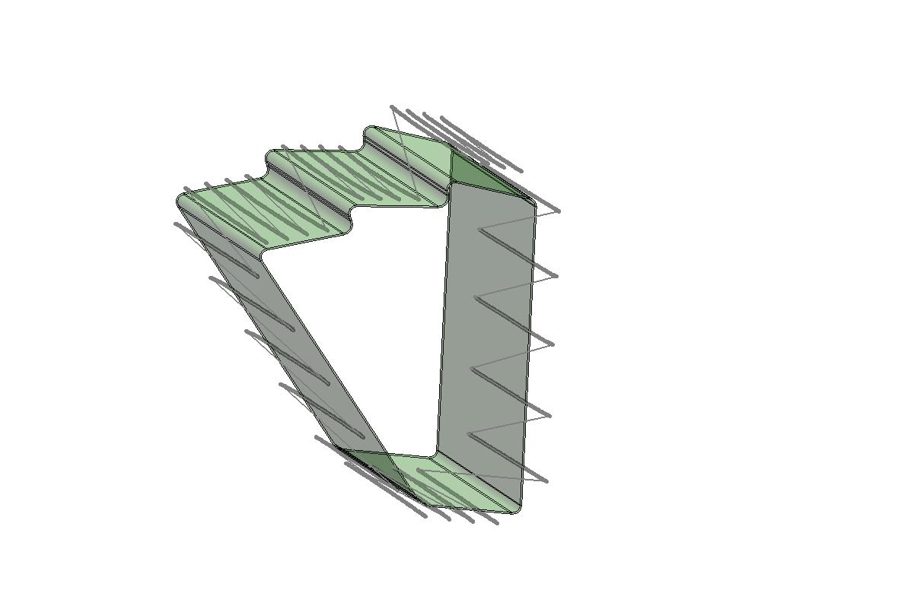
C:\Documents and Settings\Howard Wieman\My Documents\aps project\mechanical\macro API play\sector_scan_raw_vert_no_wt_all.SLDASM
with:
V_no_W_all.txt
sector_scan_raw_vert_no_wt_all.swp

8/4/2009
Xiangming Sun wrote c++ code to move columns to fix the Connors data. That code is located at:
C:\Documents and Settings\Howard Wieman\My Documents\aps project\Xiangming Sun\Xiangmings code to shuffle connors CMM files

Working from MS-DOS scripts of Michal see:
C:\Documents and Settings\Howard Wieman\My Documents\aps project\Michal Szelezniak\Michals scripts

Developed a script for running Xiangming’s code on several files which produces separate files plus a stack of files see:
C:\Documents and Settings\Howard Wieman\My Documents\aps project\mechanical\connors\sector beam 100 gm raw data\HFT 6 Face Tube Vertical no Weight\fix_and_stack_v2.bat

surface vector check shown in picture was done with the .bat file above (still an error that had to hand delete last bogus line.
Drew the little vectors with:
C:\Documents and Settings\Howard Wieman\My Documents\aps project\mechanical\macro API play\draw_V_nw_fixed_all.swp
Tried Michal’s .bat file and changed the blanks in the read. This is for one pass. It does the same thing approximately as Xiangming’s code The following selected files work together:
C:\Documents and Settings\Howard Wieman\My Documents\aps project\mechanical\connors\sector beam 100 gm raw data\HFT 6 Face Tube Vertical no Weight\fix_m.bat
C:\Documents and Settings\Howard Wieman\My Documents\aps project\mechanical\macro API play\output_file.txt
C:\Documents and Settings\Howard Wieman\My Documents\aps project\mechanical\macro API play\M_fixed_all.swp
Really not all so exported as M_fixed_onepass.bas
8/6/2009
source code to make points from connor files
C:\Documents and Settings\Howard Wieman\My Documents\aps project\mechanical\connors\sector beam 100 gm raw data\solutions folder\raw_and_pnts\Debug\raw_and_pnts.exe
8/25/2009
fixed
raw_and_pnts.exe of above
with Michal’s help and
copied to the data directories for vertical with and without weight
used
pnts_and_raw_stack.bat
to run it giving stacked and separate files of the raw CMM data and the points generated from CMM data using radius unit vector and ball center.
these files are in with Connors data
C:\Documents and Settings\Howard Wieman\My Documents\aps project\mechanical\connors\sector beam 100 gm raw data\HFT 6 Face Tube Vertical with Weight\Vrt_wt_pnts_all.txt
and
C:\Documents and Settings\Howard Wieman\My Documents\aps project\mechanical\connors\sector beam 100 gm raw data\HFT 6 Face Tube Vertical no Weight\Vrt_no_wt_pnts_all.txt

copied files to
C:\Documents and Settings\Howard Wieman\My Documents\aps project\mechanical\macro API play
and then plotted points using following files:
sector_scan_raw_vert_no_wt_some.SLDASM
draw_Vrt_wt_pnts_all.swp
draw_Vrt_no_wt_pnts_all.swp
points look ok, but can’t see deflection from the 100 gm wt

