WBS 1.6 Software

- Alignment Software and Simulations
  - An STAR internal “Alignment Procedures Review” has been held on October 12 at BNL where progress and plans were discussed for HFT Calibration work (Survey and Alignment). The review committee issued a report containing several observations and recommendations. It can be found in this public link: http://phys.kent.edu/~margetis/STAR/HFT/Survey/Report.pdf
  - We continued our work on simulations and the development of a fully functional alignment software package for HFT. So far we have successfully modified and adapt the former SVT/SSD chain to HFT conventions and geometry for the SSD and IST detectors. Work is in progress to extent this to PIXEL detector. Figure 1 shows examples of simulation results for the SSD and IST.
  - Work has started on clarifying and establishing the interfaces of Offline geometry structures and Survey information.

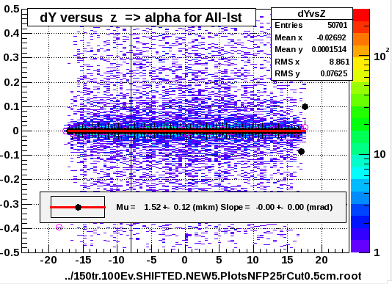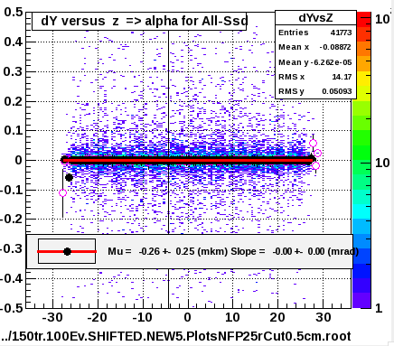
Figure 1 [left panel] The average alignment result for All-IST ladders for dY displacements and x-rotations. The results (in microns and mrad) are compatible with zero, as they should be for this simulation without geometry modifications. [right panel] The same result for the SSD.

- IST and PIXEL geometry modeling

  - The work on IST geometry modeling has made big advancements this month towards a realistic model of the detector that includes all structural details.
  - More work was done this month aiming to include in the geometry model dead (support) PXL material close to the interaction point. One such example is the aluminum sector holder and its D-tube interface.

- Survey
  - PIXEL: further survey work and software development was performed on the prototype sector and issues emerged are addressed. Also started working on survey-offline interfaces.

  - AOB

  - Progress on a Cellular-Automaton based, stand-alone HFT tracker was reported by the Frankfurt collaborators with some encouraging results.

