WBS 1.6 Software

Run14: The group is preparing for the AuAu 200 GeV/c beams, which is about to start.

- Special attention is paid to the offline chain of the SSD; to adapt it and streamline it to the current Offline environment (new readout and calibrations), and also use it to provide feedback on the SSD hardware commissioning efforts.
- Significant work was put into streamlining and automating the offline masking of the Pxl noisy areas and the Offline QA environment. The idea is to produce key histograms and calibration tables in a semi-automatic fashion for the upcoming run.
- The cosmic run data sample, magnet-Off, has been reconstructed in its entirety and used to perform an internal/relative Pxl calibration between the two Hemispheres (Fig. 1) and also between its Sectors (Fig. 2). This is work in progress where Global methods are also used for cross checking the results. One can see in the figures below that after the alignment the hit-residual distributions are showing systematic shifts of a few microns and (expected) widths of 20/40 microns for the inner/outer layers. In the case of the relative alignment of the Pixel hemispheres the corrections are significant (e.g. relative X-shift about 2mm) and we are investigating their source. This is not the case with the individual Sectors (Fig. 2) where the corrections are minute.

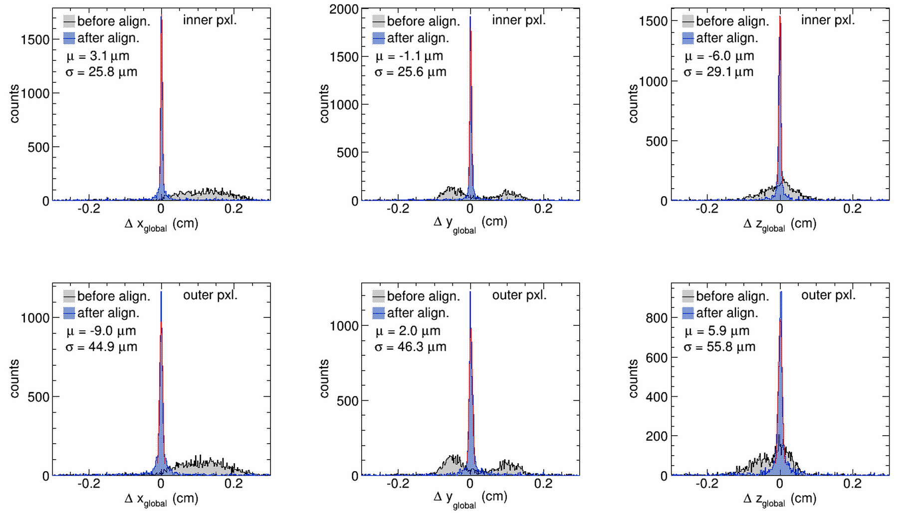
Figure 1 Hit residual distributions in X, Y and Z (columns) before (gray) and after (blue) fine tuning the relative alignment of the two PIXEL detector Hemispheres. The top row shows the residuals in the inner layer and the second row in the outer layer of the detector.
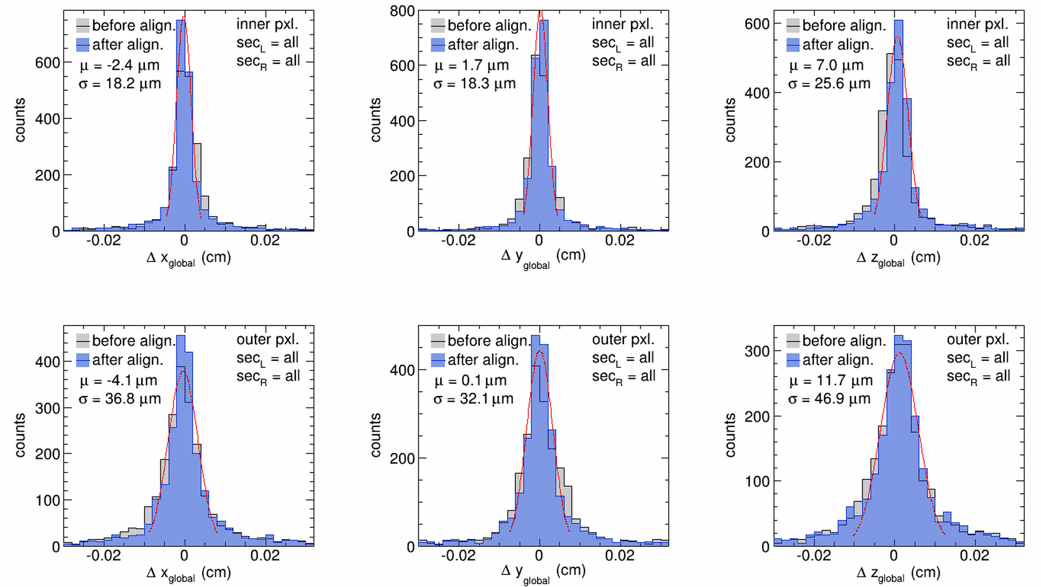

Figure 2 Hit residual distributions in X, Y and Z (columns) before (gray) and after (blue) fine tuning the relative Sector alignment in the PIXEL detector. The top row shows the residuals in the inner layer and the second row in the outer layer of the detector. One sees that the improvement is minimal, i.e. the survey information of the detector sectors and sensors did not change with installation.
- The STAR internal software review of all critical components of the HFT complex is progressing well.

