WBS 1.6 Software

CD4 (project closeout) work:

Achieving Ultimate Performance Parameter (UPP) for track DCA resolution

One of the items DOE requested the HFT team to work and report on during CD4 and transition to operations was to outline a plan for achieving the desirable (but not mandatory) ultimate performance goals (UPP) for track pointing or DCA resolution and single-track reconstruction efficiency. These two items fall in the area of software and a plan was drafted to demonstrate this. Here we report on the first item, the DCA resolution, using actual Data measurements from this year’s run, Run-14. The UPP number for the DCA resolution was motivated, at the time, by the possibility of using readout cables with Aluminum traces instead of Copper, an alternative that reduces the overall average radiation thickness from about 0.5% X₀ to about 0.38% X₀. In Run-14 the installed copy of HFT had all but two inner ladders made with Cu-cables; two sectors (#6 and #7) had inner ladders with Al-cables.

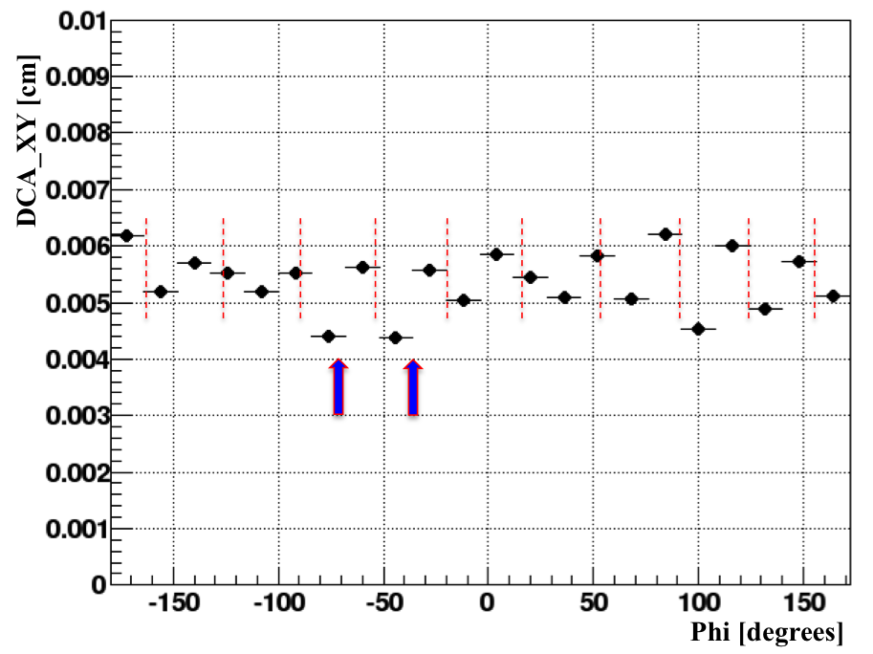

Figure 1 : DCA vs phi for p>0.5 GeV/c. The blue arrows show the location of the two PXL ladders (6 and 7) that were constructed with aluminum traces in the readout cables instead of copper traces. The red dashed lines show the approximate location of the sector walls.

Figure 1 shows the average DCA-XY resolution for tracks with momenta greater than 0.5 GeV/c as a function of the azimuthal angle in degrees for all hadrons. The red dashed lines show the approximate location of the sector walls. The location of the two sectors (#6 and #7) with Aluminum-trace cables in the inner ladder is shown in the figure by the two blue arrows. We observe that the average DCA value in these two sectors for this momentum range is lower than the average values in the other sectors.

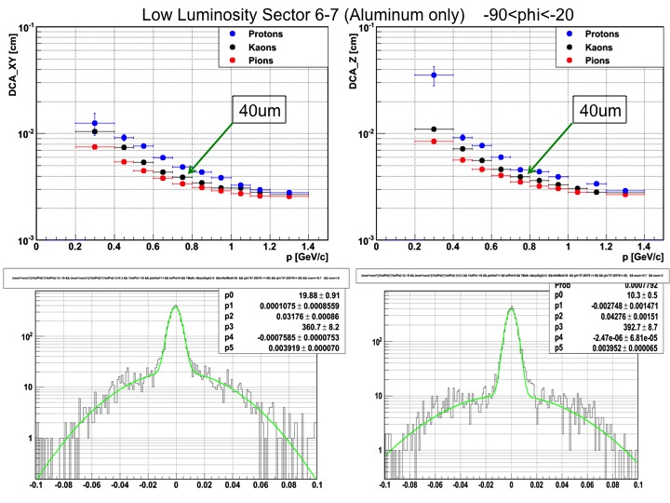
Figure 2: DCA-XY [left panels] and DCA-Z [right panels] resolution for tracks crossing the PXL sectors #6 and #7. The lower panels show the actual fits of the raw DCA resolutions for Kaons with momentum in the range 700<p<800 MeV/c.

Figure 2 shows the DCA results in the XY [left panels] and Z [right panels] directions for a low-luminosity data sample taken for calibration purposes. Low luminosity results in very low pileup hit densities in the PXL detector and lower track densities in the TPC, i.e. the tracking environment is very ‘clean’. The lower panels show the raw DCA distributions and fits for Kaons in the required momentum range of 700<p<800 MeV/c. The achieved resolution for both directions in this low luminosity/low noise environment is 40 microns. A similar analysis in a regular (high) luminosity environment resulted 44 (46) microns for DCA-XY (Z). This clearly demonstrates the achievement of the DCA-UPP in the data.

Run-14 (Au+Au 200 GeV/c ) work:

Calibration

- The IST gain calibration work for Run-14 data is quickly advancing.
- Work continues on the SSD software and calibrations.

Tracking/Vertexing

- The Main focus is still to set up a baseline tracking geometry together with the S&C group. Several issues have been identified and now working on the Sti geometry for IST and SSD. The PXL detector geometry seems to be fine.
- A tracking efficiency study in the PXL revealed several issues in Sti, the tracking software. Hao Qiu, the author of this study, worked closely with tracking experts at BNL and several issues have been fixed.
- A study on verifying and fine-tuning the event vertex finder for events with HFT hits is still in progress. Several issues have been identified in the vertex-ranking scheme and an optimization of the criteria is under way.

