**WBS 1.6 Software**

1) Some progress was reported on analyzing some test PIXEL survey data using the LBNL Coordinate Measuring Machine (CMM). Calibration Balls and PIXEL (bare) Sector data were fitted with the MINUIT fitting machinery as spheres and planes respectively.

2) A new, initial work on the D+ 3-body decay using the Kalman filter has produced the first inv. mass peaks using a small simulation sample (signal/background not to scale) as seen in the figure below, left panel. The work to optimize the cuts (S/N) and extract realistic (properly scaled) S/N levels is next.

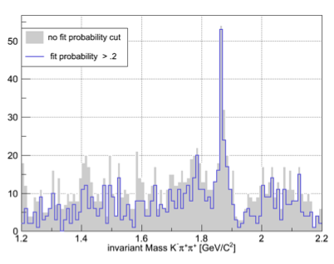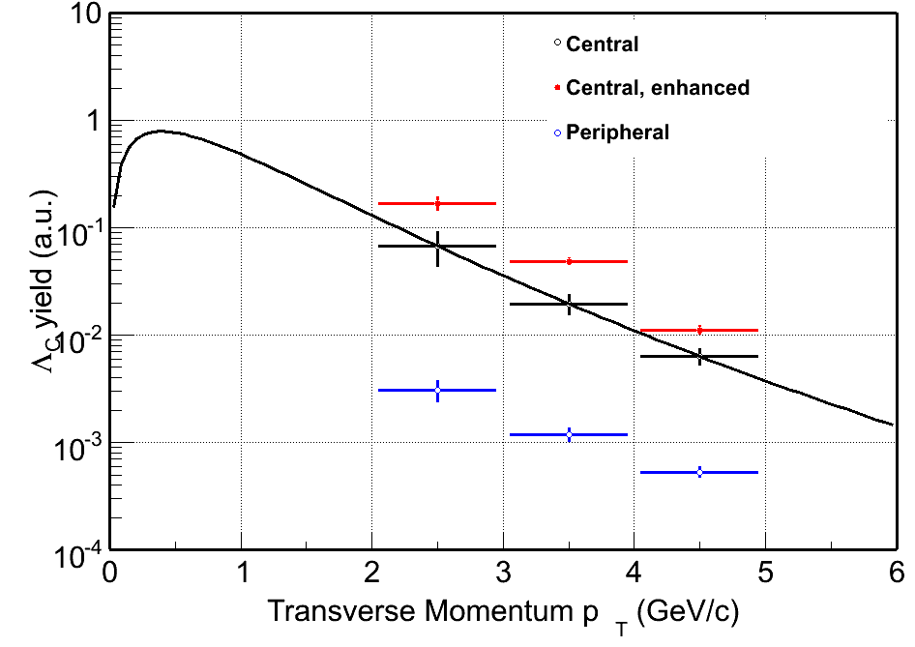

3) The work on the Ds 3-body decay channel via the F-meson (Ds->F+p->K+K+p has been revisited using a more realistic estimate on PID capabilities and background. A special (simulation) production was done for this purpose. Initial estimates were presented to the group but this is still work in progress.

4) Also for the first time estimated pt spectra for the Lc baryon were produced (see figure above, right panel).