**WBS 1.6 Software**

1) First results for the Ds particles and pt higher than 4 GeV/c (from the special production we performed in December 2010) were reported by the UCLA (see figure below). Results, from the same production, on D* are still to come.

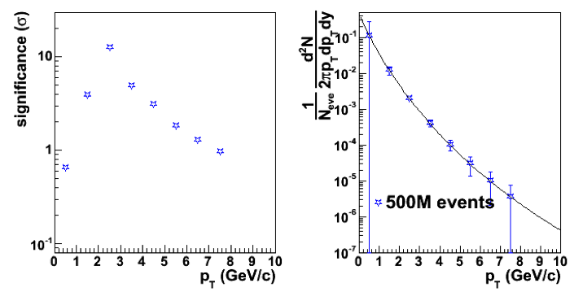

2) Worked on second version of the Software WBS-1.6 Dictionary and schedule.