**WBS 1.6 Software**

1) Started work on HFT Geometry update. This work started with the training of people in the new STAR framework, the Virtual Monte Carlo (VMC), a root based simulation/geometry package. The figure below shows the modeling of the new beam-pipe in the VMC environment. It is used as an exercise to familiarize oneself with the coding environment.



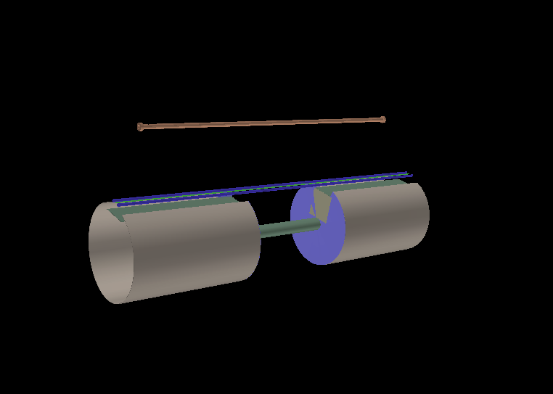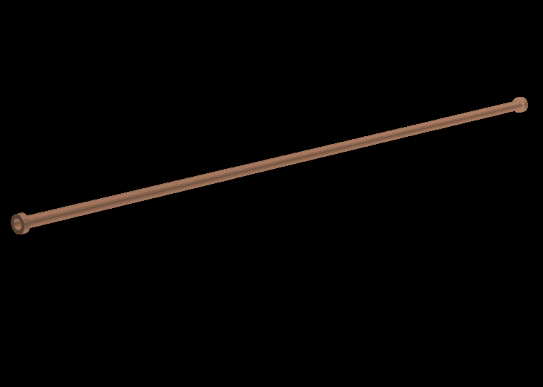

Figure 1 Modeling of the new beam pipe in VMC