**WBS 1.6 Software**

1. **Alignment Software and Simulations**
   1. Simulations and developmental work was performed in order to establish a working chain for HFT alignment based on the SVT/SSD experience and code. The initial work is focusing on SSD and IST and it will be followed with the PIXEL integration. Shown in the figure below are the correlation plot of SSD local hit position and the tracks prediction (left panel) as well as their difference distribution (right panel). This is for an undisturbed geometry of SSD and the mean of the difference should reveal possible shifts. This is only a low statistics demo figure.

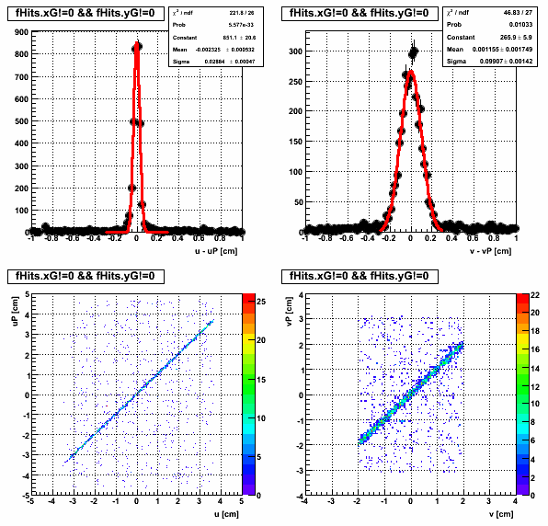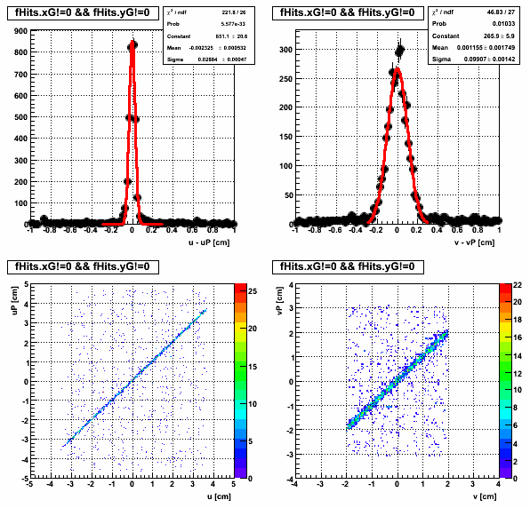

Figure [left panel] The correlation, in local coordinate system, of the hit position in RF (u) in the SSD versus the TPC track prediction on the detector surface (uP). The SSD hits were not used in tracking. [right panel] The distribution of the difference of the two quantities.

* 1. An STAR internal “Alignment Procedures Review” has been setup for October 12 at BNL.

1. **IST**
   1. Work on the IST fast simulator has been performed in order to initially separate it from the PXL fast simulator. Some issues were identified on hit smearing methods and they will be addressed in the next version.
   2. Work on IST geometry modeling has also started. The goal is to include more structural details in the geometry model.
2. **Survey**
   1. PIXEL: further survey work and software development was performed on the prototype sector and issues that emerged are addressed. The figure below shows full ladder scans (10 chips) obtained using the visual probe. The figure below it shows the survey apparatus configuration; one can see the rotator, the shaft section with the calibration balls in the middle and the prototype PXL sector on the right part of the figure with the 3 ladders exposed.



1. **AOB**
   1. We have looked at the Au+Au data at 11 and 19 GeV energies in an attempt to better understand the background and beam quality at low energies as this will impact the first layer of the prototype PXL sensors in the upcoming engineering run, Run-13. It turns out that the background and poor beam quality at low energy is a concern. These were summarized in a document.
   2. A document was put together specifying the HFT software support anticipated from the STAR, BNL-based, infrastructure group.
   3. The chip developers submitted to us a document on PXL sensor analysis of the CERN test beam data. It will be the basis to develop a slow and fast simulator for PXLs.