**HFT**

**Heavy Flavor Tracker**

MONTHLY REPORT

September 1-30, 2010

|  |  |
| --- | --- |
| Performing Organization | Brookhaven Science Associates |
| Location: | Brookhaven National Laboratory |
|  | Upton, New York 11973-5000 |
|  |  |
| Contract Period of Performance | FY2010-FY2014 |



**HFT MONTHLY PROGRESS REPORT**

**September 2010**

**I. Contractor Project Manager’s Assessment**

The technical schedule and cost status is judged satisfactory.

Technical Progress and Accomplishments

There has been progress on particularly PXL development identifying a potential vendor for the thin Kapton/Al cables. The components for the prototype insertation mechanism are progressing. The first iteration of the design for the SSD ladder board is complete.

Issues and Concerns

Still on track to have first draft of bottoms up schedule, by October but with not as much time for internal review ahead of meeting as was envisioned in July..The October 14 HFT technical and management meeting that will review the schedule, costs will go ahead.

**II Detailed STATUS by WBS**

**WBS 1.1 Project Management**

Individual meetings with project control and subsystems have taken place.

The monthly telecon with HQ took place on September 11. Followed up on ESAAB minutes at that meeting. It was confirmed the then project has fulfilled al the required responses from the report of the pre CD-1 review, and that these are satisfactory. The exact meaning what is means to make the PEP more concise is still unclear – guidance from DOE is needed on this point.

The NEPA document needed for CD2/3 was received.

**WBS 1.2 PXL detector**

PXL Electric

We have made significant progress on the PXL detector this month. We had an in-person meeting with Rui de Olivera (head of the CERN Printed Circuit Board (PCB) shop). The CERN PCB shops appear to be fully capable of fabricating an aluminum conductor flex cable that would meet the requirements of the PXL readout cable as currently envisioned. A proof of principle is shown below in the form of cable developed for the ALICE pixel detector.

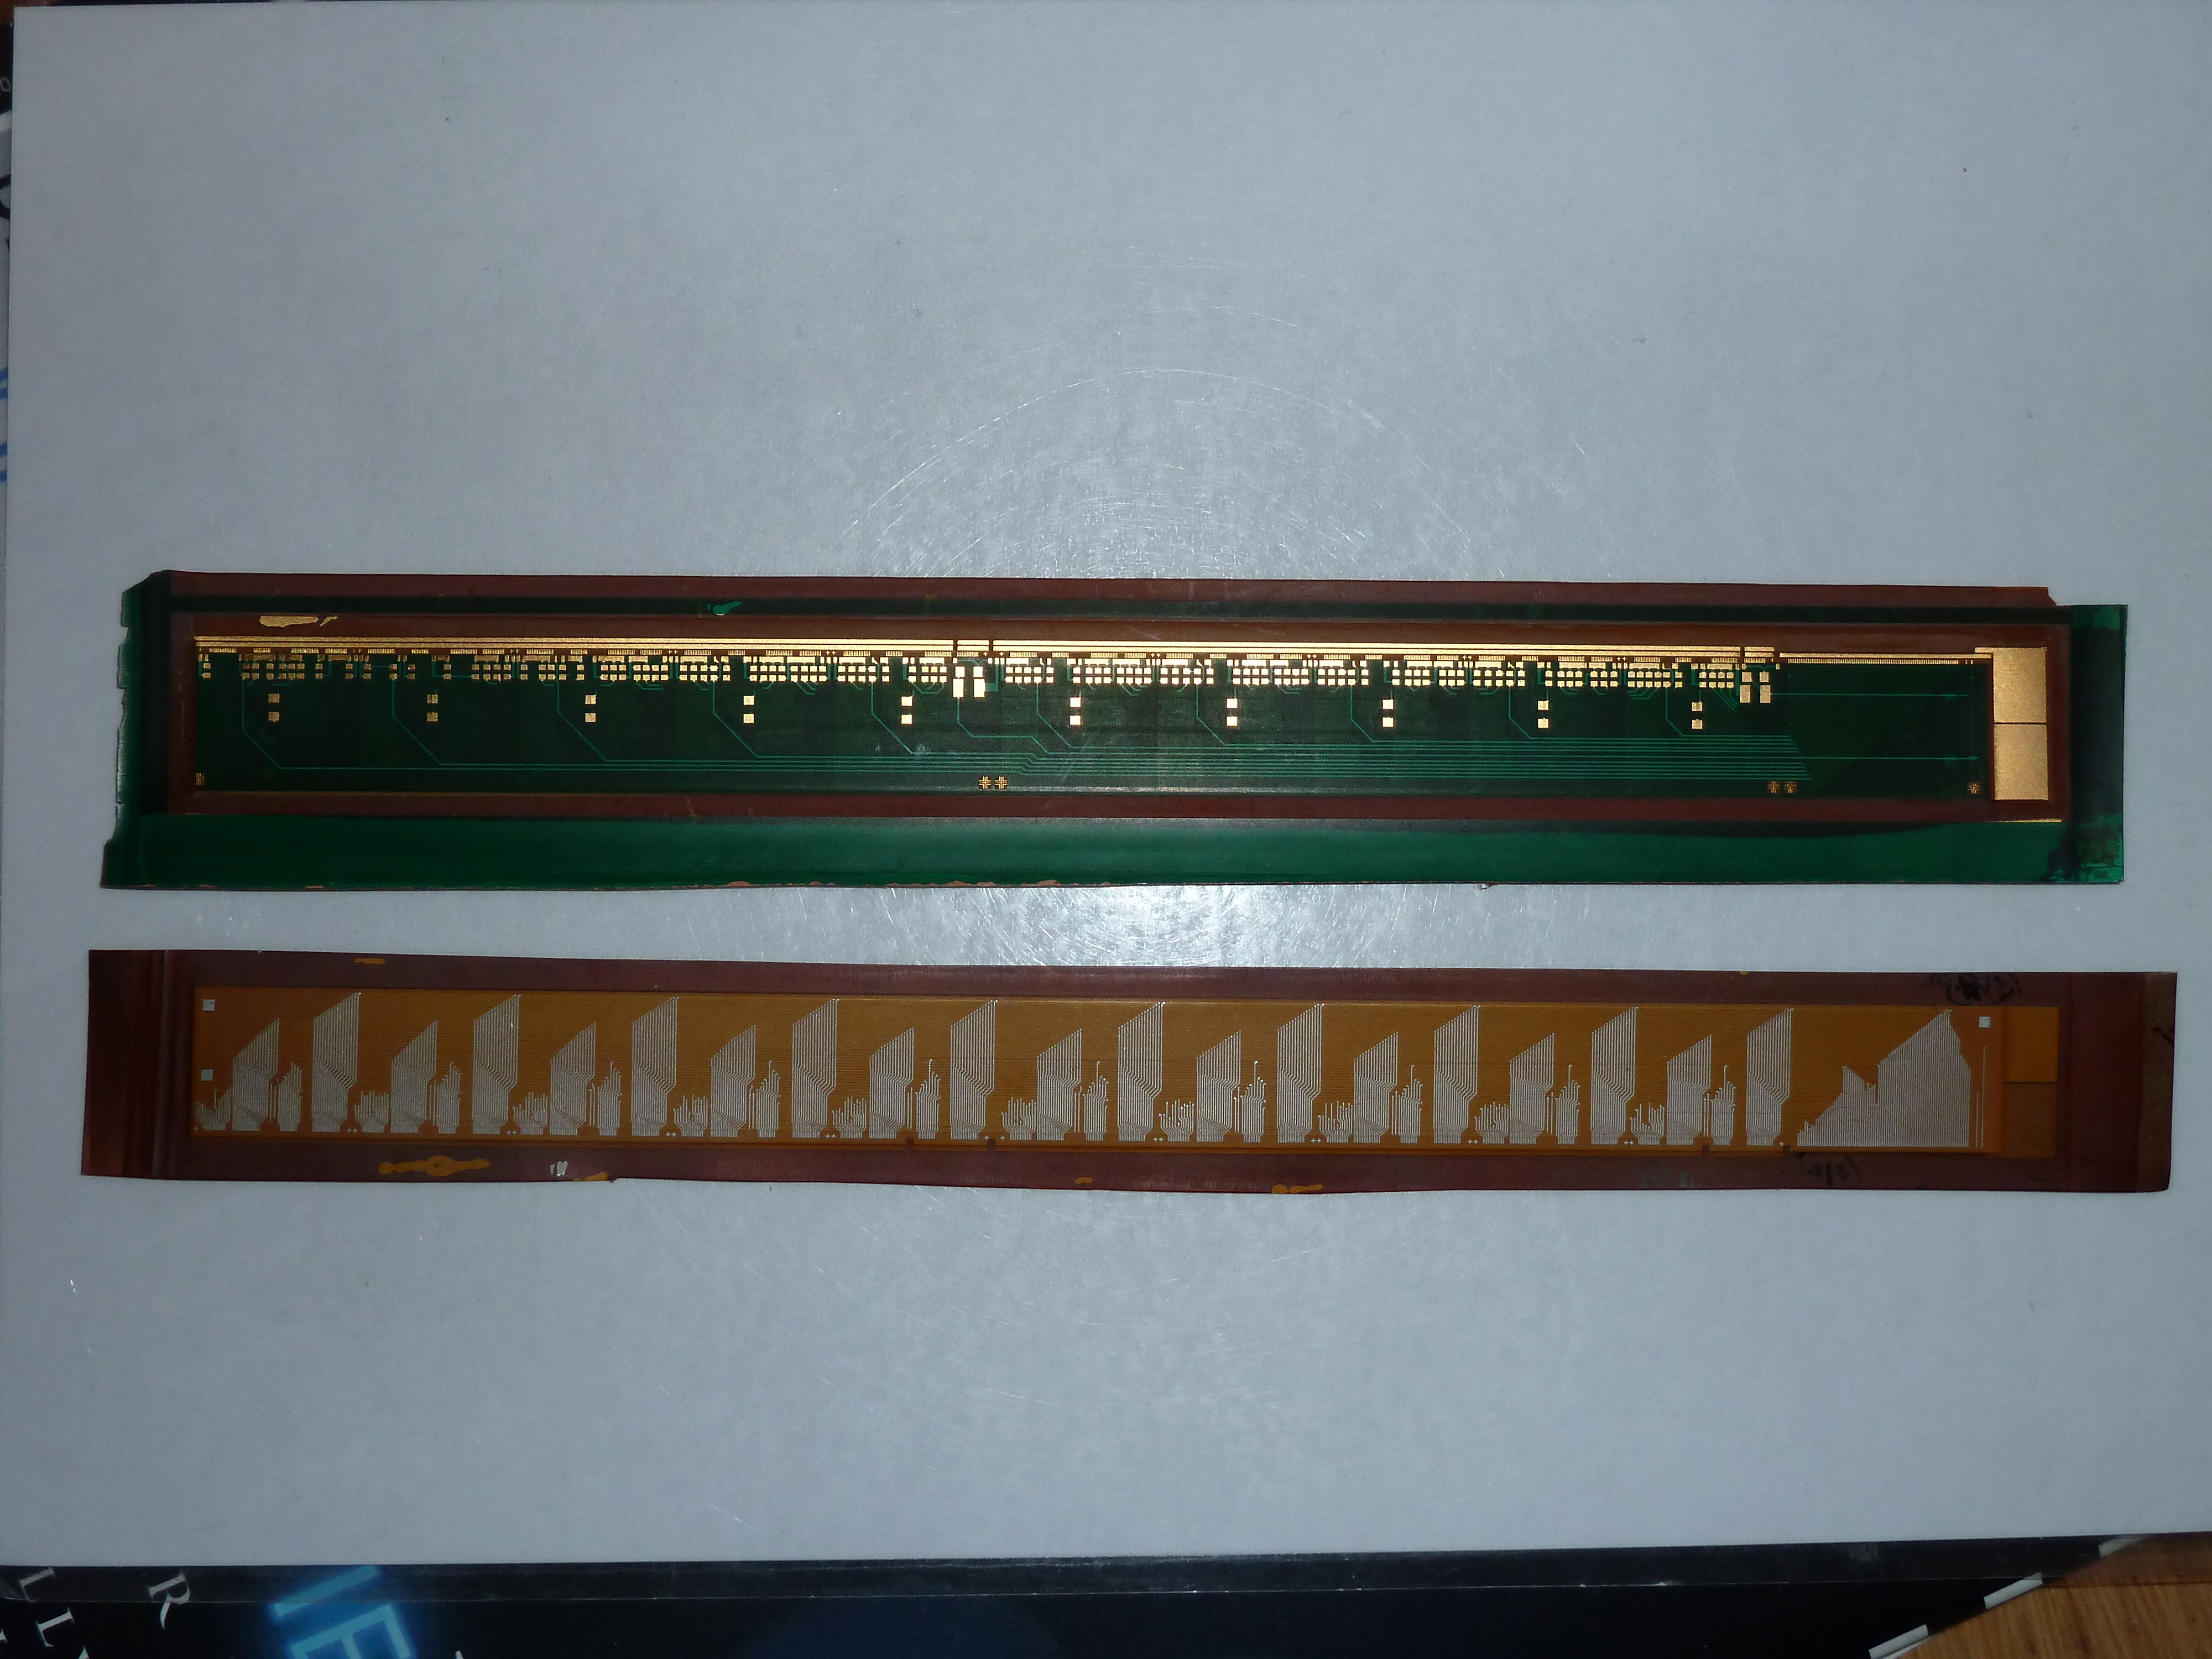

Figure 1 Aluminum conductor flex cable developed for the ALICE PXL detector. This cable is four layers with micro-vias and a 50 um feature size. The top side of the cable is gold plated to allow for wire-bonding and soldering. The lower cable in the picture shows one of the inner layers in aluminum conductor.

The timescale for delivery of boards can be negotiated but is similar to standard industry timescales. To produce the 200-300 cables that we need would require about 3-4 months. It would be better to work out a delivery schedule that allows for slower production if it can be arranged with the PXL schedule. The cost for the ALICE cables (50 um trace and space and microvias) was 170 SF per cable. This is a much more complex cable than the STAR PXL cable. He estimates that, based on my description, the cost would be about half, or 85 SF per cable. We can pay him just as we would any vendor. He will give a written quotation and can invoice LBNL. Rui recommends gold as a finish for wire bonding and component attachment (soldering or conductive adhesive). This would consist of 5-6 um of nickel followed by 0.1um of gold. They have not had good luck trying to get bond wires to stick to the amorphous aluminum that is the product of vacuum deposition. Since the CERN PCB shop also makes standard PCBs, we will do fabrication for the next 3 phases of ladder cable development there. This will serve as a way to familiarize the CERN shops with our designs, gain their advice and work out any communication or procurement problems before the aluminum conductor cable production fabrication. We now have a well-defined path to the lower radiation length PXL detector as well as a more reasonable cost estimate for the cable fabrication.

Meetings were held with IPHC in Strasbourg with Marc Winter, Christine Hu and other members of the PXL sensor design team. The main focus was to feed back information gained from the testing that we have done on sensors in a ladder configuration. These tests have resulted in us requesting several small changes to the final PXL sensor design. These include converting the sensor “START” signal from a single-ended to a differential LVDS signal, removing the requirement of bonding to the “RSTB” bonding pad, and the implementation on the “SPEAK” signal over LVDS or defined in a fixed state by using an internal “pull-up” resistor. IPHC has agreed to these modifications and will implement them in the initial design for the PXL sensor. The net result of these changes will be a full differential sensor interface for running conditions, one less trace in the bonding area of the sensors on the cable, and fewer bonding wires.

In addition we have made progress in the probe testing, ordering a new probe testing card and in the planning for a set of latch-up measurements to be done at the LBNL 88” cyclotron in early November. We plan to test new MAPS prototypes and all PXL detector electronics components, which are planned to be located in high and moderate radiation areas in STAR. MAPS prototypes to be tested for latch up and SEU cross-sections are Mimosa 26 and a dedicated chip for latch up tests designed at IPHC. The LU test chip is composed of shift-registers that are built with digital cells with different spacing between NMOS and PMOS transistors. The latch up test results will help to assess the need for designing new, latch up resistant digital cells for use in sensors for the PXL detector. As soon as the full testing setup is assembled, which is expected to happen in the second week of October, we intend to be on-call and ready to fill in empty time slots that may appear due to cancellations or earlier terminations of user runs at the 88” cyclotron. In this scenario, there is a possibility that latch up (and SEU) test results would be available before the end of October. A more likely outcome, however, is that we will use free beam slots in the 88” cyclotron in early November. A complete plan may be found here <http://rnc.lbl.gov/hft/hardware/docs/latchup/Latchup_plans_2010_(draft2).doc>

PXL Mechanics

Machining of parts for the prototype PXL support and insertion mechanics is ongoing at the main machine shop at LBNL and at the University of Texas Physics Machine shop. Photographs of example parts are shown in Figure 2 along with the solid model. The parts shown need to be reasonably low mass and are machined from aluminum with 2 mm thick wall, contoured for strength. A significant quantity (150 lbs) of fixturing parts have been completed and shipped from the University of Texas Physics shop.

Design work is continuing on the alignment apparatus that will be used to position the PXL storage box such that the detector can be transferred onto the rails in the Inner Detector Support cylinder. These rails (round 2 cm diameter carbon composite tubes) are illustrated in the model in Figure 2. This design work is less than half done, but should be largely complete by the end of October.

A part of the insertion system is a device that couples the slide carriage that rides on the rails to the hinged structure supporting the PXL detector. During detector insertion this coupling mechanism provides a rigid clamped coupling. Once the detector is inserted into the kinematic supports the direct coupling is released so that the kinematic mounts provide the only detector support. This relieves the over constraint that could potentially compromise position reproducibility. The design of this part is complete and quotes have been received for the fabrication of the bellows pistons that activate the coupler.

Figure Machining progress on the prototype PXL insertion and support mechanics. The photographed parts have been machined at LBNL and are finished. The green half cylinders in the model will be fabricated in carbon fiber. The University of Texas Physics machine shop has completed the machining of the required assembly fixtures for this carbon part. The forming mandrels for this carbon part are being done at LBNL and this work is over halfway completed.

**WBS 1.3 IST detector**

**--------------------------------------------------------**

A quotation has been received for a dummy large IST hybrid. This dummy should closely mimic the real large hybrid of which the design has not been finished yet. It should have the same number of kapton layers, realistic copper traces and bondable gold in designated areas. The dummy will be laminated to a prototype IST ladder to study the feasibility of this process and to determine if reliable wire bonding is possible to the assembly. This step should be done as soon as possible to be able to finalize the large hybrid and ladder design. Unfortunately the quotation came out a bit higher than expected for a pretty much blank dummy and other vendors are being contacted.

The specifications of the IST sensors were discussed in person with the local Hamamatsu representative, no issues were found. The rough estimate of a 6 month prototype production was reconfirmed. The representative did warn for a slight price increase due to less favorable yen-dollar exchange rates.

The testing of the APV readout chips is ongoing with both the IST pre-prototype and the FGT readout boards. Although the FGT is a different project, it shares an almost identical readout chain with the IST. Because of higher priorities at MIT/Bates for the FGT project there is a delay in the writing of the calibration code for the IST test readout of the pre-prototype. Hopefully this will be finished in October. The issues with unreliable I2C seem to have been resolved by issuing a hard reset when the APV chips get powered up. Grounding studies are done for the FGT readout boards using the analysis code developed for the IST pre-prototype.

The IST readout system consists of an Wiener MPod crates, APV Readout Modules (ARM's) and APV Readout Controllers (ARC's). These are essentially identical to those being developed for the FGT project. The first ARC's, which accept STAR triggers and provide the interface between DAQ and the ARM's, have been produced for the FGT project and testing will begin shortly. The full design of the ARM has to be finalized still. However, the interfacing with the APV front-ends through a long readout cable is being tested successfully already. This interface provides power to the APV chips but also does optimal filtering of the signals, which get distorted by the long signal cable. The first prototypes for the ARM are expected before the end of CY2010.

**WBS 1.4 SSD detector**

Ladder Board

A major milestone has been reached on the ladder board. The design of the prototype Ladder Board PCB is finished and ready for fabrication. Just prior to production of this design, a few wrongly ordered parts were discovered. The correct parts have been ordered and will arrive before the PCB is completed. Also, discrepancies with the part layout and the board design were found and incorporated into the prototype Ladder Board. Components to populate the prototype ladder card have been ordered, and, with a few exceptions, have been received.

SSD Readout board (RDO)

Additions to the code residing in the slave FPGA on the RDO now include a facility to manage the storage and downloading of code to configure the FPGA on the ladder card via the optical fiber.  This code is developed at BNL and is in the process of final simulation.

No work has been done on the remaining FPGAs (VME and DAQ/TRG) on the RDO card (Subatech responsibility).

Discussions on the design of the board have started.

Management

Work has proceeded on the cost and schedule document. The tasks have been listed and the relationships between these items have been created. Work has started on putting a realistic schedule into this document.

**WBS 1.5 Integration**

Assembly Area

Gerrit VanNiewenhuizen and Dana Beavis met with the STAR Operations group to discuss the needs for the FGT and the HFT for the assembly area outside of the IR. The STAR ops group agreed that the clean room would be for FGT in Feb. 11. They were reluctant to reserve the entire “clean room” area for the FGT. Justification of the improvements is desired by the support group.

A preliminary layout of the assembly area was generated showing the HFT with beam pipe in the “clean room” and a tent in the hall for assembly. Nearly all the assembly area is used when these items are in place and STAR is rolled out. It does appear that the IDS can be moved from the clean room to the tent. In addition if the tent is not too large it appears that the insertion platform can be moved into the area at any time.

The insertion platform was found to have minor damage and weather decay to the wood decking. Plans were made to move it inside during the winter and refurbish the platform so that it is ready for use at the beginning of the shutdown.

Rack space in IR

The racks have been assigned on the south platform for HFT. In Oct. PXL will choose from the options presented them. In Oct. the PXL small rack located near or on the pole tip will have a location determined. Cable tray and routes were discussed and examination will occur in Oct. during the BNL meeting.

Beam Pipe

Integration had discussions with the CERN people that will work on the NEG coating and heating jackets of the beam pipe. A minimum of four hous is requires to leak check a flange during assembly. The Project should plan on a week of effort for beam pipe bake-out in the IR and a week of time lost due to conflict in the vacuum group commitments. The FGT and HFT subsystems need to specify how high the temperature can go at their detector during bakeout. IST thought 35o C would be acceptable. PXL will not be in during bake-out.

IDS

Progress on the mandrels for the WSC and MSC were pending the establishment of the accounts for the work. The accounts became usable at the end of the month.

The analysis of the IDS will need some documentation and review to obtain final approval. The Project is confident in the design and is comfortable delaying the documentation and its review until after the cost and schedule meeting in Oct.

PXL Support

Work progressed on the PXL insertion tooling with the goal to establish the platform requirements.

Safety

Samples of cables that will be used for the FGT and the HFT were given to the fire engineers for burn tests. Results are not yet known.

Management

Work on updating the cost and schedule progressed in anticipation of the Oct. 14 BNL meeting.

**WBS 1.6 Software**

1) Final power-point file for the High-z radiation GEANT study has been done and posted. The study was performed to test the hypothesis that part of the observed/measured radiation increase at distances of a few meters away for the interaction point comes from interactions of produced particles with the beam pipe. The results verified the hypothesis.

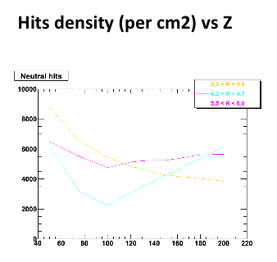

2) D_s -> (Phi)pi -> KKpi work has started. Results are expected to appear by the time of the TC meeting at BNL. This revived study looks at the Ds decay channel that involves the Phi meson. A specific simulation data set was produced for this study.

3) The D+ reconstruction work has started. A simulation production has been found and the D+ 3-body decay channel has been explored. In this renewed attempt a secondary vertex fitter based on the Kalman filter is used. First results are anticipated by the TC meeting, mid-October 2010.

4) An initial version of the WBS 1.6 detailed task list has been released for feedback to the group. The next step will be to refresh the Institutional responsibility task table and develop a detailed schedule.

**Financial Status**

Project funds have been received for initial efforts in the balance of FY10 through February of FY11. Funds in the amount of $940K have been distributed to Lawrence Berkeley National Lab. Project IDs and tracking have been established for the LBNL efforts. The distributions of cost at completion on other WBS items are to be determined at base lining.

|  |  |  |  |  |  |  |
| --- | --- | --- | --- | --- | --- | --- |
| **WBS** | **Title** | **Monthly Actual** | **FY to Date** | **Project to Date**  **k$** | **Commitments**  **K$** | **Cost at Completion**  **K$** |
| 1.1 | Management | 4.1 | 4.1 | 4.1 | 0 |  |
| 1.2 | PXL | 7.4 | 7.4 | 7.4 | 27.5 |  |
| 1.3 | IST | 0 | 0 | 0 | 0 |  |
| 1.4 | SSD | 0 | 0 | 0 | 0 |  |
| 1.5 | Integration | 7.3 | 7.3 | 7.3 | 0 |  |
| 1.6 | Software | 0 | 0 | 0 | 0 |  |
|  | R&D | 28 | 260 | 260 | (11.7) | 280 |
|  | Contingency |  |  |  |  |  |
|  | Total | 46.8 | 278.8 | 278.8 | 15.8 |  |

**Acronyms**

IST Inner Silicon Tracker

IDS Inner Detector Support

OFC Outer Field Cage

FPGA Field Programmable Arrays

WSC West Support Cylinder

ESC East Support Cylinder

OSC Outer Support Cylinder

FGT Forward GEM Tracker

MSC Middle Support Cylinder