**WBS 1.6 Software**

1) Initial simulation work from Purdue group on D* capabilities of HFT was presented showing good prospects for their reconstruction capabilities as demonstrated by the figures below. Further work on realistic background estimation, PID and cut optimization is in progress.

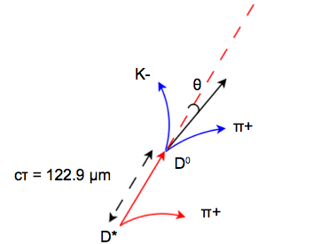

Figure-1: Decay of the D* particle

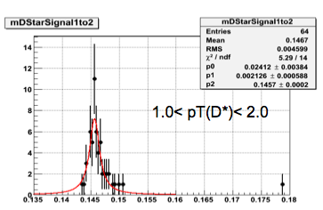



Figure-2: (D*-D0) mass distribution in 1<pT<2 GeV/c

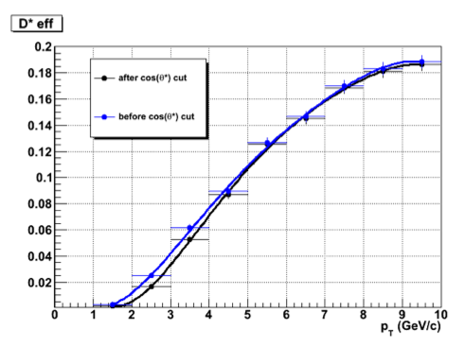

**Figure-3: D* reconstruction efficiency at a function of pT**