September 18, 2012

Run-13 Au+Au : The HFT perspective

Introduction
STAR management has proposed that the second priority in Run-13 be a low-energy point - proposed 14.6 GeV - instead of a 200 GeV engineering run for HFT. This decision is mainly driven by the desire to fill in another low energy point for BES. This is of course not our preferred action so we present below a short position paper on the HFT point of view: how this would affect our capability and what we can learn, and argue for a Au+Au run at full 200 GeV energy.

Impact on the Engineering Run Goals
The HFT group is planning and preparing to install several fully instrumented PIXEL sectors in the experiment for the next run, Run-13, which is the only available opportunity for an engineer test before full system installation next year. The main goal for this run is system verification and correction; this includes the study of the collision environment, detector response, backgrounds, operational experience and first look at basics detector performance. At the same time, assuming good performance and data integrity, we could be able to attempt the extraction of some charm physics as several simulation studies have shown. As it becomes immediately obvious, most of these goals will be compromised by a low energy run. Below we list our argument in no particular order:

- We will not be able to test the sensors in the high multiplicity environment of Au+Au 200 GeV collisions. The PIXEL sensors and readout system will not have the chance to ‘see’ the full load anticipated at 200 GeV. This is includes the hits from the primary collision but also the hits from pileup collisions and spiraling electrons from Ultra-Peripheral AuAu Collisions (UPC). In order to experience this we will have to wait for full system installation and operation in Run-14, the run that HFT is supposed to accumulate large, high quality data samples for precision physics measurements. A major system test in the real environment of Au+Au collisions at 200 GeV is thus compromised.
- We will not be able to study the background radiation at our working position (only a couple of centimeters from the beam line center). This includes Halo but also the UPC electrons. Dark current (radiation) and hit density studies again will have to wait for the full system installation and operation next year. The engineering run was also to test for vulnerability to wakefield generated noise (or other unanticipated noise source). We don’t expect this to be an issue with our detector design, but if the engineering run exposes a problem then RF shielding would be implemented.
- Most collisions will be not useful due to poor beam properties at low energy and definitely outside +-10 cm useful PIXEL acceptance due to anticipated poor vertex position trigger performance at very low multiplicities. This coupled to poor delivered luminosities, the large beam diamond at the detector and the increased backgrounds will render most of these data of little or no use. Figures 1, 2 and 3 demonstrate these points. Figure 1 is real data from Run-10 where we recorded about 55 million interactions of Au+Au collisions at 11.5 GeV, an energy close to the proposed one. What is shown is the event vertex position in the transverse plane (X-Y) for valid/triggered minimum bias events.
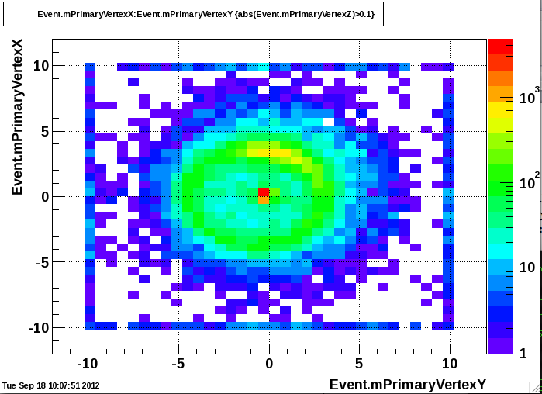
Figure 1 Primary vertex position in the transverse plane for Au+Au collisions at 11 GeV/c. The red circle denote the position of the beam pipe (radius of 4 cm).
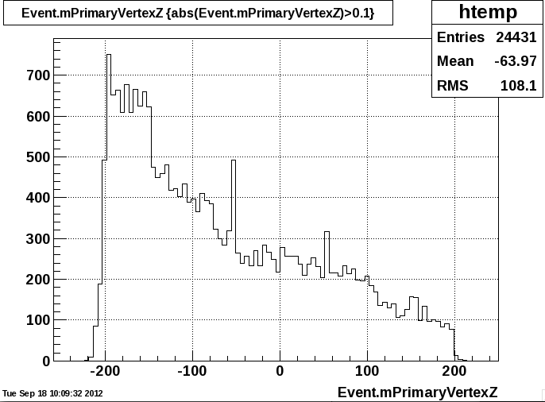
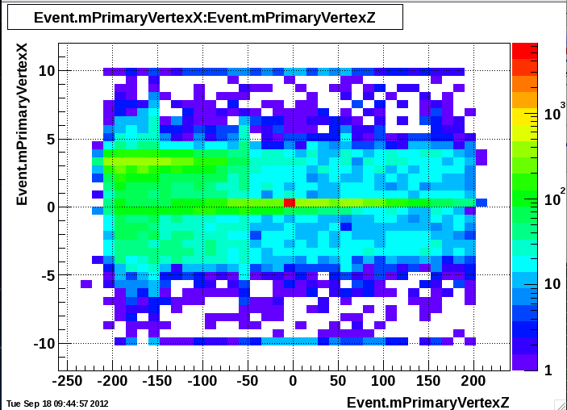
Besides the good events near the origin one can easily see the outline of halo events near the position of the beam pipe (which is shown as a red circle at 4cm). Figure 2 shows the X position of these vertices vs the Z position (beam direction). The insert is the histogram profile along the Z-direction. One can see that most of the ‘beam scrapping’ events happen upstream but they appear as valid events at the edge of the TPC. This significant halo is going to hit the first PIXEL layer sensors, which will be in the vicinity of 2.5 to 3.5 cm from the beam pipe center. Also, as we see in the insert of Fig. 2, the events at these low energies are distributed over large distances therefore, even if we deploy an event vertex trigger only a very small fraction of valid events will be captured in the +-10cm PIXEL useful acceptance (less than 5%). As Fig.3 shows (right y-axis) the delivered luminosity for this energy was less than 10% the corresponding full energy luminosity. This points to a veto rate (at best of a few KHz). If we apply the acceptance factor of the PIXEL detector we can anticipate about 100Hz event rate at these energies. This points to a marginally useful event sample for any studies. All this assumes that at the proposed run the beam characteristics are going to be similar to those in Run-10 Au+Au 11.5 GeV.

Figure 2 Event vertex position in the X-Z plane (side view). The insert is the profile histogram along the beam (Z) direction.
- At the same time the TPC - determined event vertex will have about four times worse resolution at 14.6 GeV than at 200 GeV thus the reconstruction parameters, in terms of rates and resolution, and their study will rapidly deteriorate. This is also due to several other factors like the partial angular coverage of the PIXELS, the absence of both intermediate trackers (SSD and IST) and in general the challenging tracking environment is these conditions.

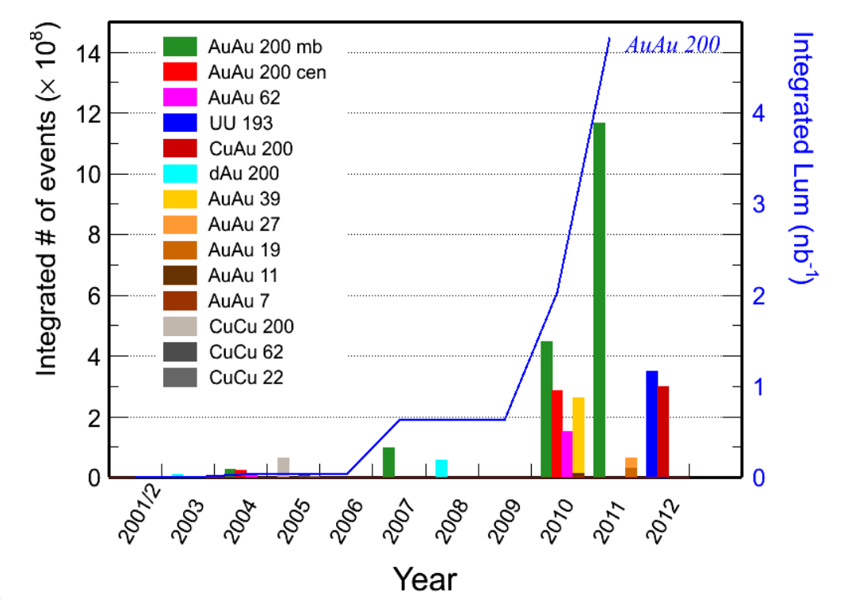
Figure 3 Integrated number of events (left vertical axis) or Luminosity (right vertical axis) for various beam configurations and run periods.
Having said that we think that there are certain things we can learn from a engineering run at the proposed energy, but that would be much less optimal that a run at the desired full energy of 200 GeV. By having the system test performed at a much lower energy, i.e. much different environment than the anticipated one next year, when the full system is installed, we believe, also given the recent experience of our PHENIX colleagues, we introduce an extra risk factor for unforeseen trouble at full system commissioning.
This, in turn, might introduce further delays in delivering the Physics of HFT in a highly competitive environment at RHIC and CERN. We are not sure if the Collaboration really wants to take that risk.

