Software:

1) Final power-point file for the High-z radiation GEANT study has been done and posted. The study was performed to test the hypothesis that part of the observed/measured radiation increase at distances of a few meters away for the interaction point comes from interactions of produced particles with the beam pipe. The results verified the hypothesis.

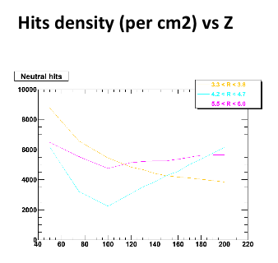

2) D_s -> (Phi)pi -> KKpi work has started. Results are expected to appear by the time of the TC meeting at BNL. This revived study looks at the Ds decay channel that involves the Phi meson. A specific simulation data set was produced for this study.

3) The D+ reconstruction work has started. A simulation production has been found and the D+ 3-body decay channel has been explored. In this renewed attempt a secondary vertex fitter based on the Kalman filter is used. First results are anticipated by the TC meeting, mid-October 2010.

4) An initial version of the WBS 1.6 detailed task list has been released for feedback to the group. The next step will be to refresh the Institutional responsibility task table and develop a detailed schedule.