WBS 1.6 Software

- Alignment Simulations
  - A new geometry library with the full HFT (including the SSD and IST) is built that will allow us perform (mis)-alignment studies in order to check the validity of the code and the achieved resolutions (translations and rotations). Figure 1 shows a cut out of this geometry where one can see the different HFT components and the support structures.

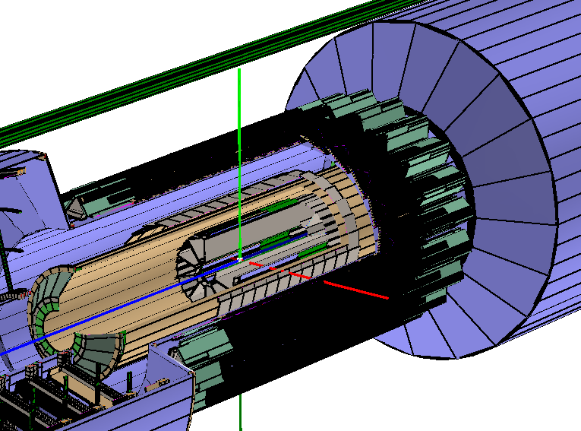
Figure 1 A cut out of the HFT geometry in GEANT. The three detectors and their support structures can been identified.

  - The offline chain was modified and problems were fixed so that hit and tracking finding is possible with the new geometry.
  - The next step is to produce small data sets for testing
- Tracking
  - Ivan Kisel and collaborators from GSI/ALICE will visit in August BNL. We have planned for a few collaborative activities and technology transfer including the possibility/feasibility to use CA (Cellular Automaton) techniques for HFT seed and/or track finding.
- Survey
  - PIXEL: some problems with the sector rotating mechanism were encountered and the vendor was conducted to address the problems.
  - SSD: New measurements on the ZEISS CMM confirmed the existence of gravitational sagging of the ladder. The figure below shows the setup for surveying the SSD ladder in the vertical position (left) and the net gravitational sagging effect (right) which is a few hundreds of microns (well within tolerances). This gravitational effect is going to be taken into account (for the first time since the SSD was build).

- Pixel simulator
  - The analysis of the CERN test data is done at IPHC and documentations is being produced.
  - This is the basis for the development of a Pixel fast simulator

