Phenix HFT 6 Face Tube
Feature Labels

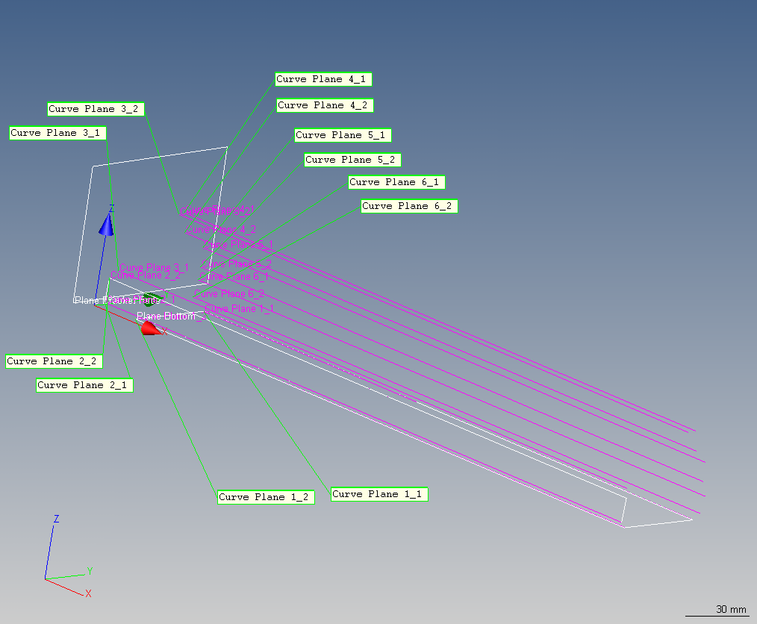

Injection and Extraction Diameters

