STAR Heavy Flavor Tracker (HFT)

Response to CD-1 Physics Questions

July 28, 2026

Introduction
This report is written in response to the questions raised in the DOE document “ Report on the Technical, Cost, Schedule and Management Review of the STAR Heavy Flavor Tracker". This review took place at Brookhaven National Laboratory in November 12-13, 2009, and is referred to here as the CD-1 review.
In the first part we describe the simulations that have been performed since the review and then address all the relevant questions.
In the Appendix we list the relevant excerpts from the DOE CD-1 report that we have attempted to answer in this report.

New HFT Simulations

Update on Simulation work

The main theme in the CD-1 questions is the design impact on the physics, especially the lower p_{T} regions that is more sensitive to detector thickness. In order to increase the statistics in the low p_{T} region we ran two extra productions (one for each PIXEL thickness scenario “thin”/”thick”). At the same time we increased the number of embedded particles in each “background” Hijing event from e.g. 5 D⁰ to 20 D⁰ per event. We also used a ‘power-law’ instead of a ‘flat-p_{T}’ spectra shape for the D⁰s in order to use a more realistic shape but also to naturally enhance the statistics in the low p_{T} region.

We also ran a ‘Fast’ and a ‘Full’ simulation with the ‘HYBRID’ technology replacing the PIXEL layers in order to justify the technology choice but most importantly to be able to make comments on STAR vs PHENIX capabilities.

Another area of interest is cut-optimization work performed in the low p_{T} region (0-2 GeV/c). The optimized set of cuts is then compared to the ‘standard’ or ‘CDR’ set. This work was done using both the Fast and Full simulations in order to maximize the signal significance (S/N) in the p_{T} region of interest.

To summarize the additional simulation efforts after the CD-1 review:

- We ran new productions for thin/thick scenarios to more than quadruple our available statistics in the low p_{T} region.
- We evaluated/compared the performance of PIXEL/HYBRID scenarios.
- We performed cut-optimization studies for enhanced low p_{T} D⁰ significance.

Simulation Environment
All simulations in this report where performed in the same environment as the ones included in the CDR and CD-1 presentations, i.e. the standard STAR reconstruction chain is used as well as the same HFT detector configuration (geometry). The HFT geometry used in all simulations (slightly different than the latest design) comprises of two layers of PIXEL detectors at 2.5 and 8 cm radius, one IST layer of 600 (r-φ) x 6000 (z) micron strip-lets at a radius of 14 cm and the existing SSD detector at 23 cm radius.

In the following we will study the impact of increasing the mass of the first layer of PXL detector from the design value of 0.37?% X₀ (using Al cables) to the value given as a CD-4 parameter of 0.52?%X₀ (Cu cables) and of increasing the internal stability from 20μm (design value) to 30μm (CD-4 parameter). In the GEANT simulations presented below we have used a slightly different (older) set of thickness numbers since we did not want to change them mid-stream. The numbers used are 0.32% and 0.62% for the ‘thin/thick’ scenario correspondingly.

Concerning the STAR/PHENIX comparisons of physics capabilities we must point out that the STAR environment was used for both Fast and Full simulations. What we mean is that differences in actual acceptance and reconstruction efficiencies were not taken into account. The comparison was focused more on the difference of the PIXEL and HYBRID technologies.

Answers to CD-1 questions

• Studies should be carried through to the final physics measurement, showing the degradation of the final physics significance if key requirements are not met:

–Give an explicit evaluation of what the loss in low-pT efficiency does regarding the fundamental physics questions relating to flow and energy loss of heavy quarks in the hot-dense medium. Evaluate this loss in terms of current theoretical models and show whether these are well tested by the measurement above ~2 GeV/c or if the loss of statistics at lower pT is a critical loss.

Low p_{T} is important for studies of collectivity. Energy loss is a high p_{T} phenomenon. We limit our discussion to v2, where low p_{T} is important. The simple argument is that flow is a hydrodynamic phenomenon and data and hydro predictions agree up to about 1.5 GeV p_{T} at which point data deviate dramatically from hydro. In Figure 1 we present precision of measurement that may be achieved by assuming two limiting cases for a model calculation. The model is based on the coalescence assumption. Coalescence is empirical observation deducted from v2 systematics. At low p_{T} we have mass scaling/splitting (hydro) and at high p_{T} leveling off and scaling with number of constituent quarks. The v2 at high p_{T} is not a hydro effect but is due to quark energy loss. Reference Error: Reference source not found has no predictive power at high p_{T} (above 2 GeV). Energy loss mechanism is not included. It uses light quark momentum distribution and for the heavy quark either non-interacting distributions (no flow) or completely thermalized distributions with transverse expansion (flow). In fact, if constituent quark scaling is to hold in charm sector, the v2 value at high p_{T} is determined only by the fact that the D0 is a meson, thus the two curves are expected to merge. Therefore, there is no realistic model on the market that would give quantitative guidance for v2 values at low p_{T} anunrealistic predictions for v2 at high p_{T}. Comparison has to be on systematic of v2 scaling as a function of particle mass. If heavy quark flows, the systematics will show it.

However, this shows the importance of testing of coalescence in the charm sector. Besides v2 scaling, Λ_{C} and D0 cross sections are ideal test.

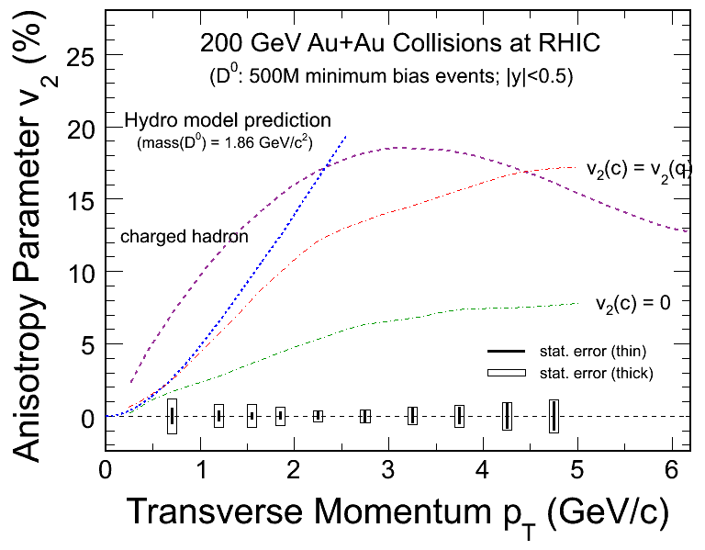
Figure 1 (PLACE HOLDER)Elliptic flow (v2) vs p_{T} in Au+Au collisions at 200 GeV/c

2. figure:
As a function of pT calculate ratio of significance for the three cases
(reference is thin)
Thick/thin
Thin with incr. resolution/thin
Thick with incr. resolution / thin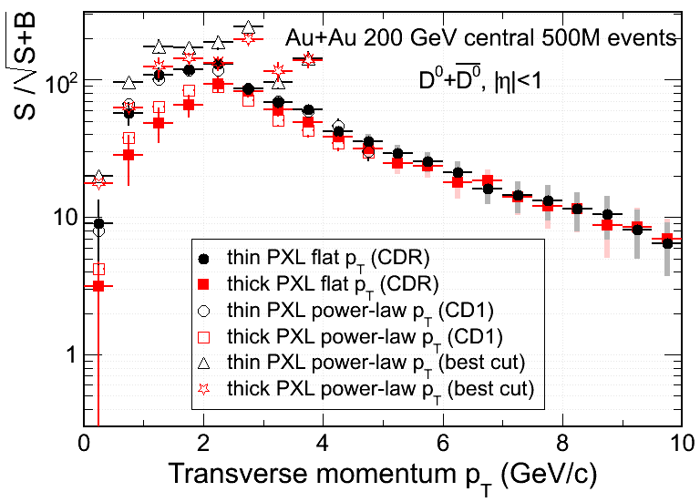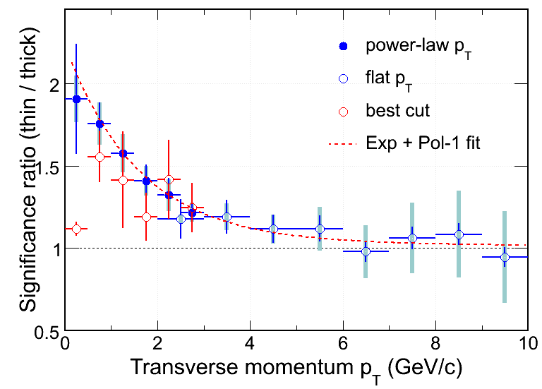
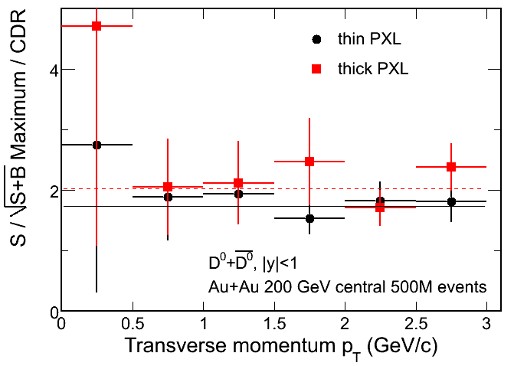

Figure 2 (PLACE HOLDER) Signal significance as a function of pT
The resolution (stability) data will come from fast simulations

• Compare the significance of planned charm and beauty measurement to be done with the HFT to similar measurements expected from the upgraded PHENIX detector. Comment on how significant an advance in theoretical understanding of energy loss and flow for the hot-dense medium the HFT would provide compared to the earlier anticipated PHENIX measurements

PHENIX has not shown simulations that would establish the capability to do topological reconstruction of D-mesons. Therefore we will attempt a qualitative comparison of what can be done with the HFT and PHENIX with respect to the physics extracted from the measurement of the electrons from semi-leptonic D- and B-meson decays. We believe the following statements to be correct:

- The theory development in the area of energy loss is progressing rapidly and it is not obvious what it will be in a few years. It is, however, safe to say that quality data are the requirement for theory progress.

- All measurements by STAR based on topological reconstruction are original and without competition at RHIC.

- PHENIX and STAR will both measure charm/beauty production cross sections from the electron spectra.

PHENIX will measure the separate spectra of electrons from charm and electrons from beauty. The new information that the HYBRID vertex detectors will provide is the electron impact parameter (DCA) from the event vertex. The reconstruction technique is based on applying DCA cuts to reject background and then fit the yields in various pT bins. This will result the sum of D and B decays which can be further separated using invariant mass hypotheses and clean-up. However, they probably have to assume, or get theory guidance, on spectral shapes and/or relative species chemistry; i.e. the ratio D+/D0, etc., in order to separate the D+ from the B contribution. Otherwise the D+ and B are highly degenerate in the method using a single track displaced from the vertex. As we mentioned this can be alleviated with the use of multi-particle correlations (since another thing that distinguishes B from D is the different mass, and therefore invariant mass distribution from a few particles), but it is not demonstrated how well that works in Au+Au and within their acceptance, except for a first look in a poster at QM.

However: there is a loss of information in the B and D R_{AA} vs. the electron from B and D R_{AA}, since there is momentum smearing.

So, to summarize some advantages:
Direct reconstruction of momentum, and so possibility to look at momentum dependence of R_{AA} of mesons directly

Ability to look at chemistry: again, to test coalescence mechanism at intermediate pT and as a precise test of a necessary input to the displaced-track method.

Electron v2 cannot contribute to the question of thermalization. In that measurement the parent pT is not determined to better than 3 GeV. We have argued for low pT before. Also at high pT v2 is pT dependent , to a lesser extend.

Xin and Yifei will try to quantify the losses in precision of D and B separation due to the fact that p+p branching ratios have to be assumed.

Appendix:

Show fast simulation of PHENIX significance. Show that at high pT it is the resolution and not the thickness. And point out that simulation is for 2 pi and STAR acceptance.

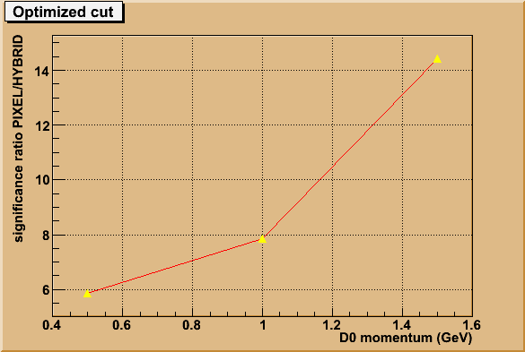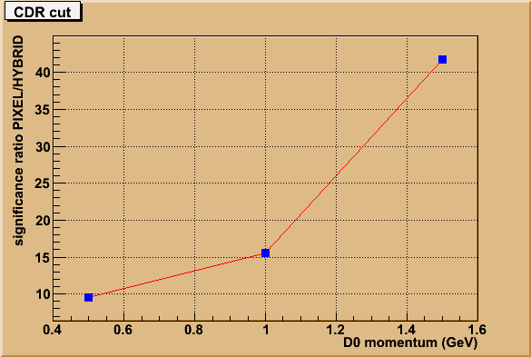
Figure 3 Gain in significance by using PIXELS vs HYBRID detector elements

Timescale:
We should have a draft by the collaboration meeting good enough that we can give to Steve, and plan for submission on mid-April at the latest. Any speed-up is important, so one can start discussing a schedule with DOE on CD-2/3.

Key-parameters (reco I)
These were taken to be PXL layer thickness, and internal alignment/stability. This matches our full (and analytical) simulations.

General Considerations:
- we should answer as specific as possible
identify key parameters i) thicjness ii) vibrational 20-30

enclose in app. Howards fast sim that evaluate effect of thick.. of resulting S/B.
1)
The new fig from Yifei gives the diff for v2(pt) in two scenario’s. Comment that improvement in top. Rec. has resulted in *2 over presentation at CDR.

+)Hydro flow of Do can be determined even with thick.

Hydro flow cannot be tested with only data > 2 GeV/c
The development of v2 from low to high is of theoretical interest, (teany with many citing newer articles) Determination od drag coefficients.

-) The lambda-c actually becomes a marginal measurement with thick, Worth to iterate the new result for Lc and plot properly with errors i.e. only say for enhancement of Lc/do

-) point out other Charmed mesons that can be reco. Ds..

2) Phenix:..
- give our understanding of Phenix
flow for electrons from Charm above 2 GeV/c
c-b sep from electons, assuming pT shapes?

Again stress that the ambiguity in not knowing the Do directly, and relying on electrons only. Point out that the Do spectraum shape is used in b-c seperation

Update on Λ_{C} Simulations

Since CDR we have increased statistics of our simulations, to allow for better optimization of cuts also in the Λ_{C} analysis. Despite these improvements, estimated errors in the 2-3 and 3-4 GeV/c p_{T} bins haven't changed significantly, showing robustness of our CDR estimates.
A significant improvement was achieved in the 4-5 GeV/c p_{T} bin, where we didn't require full identification of daughter particles, which resulted in improvements in Λ_{C} reconstruction efficiency and (as background is modest in this higher p_{T} bin) increased the Λ_{C} signal significance.
Note that in the figure, the discrimination should be made between estimated errors and the 2 scenarios of Λ_{C} /D0 ratio - not between the two sets of estimated errors. The significance of this discrimination is in the range 2-4 sigma in the case of an enhanced ratio and about 4-6 sigma in the extreme case of no-enhancement.
Similar simulations and analysis of simulated data were conducted for the "thick" detector configuration. However, Λ_{C} /D0 measurement with similar errors turned out not to be feasible with reasonable statistics in the "thick" detector configuration.

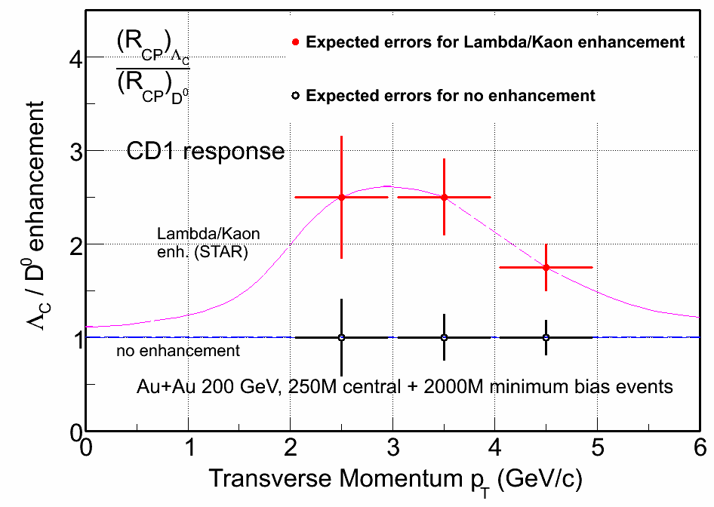Figure 4 Ratio of Λ_{C} to D⁰ meson.

References:

V. Greco, C.M. Ko and R. Rapp, Phys. Lett. B 595 (2004) 202
Coalescence refs
G.D. Moore and D. Teaney, Phys. Rev. C 71, (2005) 064904
W. Zajc, private communication

