WBS 1.6 Software

Run14 (Au+Au 200 GeV/c) Fast Offline Analysis: The group is monitoring, QA-ing, calibrating and analyzing the data. A few million Au-Au events have been processed with the fast-offline reconstruction chain in order to start a more in-depth analysis of the HFT complex.

- QA/Masking: A lot of work was put during this period in better integrating and improving the PXL/IST QA effort and their monitoring. The sensor characterization/masking criteria were also revised as to maximize the usage of fluctuating elements.

- Alignment [intra-PIXEL, IST relative to PIXEL and PXL-IST relative to TPC]. This work continues with the analysis of a Magnet-Off, Low-luminosity, Au+Au sample that was taken and reconstructed for this specific purpose. Preliminary, low statistics results confirmed that the initial cosmics-based alignment achieved precisions down to the 10-20 micron level with the possible exception of 2-3 pxl sectors that need a closer look. Figure 1 shows a snapshot of the Pxl Sector-to-Sector relative alignment using a low statistics, low-luminosity data set and a technique based on comparisons of the reconstructed event vertex position using tracks from the same sector (presented in an earlier report).

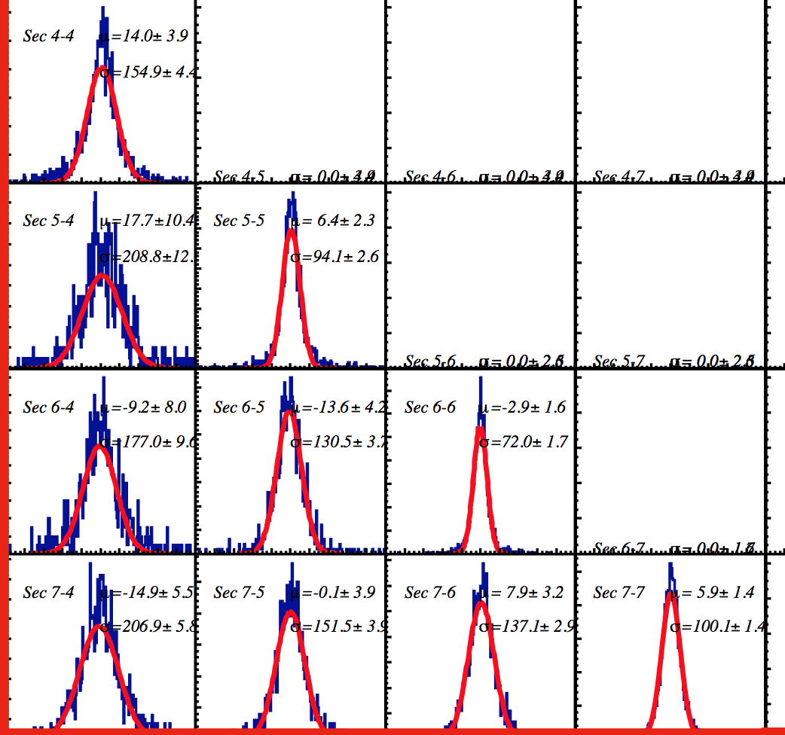

Figure 1 : Example of PXL Sector-to-Sector alignment verification and fine tuning using a low luminosity, magnet off, data sample. The figure shows the difference in the X-coordinate of the event vertex reconstructed from tracks passing through two different Pxl sectors (off diagonal elements) or a sector and the full detector (diagonal elements). We observe relative deviations around 10 microns.

- DCA [pointing] Resolution (Preliminary). Using a sample form the fast-offline reconstruction chain we obtained first estimates of the pointing accuracy of the HFT detector (a KPP parameter). Figure 2 shows the transverse plane (X-Y) resolution as a function of inverse momentum. The black line is the result of a fit using a function incorporating both the detector resolution and the scattering term (see insert below the figure). This pointing resolution is compatible with calculations and simulations of the detector as built.

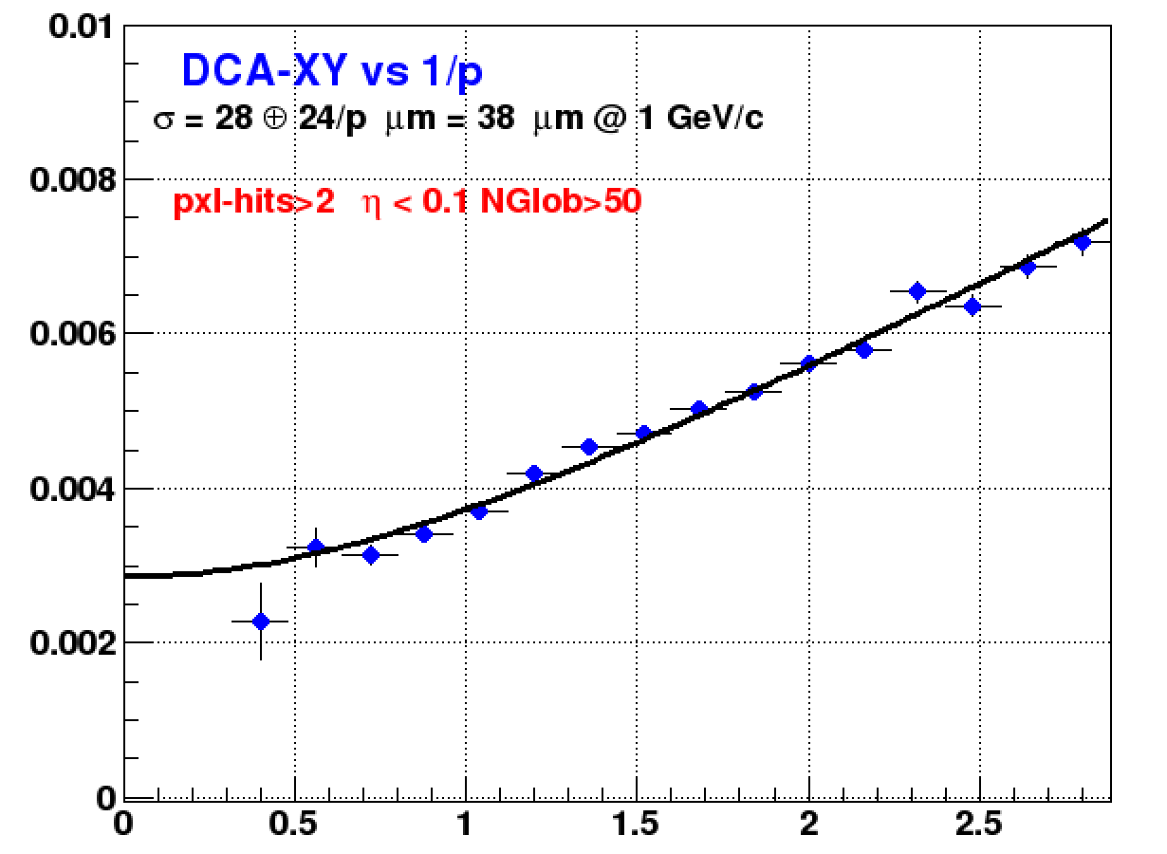
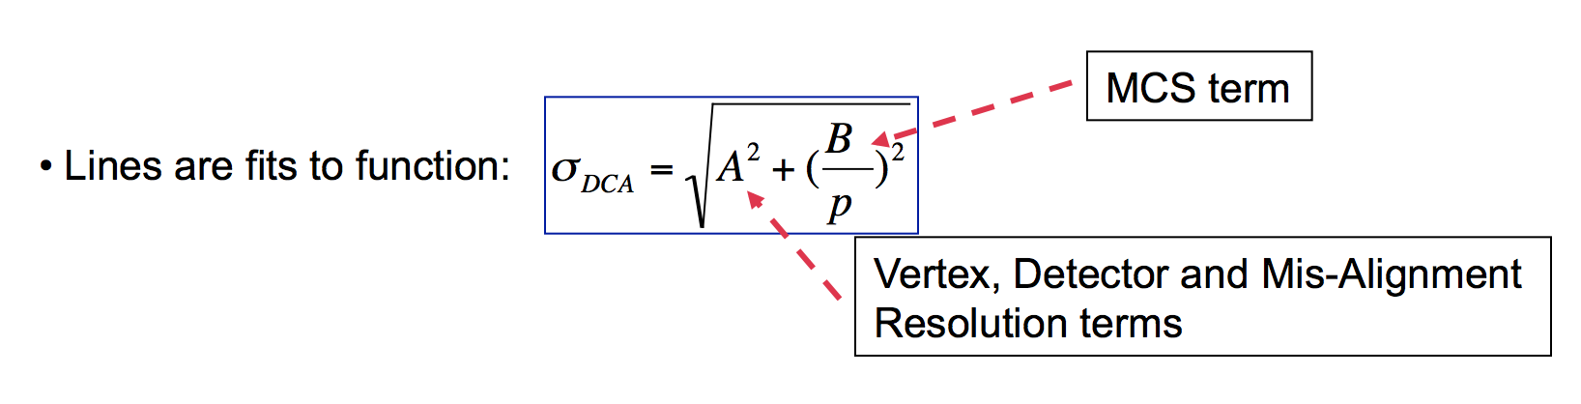
Figure 2 : Preliminary pointing resolution of the HFT detector in the transverse plane (X-Y).

- Pixel/IST Hit Reconstruction Efficiency (Preliminary): Using the cosmic data sample we have obtained some preliminary hit efficiency figures for the PXL detector. Similar studies were performed for the IST. Figure 3 shows the method used to make this estimate. Typically a cosmic ray will leave 4 hits in the pxl layers. Using 3 of these point one can construct a line and extrapolate it to the layer of the 4th hit and look for a hit there (see fig-3 left panel). The ratio of successes to total tracks is the estimate of the efficiency. An overall number of 97% was obtained.

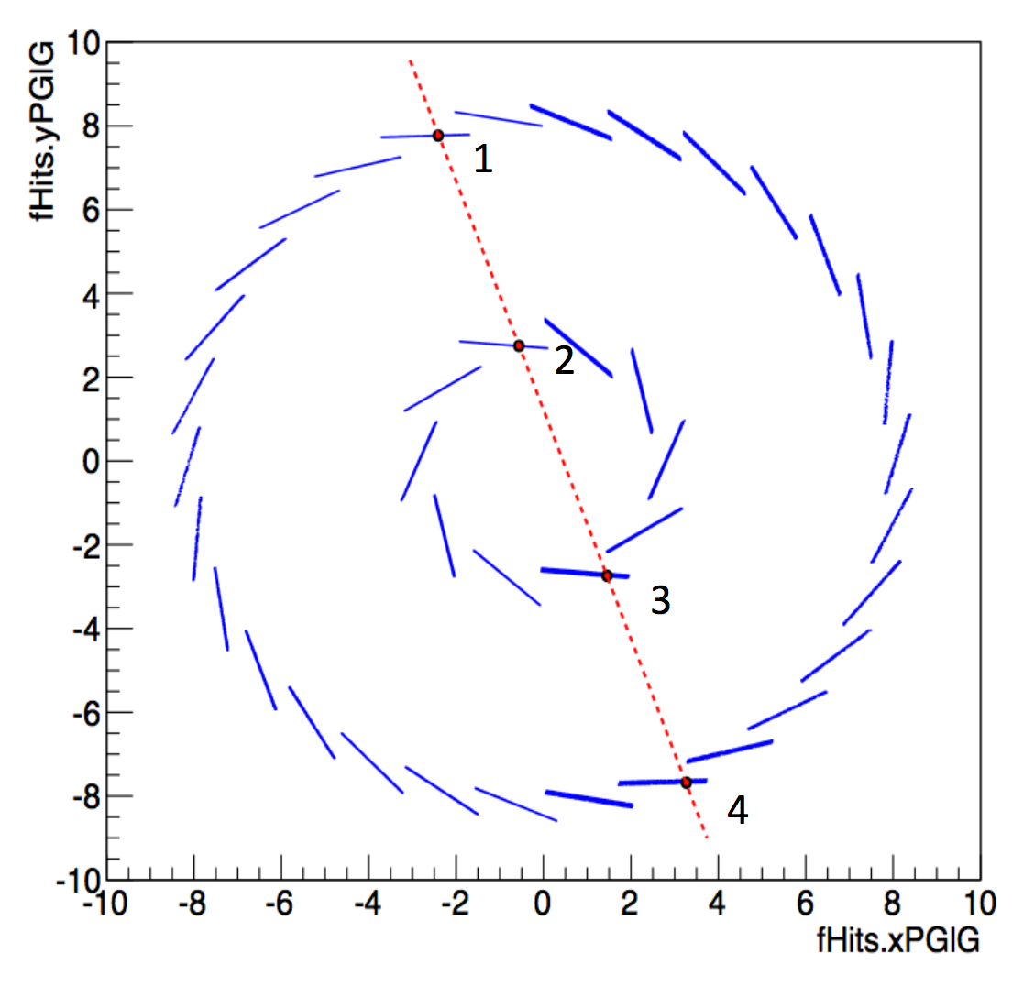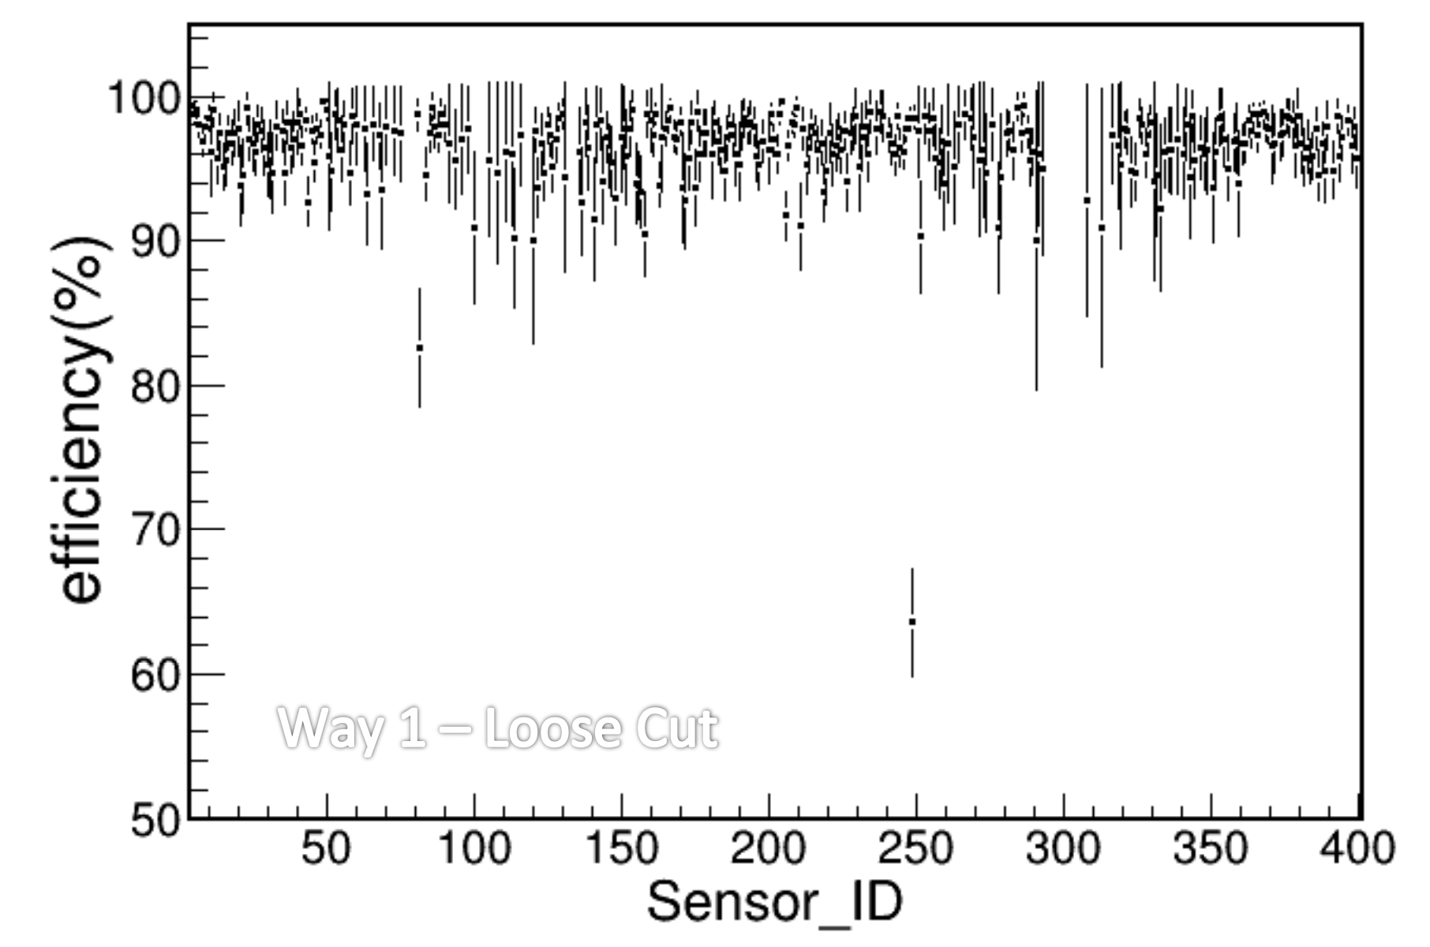

- Other Analyses: A variety of other reconstruction tests and analyses are currently under way (e.g. understanding the event vertex reconstruction efficiency, determine the position of the beam and beam pipe relative to HFT etc).

CD4: We continue the preparations and needed simulations for the CD4 review and the two KPPs our group is responsible for, i.e. the DCA resolution and overall efficiency. Both simulations and data are to be used to determine these parameters.

