WBS 1.6 Software

- PIXEL prototype Run-13 data analysis

  - The software group continued the software development, calibrations and data analysis of the recorded data. More analytically:

  - The SURVEY geometry Db for the Run13 configuration was finalized and implemented in the offline chain and in production.

  - We made substantial progress toward the masking of hot pixels/columns/rows, ie the code, Db entry and retrieval,. A first pass was put in production. Below you see a noisy sensor before (left) and after (right) the masking of bad pixels. In this particular case the noise accounted for more than 70% of the reconstructed hits.

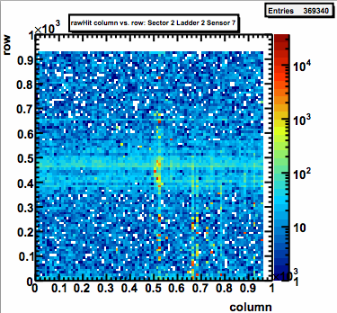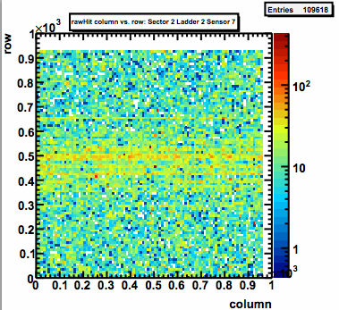

  - An initial TPC space-charge and beam-line calibration was performed and implemented in the production.

  - A first pass on Alignment of Sector-7, the one showing the largest offsets from the ideal/model geometry was done and the results (see example of correction in the figure below) are encouraging. On the left we see shifts in the Y-direction of ~2mm and the presence of rotations (related to the slope of red line). After the first alignment pass (right histogram) we see shifts of a few tenths of microns and only a small residual slope. We expect that after we perform 3-5 passes the overall shifts from true positions will be less that the pixel size. 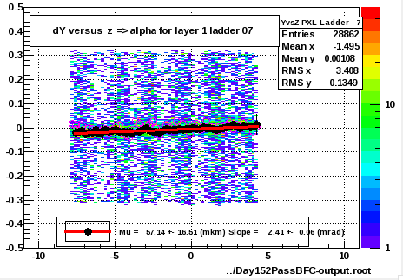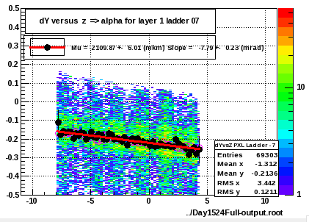

BEFORE
AFTER

  - We begun hit reconstruction efficiency studies.

- IST/SSD

  - We had further discussions on IST offline chain and the IST/SSD survey data organization.

- AOB
  - Simulation work to further test the alignment procedures and resolution is ongoing.

  - A meeting with the STAR Software and Computing team is scheduled to take place the week of July 9th at BNL.

