D⁰ reconstruction for CDR

10k Hijing Au+Au 200 GeV central events are produced in full STAR geometry environment with new updates. The new beam pipe is designed with a radius of 2 cm from the detector center and a thickness of 0.0762 cm. The pile-up effect was included in the PIXEL simulation at a rate corresponding to RHIC-II luminosity. The event vertex resolution is 0.01 cm in X-Y and 20 cm in Z assuming Gaussian distributions. Events are only generated within ±5 cm in V_{Z} from detector center. 5 D⁰’s were embedded flat in p_{T} (0.2-10 GeV/c) or following power-law distribution (0.2-5 GeV/c) in each Hijing central event with 100% branching ratio (B.R.) decay to hadronic channel (D⁰→K⁻π⁺, B.R.|_{PDG}=3.83%). The pseudo-rapidity distribution is flat in ±1 and azimuthal angle distribution is flat in 2π. Their daughter particles K, π were identified via selection on the m² distribution provided by the full barrel Time-of-Flight detector (BTOF) with 100ps timing resolution.

The D⁰ was reconstructed with the same topological cuts as those in CD0. The additional TOF m² cuts were applied at low p_{T} (<3 GeV/c) for Kπ identification. Tracks with large m² were rejected as protons. At high p_{T} (>3 GeV/c), Kπ can not be separated, only m² cut applied for proton rejection. Mis-identification of Kπ is included in the background estimation.

The D⁰ reconstruction efficiencies in Au+Au 200 GeV central collisions are shown in Figure 1. Squares and circles are D⁰ efficiencies before and after applying the topological cuts, respectively. The D0 efficiency in CD0 is shown as black solid symbols. In order to have good statistics at high p_{T}, the embedded D0 p_{T} was input as a flat distribution. The efficiency with thin PXL geometry was shown as red open symbols, while the one with thick PXL geometry was shown as blue open symbols. At low p_{T} (<3.5 GeV/c), a power-law distribution with <p_{T}> = 1 GeV/c, n = 11 was used as the input D0 pt distribution to reduce the statistics error of the efficiencies, one of which with thin PXL geometry was shown as red solid symbols, while the other with thick PXL geometry was shown as blue solid symbols.

The “thin” and “thick” geometries are corresponding to the mass of the IST and PIXEL (PXL) layers.
Thin PXL ~0.32% X₀, thin IST ~1.32% X₀.
Thick PXL ~0.64% X₀, thick IST ~ 2.64% X₀.

Reconstructed D⁰ signal was scaled to match the expected D⁰ production yield × B.R. per central Au + Au collision at 200 GeV. The distribution of background was scaled to the expected background level by taking into account the random combination, particle mis-identification, high p_{T} proton contamination. Due to small statistics and large fluctuation of the Hijing background at high p_{T}, we used exponential function to extrapolate the background shape to high p_{T}. Different cuts were used for the different background suppression. The difference of the background shape by varying the cuts was taken into account as background systematical uncertainty.

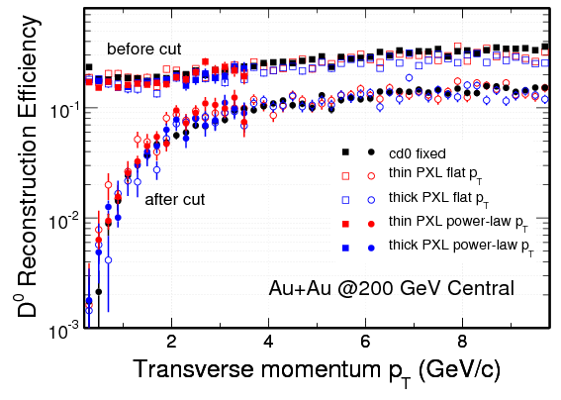
Figure 1: D0 reconstruction efficiencies in different geometry and different input p_{T} distributions. TOF PID was used for these efficiencies except “cd0 fixed”.

The significance was obtained in each p_{T} bin. Figure 2 shows the significance distributions for thin PXL with flat p_{T} (black circles), thick PXL with flat p_{T} (red squres), thin PXL with power-law p_{T} (green reversed triangles) and thick PXL with power-law p_{T} (blue triangles). The significance of D⁰ reconstruction with thick PXL geometry is lower than that with thin PXL geometry, but there is no much difference at high p_{T} (>3 GeV/c). The power-law p_{T} distribution was used to more realistically simulate the statistical errors at low p_{T} in different binning. We see clearly the capability to measure D⁰ as low p_{T} as 0.5 GeV/c.

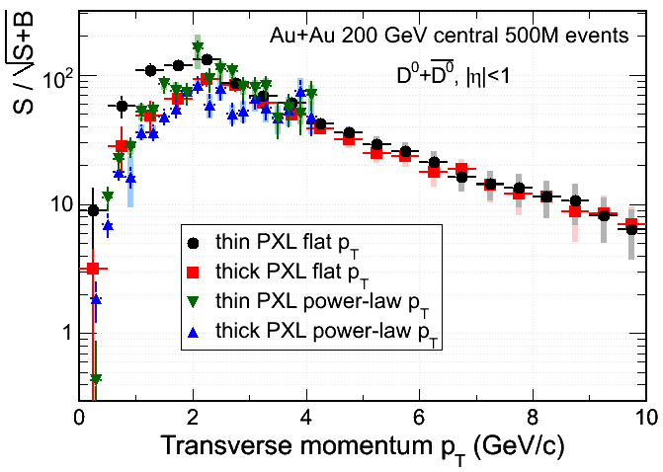
Figure 2: D⁰ reconstruction significances with flat/power-law p_{T} distributions in thin/thick PXL geometry configurations.

========= Charm v₂ and R_{CP} texts are already in HFT_CDR_v10.pdf =========

======= The main changes compared to CD0 for both v₂ and R_{CP} plots =======
The new geometry was used in PIXEL simulation. And more realistic particle identification was used. Low p_{T} (1-3 GeV/c) particle identification by the BTOF detector rejected most of the protons and partially separated kaons and pions. The good PID capability suppressed the random combinatorial background. At high p_{T} (>3 GeV/c), only part of the proton was rejected, the upper limit (lose cut on m² distribution) of the proton contamination was taken into account in the background. Add one more data point (narrower binning) at low p_{T} for D⁰ v₂ (Figure 3).
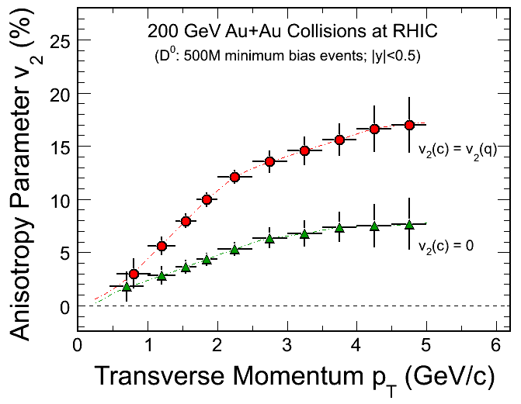
Figure 3: v₂ as a function of p_{T} for the case of charm flow the same as light quark flow (red) and for the case where charm does not flow (green). The statistical errors as a function of p_{T} are estimated for 500 M 200 GeV Au+Au minimum bias events.

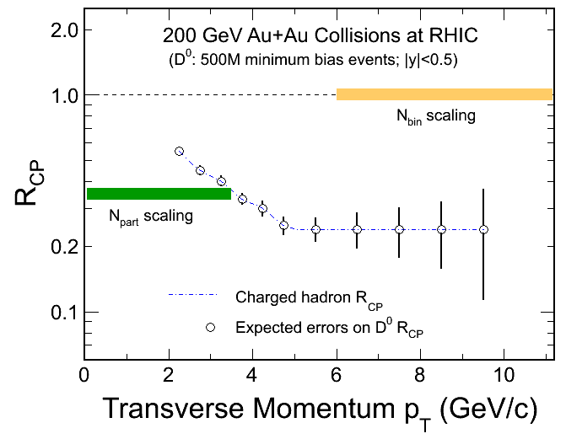
Figure 4: Assuming D⁰ R_{CP} follows charged hadron R_{CP}. Expected errors for a R_{CP} measurement as a function of p_{T} are estimated for 500 M 200 GeV Au+Au minimum bias events.

