WBS 1.6 Software

- Further work on the HFT geometry model was done in the reporting period.
As we said in the previous report this month’s work was focused on properly including/accounting of the material budget in the model.
- This is done and we believe that we have a reasonable model of the detector in GEANT.
- We plan an internal review/release of this Y2013 geometry tentatively on March 9th.
- The upper figure shows structural details of a PIXEL sector with proper Silicon, Glue, Carbon Fiber support and Al-cable material.
- The lower picture is an earlier model of the Pixel Support Tube
- At the same time, some timing tests were performed. They showed no noticeable difference between the full model and simplified cylinders.

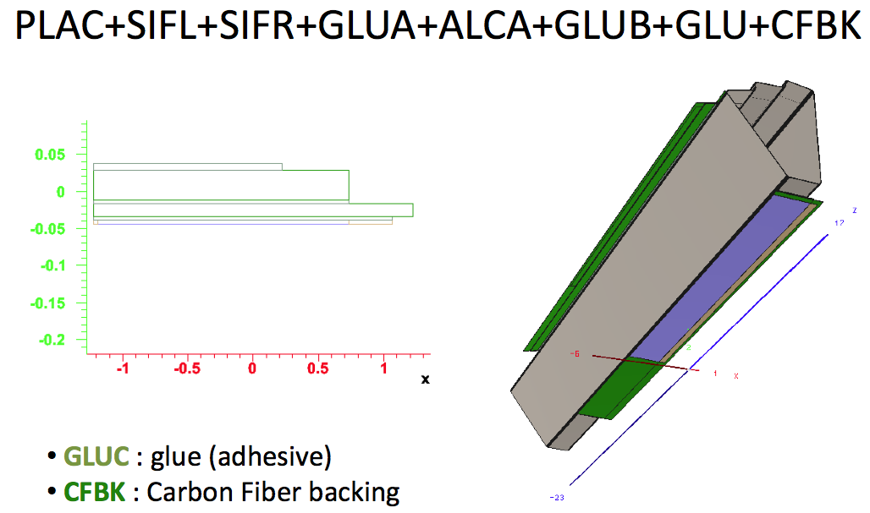

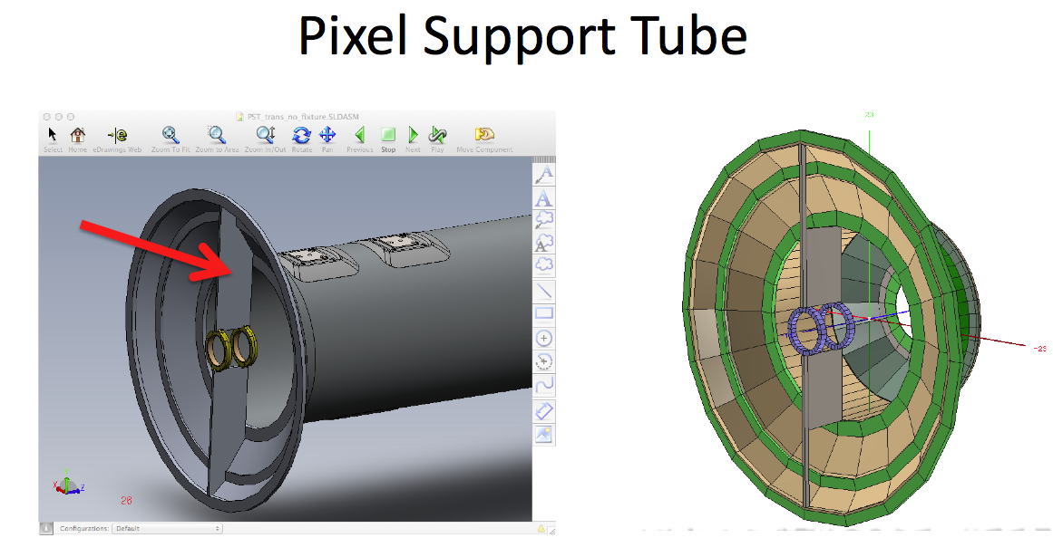
- Preparatory work started in creating the SSD software structures in CVS repository. We started by just doing a straight copy of the old-SSD structures to the new area. The Calibration structures are revisited and discussed as they are the ones that need minimum changes. The figure below shows a schematic of the structures.

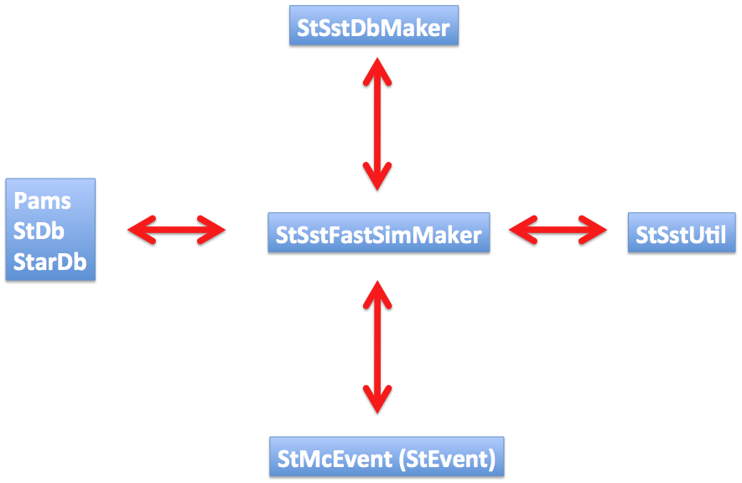

- We are revisiting the Manpower contributions from the HFT Institutions and also assign tasks to newcomers.

