WBS 1.6 Software

1) A presentation was given on the physics capabilities of HFT during the Decadal plan discussion at the STAR Collaboration meeting.

2) The work on D+ reconstruction via its 3-body decay is progressing and it is in the cut optimization step.

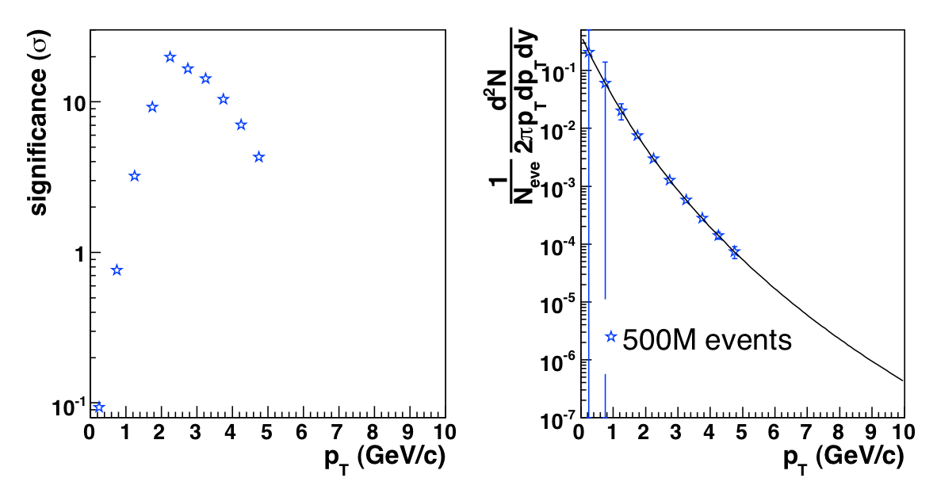

3) The Ds reconstruction via the Φ-meson decay (Ds->Φ+π->K+K+π) has been updated, using some powerful track pointing cuts and the first preliminary estimates on significance and pt spectra is shown in the figure.

4) A template for the Software WBS-tasks timeline was developed.

