WBS 1.6 Software

- PIXEL prototype Run-13 data analysis

  - An initial estimation of the intrinsic detector resolution for the Pixel sensors using tracking data in the overlapping areas of the sensors (see insert in the figure below) was attempted. For this we used the hit residual information from primary tracks extrapolated to the overlapping sensors. In order to avoid track resolution effects the difference of the hit residual in the two layers was studied (figure below). Ideally the distribution would be a gaussian centered around zero with a width equal to a convolution of the single hit resolution in each layer plus a contribution from coulomb scattering (negligible here due to short extrapolation distance). The fitted width of this distribution is 20 microns, which implies a hit resolution of about 14 micron, a value that is only a couple of microns larger than the design goal of this device. The observed offset of the distribution from zero is most likely related to calibration issues and it is under further investigation.

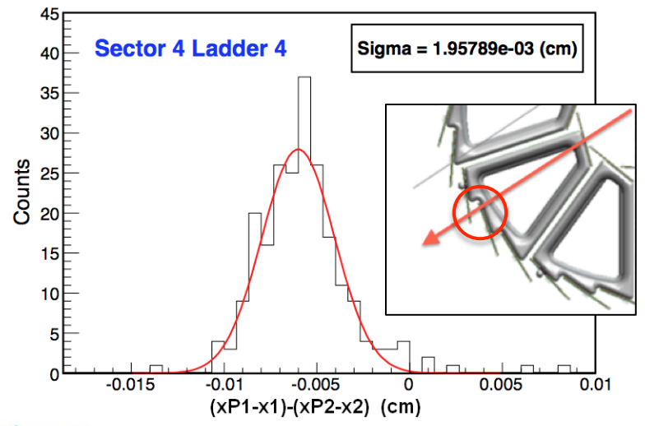
σ = 20 μm
Resolution ~ 20/sqrt(2)= 14 μm

  - A study using the proximity of two tracks (aka DCA) with the Pixel hits included on the track fit gave a first estimate of the track extrapolation accuracy of the pixel layers, an important performance parameter (KPP) of the system. In this study tracks with pixel hits from the same sector (in order to avoid relative alignment issues) were extrapolated using a simple helix model (ignoring energy loss and scattering issues) to the point of their closest approach. Tracks without pixel hits, with one pixel hit in the outer or inner layer, or both hits included, were studied in order to map the progression of the resolution as the more precise pixel hit information is added to the tracks. The tracks “common” vertex was selected to be within a few mm away from the “beam line”, the position of which is cumulatively determined with high precision. The picture below summarizes the DCA information in the two major directions, r-phi (the x-y bending plane) and z (non-bending plane), as a function of the sum of the p_{T} of the two tracks. One clearly sees the gradual improvement by almost two orders of magnitude in the DCA resolution as we go from TPC-only tracks to tracks with both Pixel hits included in the fit. We need to keep in mind that in order to extract the single track value we need to divide with sqrt(2). It is remarkable that the inferred values are below 100 microns over a wide range of track p_{T} when both pixel hits are added to the tracks. We observe that the z-direction shows a value that is about 40 micron better that the r-phi direction. This might be due to the linear (non-bending plane) track extrapolation in this direction but further studied are needed. The dashed line in the left panel is a performance estimate based on the CDR (simulation figures). More detailed studies, as well as the use of this information for calibration purposes is under way.

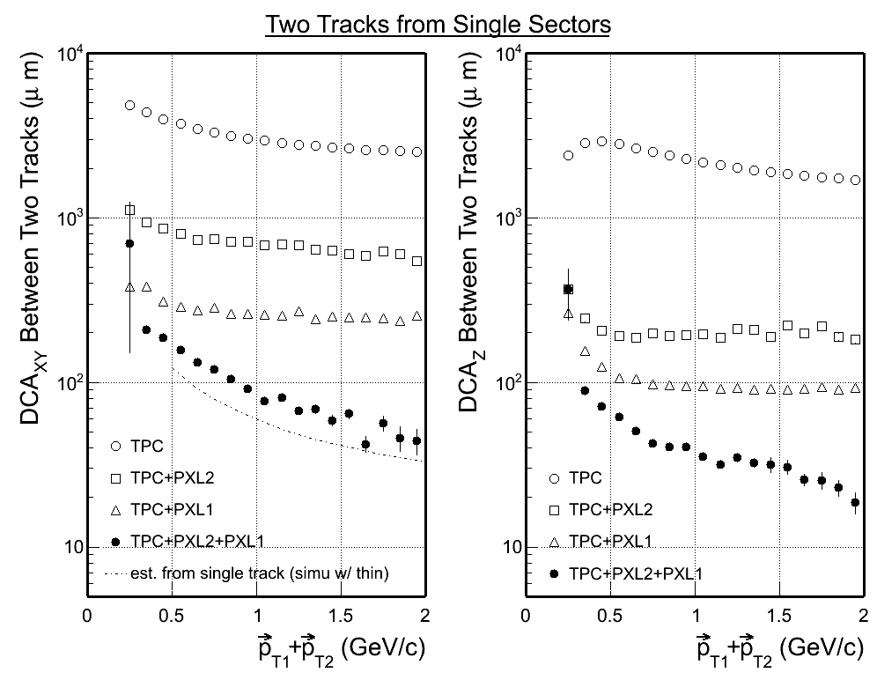

- IST/SSD

  - Some more work on the SSD survey-data organization was performed.

- AOB
  - Further simulation work to test and refine the alignment procedures and resolution is ongoing.

  - A meeting with the STAR Software and Computing team took place the week of July 9th at BNL were progress was discussed

