**HFT**

**Heavy Flavor Tracker**

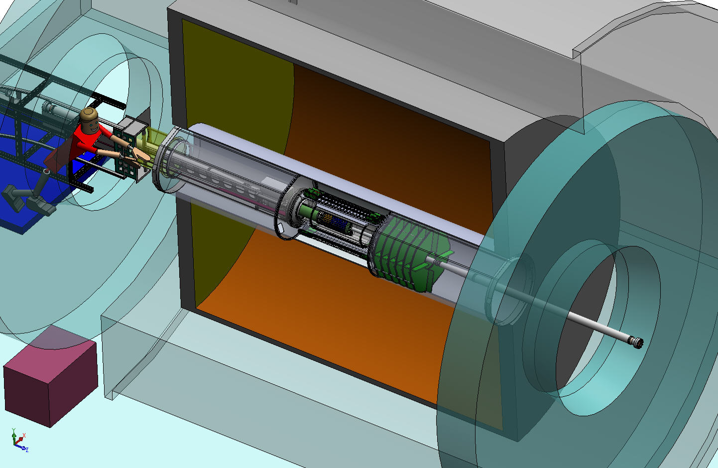

TPC Volume

**Magnet**

**Return Iron**

**Solenoid**

OFC

Outer Field Cage

IFC

Inner Field Cage

SSD

IST

PXL

**EAST**

**WEST**

MONTHLY REPORT

January, 2011

|  |  |
| --- | --- |
| Performing Organization | Brookhaven Science Associates |
| Location: | Brookhaven National Laboratory |
|  | Upton, New York 11973-5000 |
|  |  |
| Contract Period of Performance | FY2010-FY2014 |



**HFT MONTHLY PROGRESS REPORT**

**September 2010**

**I. Contractor Project Manager’s Assessment**

The technical schedule and cost status is judged satisfactory.

Technical Progress and Accomplishments

Considerable efforts have been put into the development of the baseline Cost & Schedule, and in putting the needed documentation for the baseline pre-review and review in place.

The first prototype of the Ultimate PXL sensor was submitted to the Austrian Micro Systems (AMS) foundry on schedule. The detailed design for the surveying device to determine alignment of the PXL insertion box rails with the MSC rails is complete.

There was an internal review of The Silicon sensor prototype design and order specification was reviewed on January 26th with reviewers external to the project.

The IST kapton flex hybrid design has been finished and requests for quotes for a prototype cable to be used in the ladder test setup have been requested.

An internal review of the IST Silicon sensor design was held at BNL. The recommendation has been implemented in the RFQ for the prototype sensors.

Issues and Concerns

Progress has been made on the issue reported last month on usage of the Adept database server for remote access by LBNL engineers. As result of several meetings with Adept systems people changes in settings and operating mode has reduces the access time considerable. There are though still inconveniences left in the process, and the dialogue between BNL/LBNL/MIT and Adept will have to continue to improve performance.

**II Detailed STATUS by WBS**

**WBS 1.1 Project Management**

The monthly teleconference with DOE HQ was held on December 14, 2010.

The quarterly report for Q1FY11 has been submitted.

The HFT Contractor Project Director and project team continue to revise the project documents to ensure that all recommendations for the pre-CD2/3 review , as well as the comments in the review report are addressed. Each sub-system is actively reviewing, updating and providing information for each project document deliverable. This includes basis of estimates, and design documentation

The draft of Project Execution Plan in accordance with DOE Order 413.3B is nearly complete, and needs only the final milestone tables, cost profile from cost and schedule. A draft of the Acquisition Strategy also modified to the templates from 413.3B is available.

**WBS 1.2 PXL detector**

During the month of January we made significant progress on PXL electronics and sensor tasks.

The first prototype for the final PXL sensor (Ultimate) was submitted to the AMS foundry on schedule and the procurement placed through LBNL. The first wafers should be available in mid-March.

In preparation for the receipt of the sensor prototypes the design of a testing board is underway and a schematic has been prepared and the design iterated with review from our IPHC colleagues. The draft schematic for the testing board may be found at <http://rnc.lbl.gov/hft/hardware/docs/ultimate/ultimate_individual_test_board.zip>.

Members of the sensor and readout group from LBNL visited the Univ of Texas at Austin lab and worked with Joe Schambach to finalize the preparation of the Phase-1 sensor test boards in preparation for configuring a beam telescope. We have moved to the latest Xilinx FPGA software ISE 12.3 and are modifying out firmware as required to compile and work under the new software. This is necessary as we will be designing a new RDO motherboard soon and the new ISE software is required to target for the FPGA that will be used in the new motherboard. Work is progressing on the readout firmware and software in support of this telescope test to measure the sensor efficiency to MIPs as a function of various bias settings.

We have completed the design of a testing board and associated testing system that will allow us to test the Mimosa-26 sensor on both regular and high-resistivity substrate for latch-up in the STAR environment. The testing board has been submitted for fabrication and we expect to receive it in mid-February. We plan to install this test setup just outside of the endcap magnet iron in the area of the highest measured radiation dose. This is expected to provide a tie between the measurements done at latch-up testing facilities and what can be expected in the STAR environment.

The cost and schedule documentation have been significantly updated in preparation for the next set of reviews. The technical design support documentation is mostly complete. Other documentation including schedule and Basis of Estimate work is ongoing as is organization of the document into a review package.

PXL Mechanical

The detailed design for the surveying device to determine alignment of the PXL insertion box rails with the MSC rails is complete and ready for fabrication. This system uses a cross hair laser in an auto collimator configuration plus two webcams with survey targets. The system is illustrated in the figure below. An instruction manual with a detailed description will be completed in February.

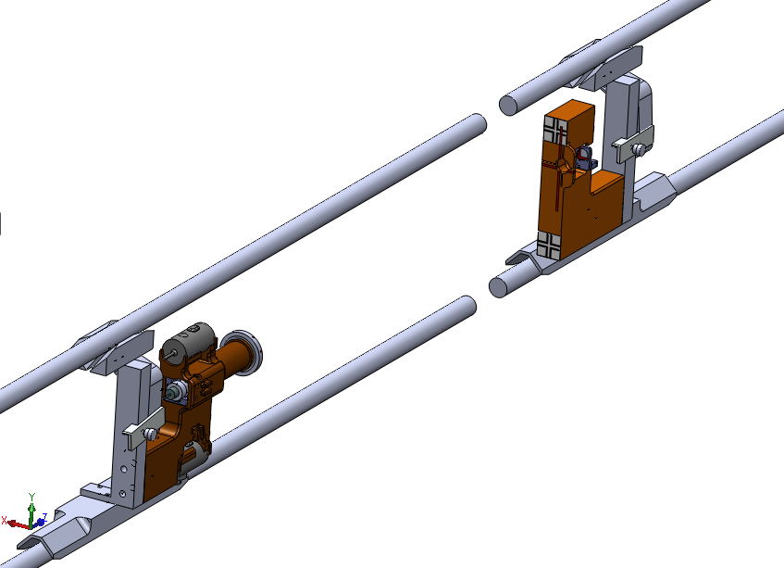

Model of the rail alignment measuring tool.

University of Texas packed the majority of the parts (220 lbs) that they have machined which will allow us to begin building the PXL insertion test system. This shipment will arrive in February.

**WBS 1.3 IST detector**

The kapton flex hybrid design has been finished after some design rule iterations with the manufacturers. We're currently waiting for quotes from two vendors.

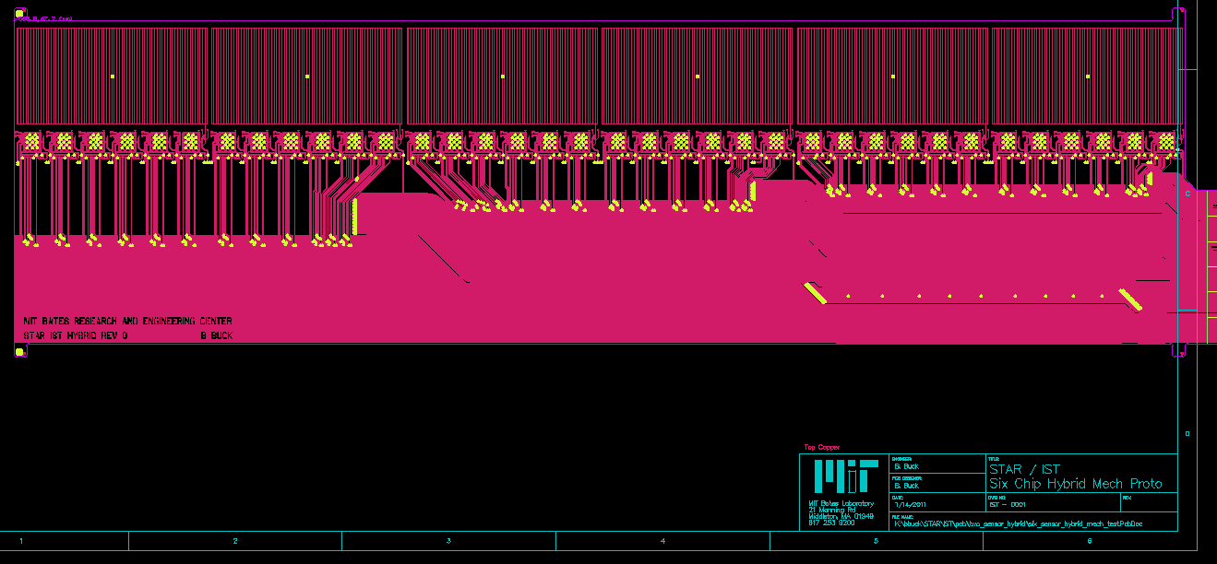

Layout of the kapton flrc hybrid. The top row is the position of the Si sensors, followed by the connection to the APD chips.

There was an internal review of the Silicon sensor prototype production on January 26th. Overall this review was very positive. Some minor issues were raised by the 3 person review committee (Dave Lynn, Rachid Noucier, BNL and Carl Haber, LBL) with respect to the proposed sensor specifications in the Request for preliminary Quotation that was sent to Hamamatsu in 2010. The specifications will be amended following the recommendations of the review committee and the official RFQ is expected to be send to Hamamatsu shortly.

The APV Readout Module (ARM) design was finished in the beginning of January and an official quotation was received on January 26th. The production order was sent out and it is expected that the bare boards will be produced before February 14th. Assembling and testing the ARM boards is planned for the second half of February and March.

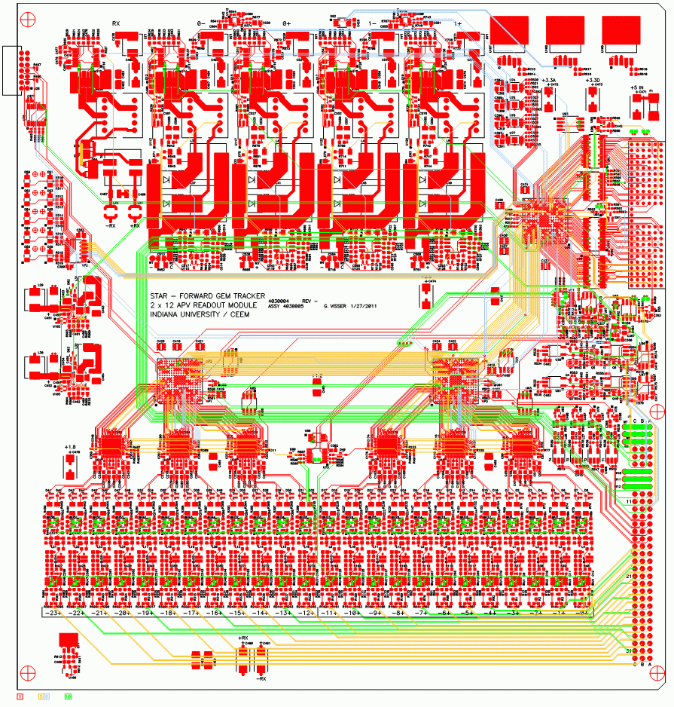

PCB Layout for the ARM module

**WBS 1.4 SSD detector**

Ladder Board

The ladder card printed circuit cards have arrived from the PCB manufacturer and the assembly process was begun. Three cards are being populated with the electrical components. As soon as these parts are loaded, the board will be tested.

Debug cards (temporary USB and JTAG interface to the ladder card) have been completely assembled at Subatech; two of these cards are being prepared to be shipped to the US. Below is a picture of one of these boards.

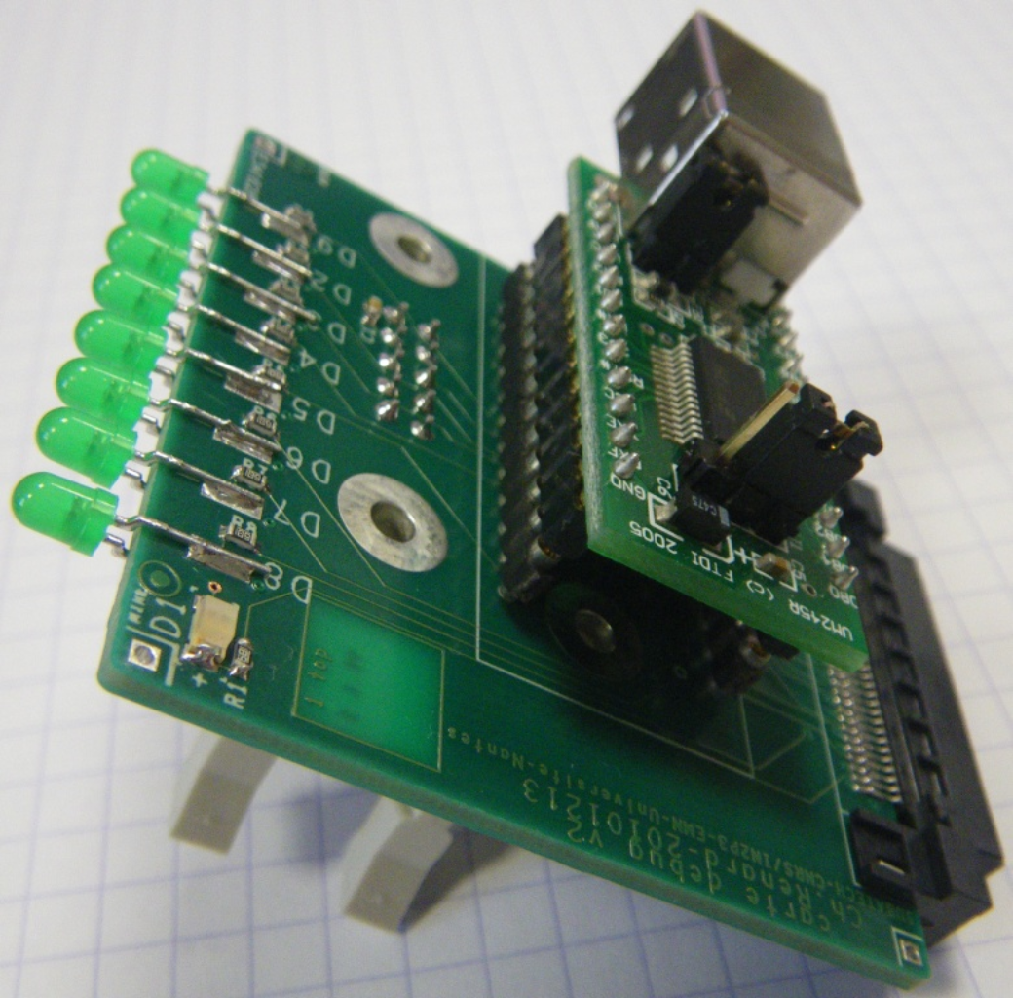

We have also created a document that specifies the connections to the ladder board. This document will be used to build a cable to power the board.

RDO Board

Firmware has been written for the RDO slave FPGA which will provide a software replacement for the Corelis (hardware) VME module that was used to provide JTAG connectivity to the components on the ladders (CoStar and Alice A128C).  The behavior of the firmware has been verified in detailed simulation and will now be integrated into the slave FPGA firmware package.  This new facility allows independent access from the slow controls host computer to each ladder.

Cooling

When the last cooling analysis of the SSD was done, there was an assumption that the power dissipation on a ladder did not change. Subsequent to that analysis, we learned the ladder board power did increase. A new cooling calculation has shown that by increasing the diameter of the hoses that are directly connected to the vacuum source, sufficient cooling can be done to keep the ladder temperature at an operational value.

Project Management

Work continues on preparation for the CD2/CD3 review. The WBS schedule has been continuously improved. Documentation such as design and cost notes, drawings and Gerber files have been collected and assembled for the review.

**WBS 1.5 Integration**

Global Structures

Work was nearly completed on the assembly sequence for the HFT. The completion date is expected to be Feb. 8. This sets the baseline for the assembly tooling for the IDS. Tooling for the flat backing rings and stiffening plates has been ordered. Ply shapes were designed for the fiber cloth for all the backing rings.

Cost and Schedule

A first pass at the complete Integration WBS was given to Project management. Some items of potential schedule risk for the IDS insertion into STAR were identified and mitigations taken. This includes a complete second ESC in case the early version in not satisfactory for the final HFT design. IDS assembly tooling was divided into FY11 tooling and later tooling. This allows the ability to keep the FY11 IDS insertion schedule at the expense of throwing the first tooling out. This will be revisited in Feb. and determined whether this risk reduction is necessary.

Integration has made it a priority that the FY11 IDS insertion MUST not slip past the summer shutdown.

Level III milestones were given to Project management.

Infrastructure

Integration also took over the PXL insertion platform from PXL subsystem. A scheme of a mezzanine attached to the east wall with a removable platform is being investigated. Integration will also work with STAR Ops to obtain racks not intended for the south Platform for PXL.

The subsystems continued to provide information for the requirements of the clean room in the STAR Assembly Hall. This room should be turned over to HFT integration for the next 4 years. Other users would be allowed access if needed.

Survey for the assembly is almost not needed, as most of the detectors will arrive pre-surveyed.

Interface drawing for the end ring and the IFC were completed by the designed (J. Scheblein) These will be reviewed by Eric Andersen and Dana Beavis and then forwarded to Bill Christie. John Schebleinis now working on an updated drawing/model of the east end cap that should be completed in Feb.

A supplemental guide on cables was distributed to the subsystem managers. The PXL connectivity document will be submitted to C-AD engineers for an initial review.

**WBS 1.6 Software**

1) First results for the Ds particles and pt higher than 4 GeV/c (from the special production we performed in December 2010) were reported by the UCLA (see figure below). Results, from the same production, on D* are still to come.



2) Worked on second version of the Software WBS-1.6 Dictionary and schedule.

**Financial Status**

Project funds have been received for initial efforts in the balance of FY10 through March of FY11. The SOW from MIT has now all the needed information and is making its way though the system at MIT. The distributions of cost at completion on other WBS items are to be determined at base lining. A no cost extension to the contract with LBNL has been issued to extend the initial efforts in preparation for CD 2/3 has been issued.

|  |  |  |  |  |  |  |
| --- | --- | --- | --- | --- | --- | --- |
| **WBS** | **Title** | **Monthly Actual** | **FY to Date** | **Project to Date**  **k$** | **Commitments**  **K$** | **Cost at Completion**  **K$** |
| 1.1 | Management | 6.7 | 20.7 | 24.8 | 0 |  |
| 1.2 | PXL | 23.9 | 87.8 | 95.1 | 47.7 |  |
| 1.3 | IST | 0 | 0 | 0 | 0 |  |
| 1.4 | SSD | 0 | 0 | 0 | 0 |  |
| 1.5 | Integration | 30.2 | 54.7 | 61.9 | 51.3 |  |
| 1.6 | Software | 0 | 0 | 0 | 0 |  |
|  | R&D | 1.6 | 13.7 | 273.5 | (14.39) | 280 |
|  | Contingency |  |  |  |  |  |
|  | Total | 62.4 | 176.9 | 455.4 | 84.61 |  |

In addition to the cost and commitments in the table the requisition for about 120k$ for the PXL sensors has been placed.

**Acronyms**

IST Inner Silicon Tracker

IDS Inner Detector Support

OFC Outer Field Cage

FPGA Field Programmable Arrays

WSC West Support Cylinder

ESC East Support Cylinder

OSC Outer Support Cylinder

FGT Forward GEM Tracker

MSC Middle Support Cylinder

ARM APV Readout Module

AMS Austria Micro Systems