**HFT**

**Heavy Flavor Tracker**

MONTHLY REPORT

October 1-31, 2010

|  |  |
| --- | --- |
| Performing Organization | Brookhaven Science Associates |
| Location: | Brookhaven National Laboratory |
|  | Upton, New York 11973-5000 |
|  |  |
| Contract Period of Performance | FY2010-FY2014 |



**HFT MONTHLY PROGRESS REPORT**

**October 2010**

**I. Contractor Project Manager’s Assessment**

The technical schedule and cost status is judged satisfactory.

Technical Progress and Accomplishments

Issues and Concerns

The CD-1 presentation as well as PEP had prototype PXL installation scheduled for summer 12 i.e. run-13. This requires the IDS + PXL insertion mechanism + small diameter beam pipe to be present. There possibility of having this in place for run-12 with installation at the same time as the outer IDS (ESC/OSC/WCS) and FGT in summer-11 had been left open.

This possibilities now seems unlikely due to

a) As noted under integration (WBS 1.5) Brush Wellman had a fabrication issue with a sub-contractor for part of the new Be-section, that will add ~17 weeks delay.

b) Resource loading the schedule for fabrication of part for the prototype PST, PXL indicates that not sufficient resources (technician) are available at LBL in the spring/summer 11.

As a consequence having IDS hardware ready for run-12 (summer/fall 11) installation will not be pursued. The schedule that plans for installation in summer 12 now has sufficient resources and slack to be met. This implies that STAR will have to be rolled out in summer 12 for installation of small diameter beam pipe and PXL supporting structure (PST, MSC).

**II Detailed STATUS by WBS**

**WBS 1.1 Project Management**

Monthly teleconference with HQ took place on October 14.

The HFT team had a face-to-face meeting at BNL on October 14 and 15 to discuss cost and schedule progress, as well as technical accomplishments and plans. Even though considerable progress has been made there is still work to be done in particular for integration and SSD. The overall cost of the project is well within the CD-1 cost range.

The FPD attended the meeting on the 14.

CPM meets with FPD on a regular bi-weekly basis, or as need arises.

The HFT management meeting takes place weekly on Tuesdays.

A face-2-face meeting is planned for December 8 and 9 at BNL.

**WBS 1.2 PXL detector**

PXL Electric

During the month of October we made significant progress on PXL electronics and sensor tasks. The PCBs that will be used for the latch-up testing at the 88” cyclotron were ordered and are expected to be delivered in the next week. We conducted an on-site visit at the 88” cyclotron, inspected the exposure tank and mounting areas used to place the devices under test in the correct orientation to the beam. We also received information on the training needed to operate the beam-line apparatus. Loading and testing our testing boards in early November and latch up testing later in the month will follow this.

We have arranged a pre production external review for the first full size prototype for the final PXL sensor. The design for this sensor has been completed at IPHC and includes the updates to the sensor interface that were described in the September report. The review will take place on December 6-7 at BNL. The review committee includes:

Velko Radeka (BNL), Grzegorz Deptuch (Fermilab),Peter Denes (or delegate) (LBNL), Howard Wieman (ex-officio)

A preliminary agenda, preliminary charge and background documentation may be found at the review website located at <http://rnc.lbl.gov/hft/hardware/docs/sensor_review/>. The scope of the review will be the design of the sensors and the readiness for submission to the foundry for fabrication. Attendees from IPHC will include:

Isabelle VALIN (Microelectronics designer), Gilles CLAUS (Electrical Engineer), Guy DOZIERE (Microelectronics designer), Christine HU-GUO (Lead Microelectronics Designer), Marc WINTER (Head of Microelectronics Group)

The cost and schedule documentation have been significantly updated in preparation for the next set of reviews. The costs for the PXL electronics appears to be slightly lower than the CD-1 estimate based on the anticipated costs for the aluminum conductor ladder cables. This effort is expected to be ongoing for the next months before the review.

PXL Mechanics

PXL mechanics Monthly Report

After multiple iterations and finite element analysis the detailed design for the support and alignment structure that will be used to position the PXL box is advanced enough to go to fabrication. This is the support system (see Figure 1 ) that aligns the PXL box with the STAR Middle Support Cylinder such that the PXL can be transferred from the box to the MSC along guide rails. The next step will be to fabricate enough of this system to test its operation with the Rail Test System.

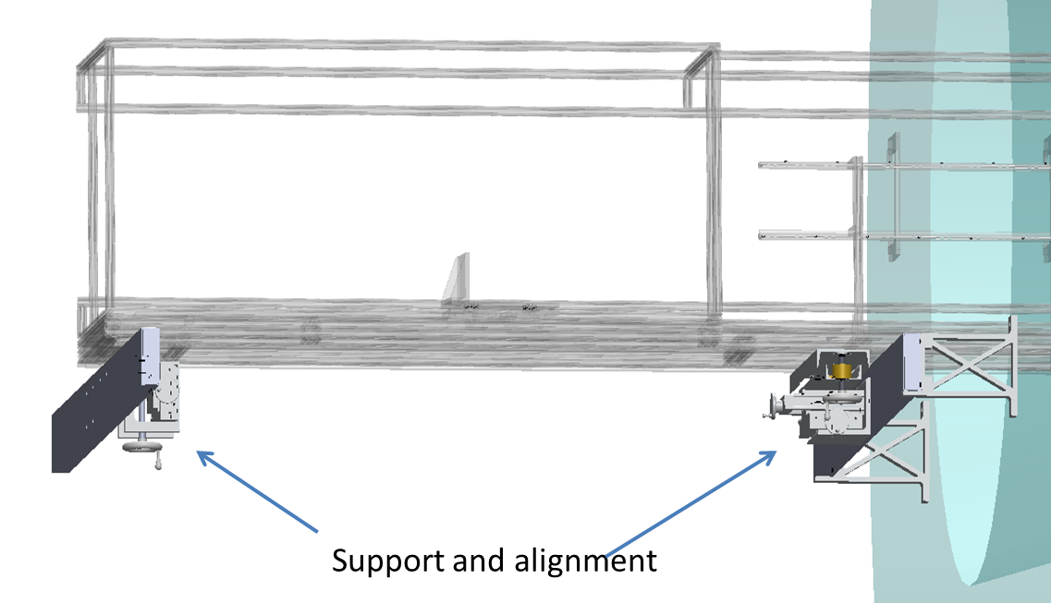

Figure 1 Support and alignment system for the PXL box. This is used to position the box for PXL transfer into the STAR detector system.

The University of Texas, Austin Physics machine shop is making steady progress on parts for the Rail Test System. We have discussed with them the parts that we will need to begin assembly at LBNL and they estimate that these critical parts will be completed by December 17th.

The machined parts required for fabrication of the carbon composite D tube (see Figure 1) are complete. This is the tooling for layup of the composite piece, the trimming of this part and the fixturing required to bond termination parts. The machining work was done at both the LBNL and Texas machine shops.

**WBS 1.3 IST detector**

A detailed ladder/hybrid prototyping schedule for the next 6 months has been added to the HFT WBS and MIT will submit a Statement of Work for this prototyping soon. The prototyping will proceed in three stages. First lamination tests will be performed which will work out the details of the lamination of the large IST kapton flex hybrids to the carbon fiber ladders. At this moment it is not clear whether dummy hybrids will be used or that it is better to immediately use the final prototype hybrids. This decision depends on the price difference and on how far the final prototype hybrid design has proceeded. Because the dummy hybrid needs bondable gold pads for testing the wire bonding its price will increase. The design of the prototype hybrid has progressed to a point that it can go out for quotations. Currently new quotations for the dummy and prototype hybrid are being requested. It is expected that a decision will be taken before the end of November. The second stage will take functional final prototype hybrids and laminate them to a functional prototype carbon fiber ladder. This ladder will have proper fitting to the cooling tube to do cooling tests and proper mounting structures to mount the ladder on a support. The third stage will take these ladders and supply them with readout chips, prototype silicon sensors and all associated components to be able to do functional testing of the whole ladder.

The order of the prototype silicon sensors has been delayed because changes in the schedules delayed completing the Statement of Work. It is almost finished and it is expected that the order can be placed soon. The expected lead-time of 6 months will lead to delivery of the prototype sensors in June 2011.

The testing of the APV readout chips is ongoing with both the IST pre-prototype and the FGT readout boards. Although the FGT is a different project, it shares an almost identical readout chain with the IST. A new calibration code for the IST test readout of the pre-prototype is available, but is not fully tested yet. A cosmic ray testing station should be available before the end of November.

The IST readout system consists of Wiener MPod crates, APV Readout Modules (ARM's) and APV Readout Controllers (ARC's). The first ARC's, which accept STAR triggers and provide the interface between DAQ and the ARM's, are being tested at Argonne National Laboratory (ANL). One of the recently purchased MPod crates has also arrived at ANL. The full design of the ARM has to be finalized still. The interfacing with the APV front-ends through a long readout cable has been tested successfully already. This interface provides power to the APV chips but also does optimal filtering of the signals, which get distorted by the long signal cable. Also choices for the clock phase control circuit and on APV on board power supplies have been made. These circuits are being tested on ARM evaluation boards. The first prototypes for the ARM are still expected before the end of CY2010.

**WBS 1.4 SSD detector**

Ladder Board

Procurement of the ladder board PC is well underway. We have a quote from the selected vendor in France. An official order should go out within days and the PCBs should be received in early December. Components for assembly of the ladder board have been received with the exception of one connector, which is expected to arrive in December.

Subatech is building a special “Debug Board” to test the ladder board. It will need floating JTAG and USB boards which have been identified. Progress is being done on building this board, as the RDO will not be ready to test the Ladder Board.

RDO Board

A preliminary layout of the RDO board has been completed. The diagram below shows a concept of the layout. Component positions have been established. There is work going on how to communicate with Slow Controls. In the pasts VME has been used. Better solutions using CANbus, Ethernet, or USB are being considered. This design needs input from two FPGAs (Master and VME) to specify the proper pins to use.

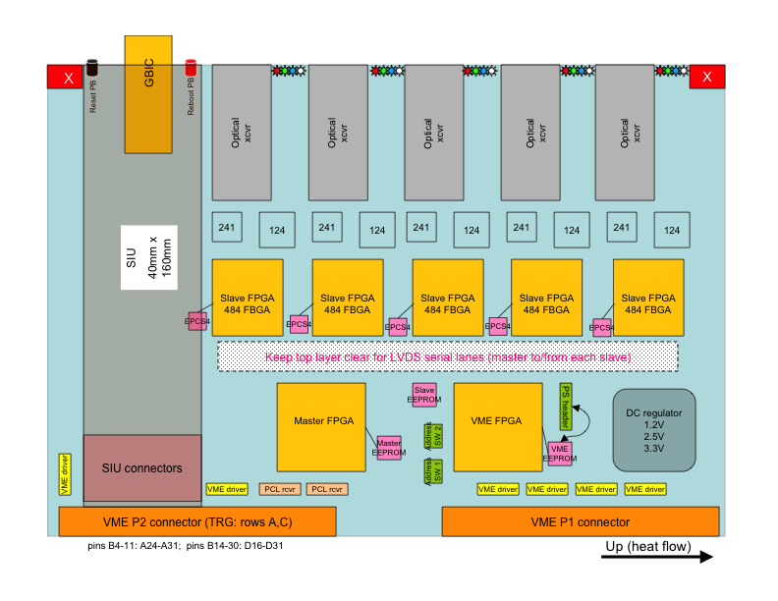

Project Management

Much work has been done updating the Cost and Schedule project worksheet. The SSD schedule and budget is being incorporated into the joint HFT document in preparation for the CD2/CD3 review.

**WBS 1.5 Integration**

Beam Pipe

Brush Wellman (BW) notified the Project that a subcontractor that was gun drilling the Be tubes for the central portion of the beam pipe had damaged one piece. A phone meeting between BW, C-AD engineers, and the integration manager was held. All parties agreed that only a quality product should be delivered and installed in RHIC. The risk for stresses and potential fractures along the gouges made it undesirable to consider using the damaged piece. The subcontractor will be sent new material. It is expected that the beam pipe schedule will be delayed for 15-20 weeks and that it could be delivered to BNL in April 2011. BW will update the schedule once the Be stock arrives at the subcontractor for gun-drilling.

This makes the risk very high if planning on having the beam pipe ready for installation in the summer of 2011 continues.

Resource Loading for Mechanical Structures

Examination of the technical labor resources required to maintain the present schedule as if the new beam pipe would be available was also found to have too much risk. Therefore, the Project now plans to use the old beam pipe in FY2012 operations. A prototype MSC is not required for next summer. Eric Andersen has adjusted the integration schedule for the structures to accommodate the schedule changes. The schedule is becoming a “resource loaded schedule” (RLS).

The FGT Project has agreed that these decisions do not impact their Physics plans.

IDS Progress

The Internal Detector Support system (IDS) has had progress towards fabrication. A quotation has been obtained for the mandrels for the WSC (West Support Cylinder) and the OSC (Outer Support Cylinder). These are the first parts to be made for the IDS. The Eastern Support Cylinder (ESC) will follow closely in design to the WSC. Purchase order and batch information for the fiber materials and the resins has been acquired. The purchase orders should soon be issued.

Safety

The NEC requirements for cables with different voltage ratings were clarified for the HFT group. All voltages must be below the lowest rated cable. The voltage limit cannot be administrative but hardware limited on sources that can exceed that rating.

The issue of ploy fuses and sense wires was also clarified for distributes electronics boards of the HFT.

The mechanical engineers are confident in their mechanical design of the IDS. They have been told they can proceed with the fabrication of parts, but there must be an engineering review conducted before the parts are used. Details of how to complete this requirement were discussed. The Integration subsystem manager has instructed the engineers that all safety factors should be greater than 3 for the IDS. Items not meeting this requirement should be reviewed as soon as possible.

The fringe field from the magnet was examined. The access rules into magnet fields contained in the BNL SBMS were reviewed. This impacts the potential location and access to the rack containing the PXL readout boards. It appears that there will be no problem with access wherever the rack is located.

C-AD Engineers were consulted on these and other safety issues related to the HFT.

Misc.

Possible gaps between the FGT and HFT Projects will be examined during the month of Nov. to ensure that there are no miscommunications on who is responsible for what parts.

Discussions between FGT, HFT, and STAR Ops began for the resources to assemble, test and install the FGT, IDS, and eventually the HFT into STAR. The HFT and FGT would prefer to have the best working environment possible for the assembly and testing. For the FGT most of this will be resolved in Nov. but some issues for the HFT may linger.

The ability to move objects into the IR was discussed with C-AD Liaison Engineer and with PXL. Options to use the present labyrinth with either a pick (4 small blocks) of the end wall using the IR crane or to redesign the labyrinth so that the PXL box will fit through the labyrinth are being considered. The discussion will continue into Nov. or Dec. Only a portal in the main shield wall that is plugged with shielding that can be removed with a forklift requires real design effort.

Management

Work on updating the cost and schedule progressed.

**WBS 1.6 Software**

1) Progress was made on analyzing some test PIXEL survey data using the LBNL Coordinate Measuring Machine (CMM). Calibration Balls and PIXEL (bare) Sector data were fitted with the MINUIT fitting machinery as spheres and planes respectively. Since is test and a step in the procedures needed to implementation of the spatial calibration of the PXL sensors and ladders.

2) A new, initial work on the D+ 3-body decay using the Kalman filter has produced the first inv. mass peaks using a small simulation sample (signal/background not to scale) as seen in the figure below, left panel. The work to optimize the cuts (S/N) and extract realistic (properly scaled) S/N levels is next.

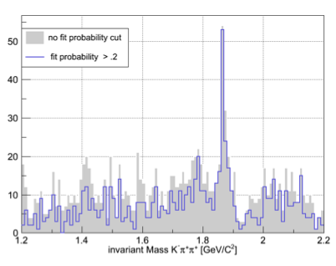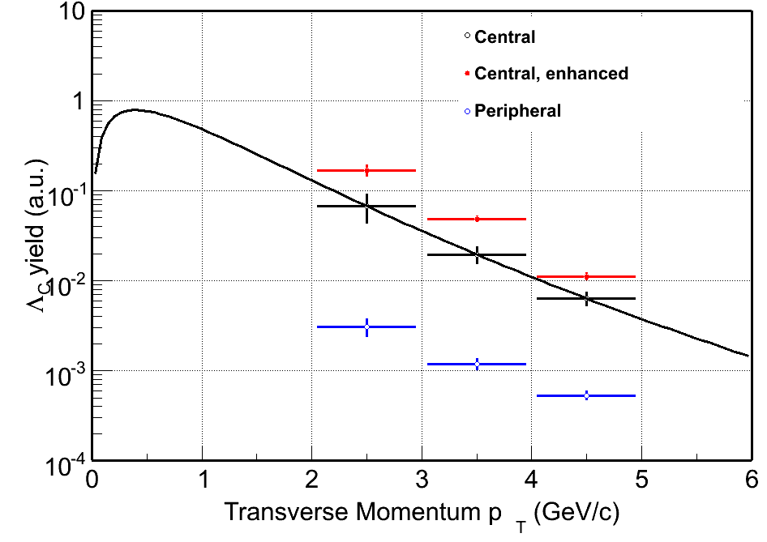

3) The work on the Ds 3-body decay channel via the F-meson (Ds->F+p->K+K+p has been revisited using a more realistic estimate on PID capabilities and background. A special (simulation) production was done for this purpose. Initial estimates were presented to the group but this is still work in progress.

4) Also for the first time estimated pt spectra for the Lc baryon were produced (see figure above, right panel).

**Financial Status**

Accounts at BNL are being setup; this includes WBS 1.1 (management), 1.4 (SSD) 1.5 (integration) as well as HFT contracts and HFT reserve.

The distributions of cost at completion on other WBS items are to be determined at base lining.

|  |  |  |  |  |  |  |  |  |  |  |  |  |  |
| --- | --- | --- | --- | --- | --- | --- | --- | --- | --- | --- | --- | --- | --- |
| WBS | | Title | | Monthly Actual | | FY to Date | | Project to Date  k$ | | Commitments  K$ | | Cost at Completion  K$ | |
| 1.1 | | Management | | 6.09 | | 6.09 | | 10.1 | | 0 | |  | |
| 1.2 | | PXL | | 27.63 | | 27.63 | | 34.9 | | 30.8 | |  | |
| 1.3 | | IST | | 0 | | 0 | | 0 | | 0 | |  | |
| 1.4 | | SSD | | 0 | | 0 | | 0 | | 0 | |  | |
| 1.5 | | Integration | | 5.19 | | 5.19 | | 12.5 | | 0 | |  | |
| 1.6 | | Software | | 0 | | 0 | | 0 | | 0 | |  | |
|  | | R&D | | 6.95 | | 6.95 | | 266.8 | | (11.7) | | 280 | |
|  | | Contingency | |  | |  | |  | |  | |  | |
|  | | Total | | 45.86 | | 45.86 | | 324.4 | | 19.0 | |  | |

**Acronyms**

IST Inner Silicon Tracker

IDS Inner Detector Support

OFC Outer Field Cage

FPGA Field Programmable Arrays

WSC West Support Cylinder

ESC East Support Cylinder

OSC Outer Support Cylinder

FGT Forward GEM Tracker

MSC Middle Support Cylinder