**WBS 1.6 Software**

1. **PIXEL prototype data analysis**
   1. *The Offline software, offline QA, dst production and calibration codes were analyzing real data within a few days after the Pxl prototype was inserted into STAR and took its first data. More analytically*:
   2. The group made significant contributions towards the run plan, trigger conditions, data taking and providing feedback. Currently, the offline data analysis and QA is completed within a day or so after data taking.
   3. The geometry Db for the Run13 configuration was finalized and implemented in the offline chain.
   4. Offline QA started working just a few days after the first data were available giving significant feedback about the state of the prototype. In the figure below (left panel) we see an outline of the three installed sectors by plotting the global x,y coordinates of the reconstructed hits. This information can only be obtained at the end of the reconstruction chain. The right panel shows the cumulative hit density distribution on a single sensor (2x2 cm2) for about 90 thousand events. Each sensor has about 1 Million pixels.



* 1. The first look at the alignment between the TPC and PXL detectors through the correlation of the TPC tracks and PXL hits was successful. Some of this work is shown in the four panels of the figure below. The bottom-left panel is the 2-D correlation plot between (TPC) primary tracks (tracks associated to the reconstructed event vertex), as they cross the sensor plane, and the nearest Pxl hit. A clear correlation/association is shown. The upper two panels are the projections of this plots on the two local-sensor axes; one along the beam axis (upper-right panel) and one in the transverse (r-phi) direction. We see two things: one is the width of 1-2 mm of the fitted gaussians which shows the (typical, expected) track extrapolation accuracy to the pixel sensors. The other is the apparent shift in the beam, z-direction of about 3mm. This is the relative placement of the PXL detector inside the TPC volume.

The lower-right panel is one example of the alignment software output. It shows the placement precision, relative to “ideal” model, of ladder-4 in sector-4 and for the x-coordinate. About 600 thousand events, semi-cleaned for noise, were used to produce this figure. The gap in the z-direction is due to masked-out sensor because of the presence of noisy pixels. One sees that the placement is within a few microns from the ideal position. It also shows that there is no apparent rotation, relative to the model, around the y-axis (beta angle). This work is in progress and one of the main software goals for this run.

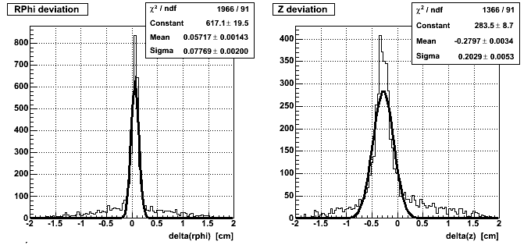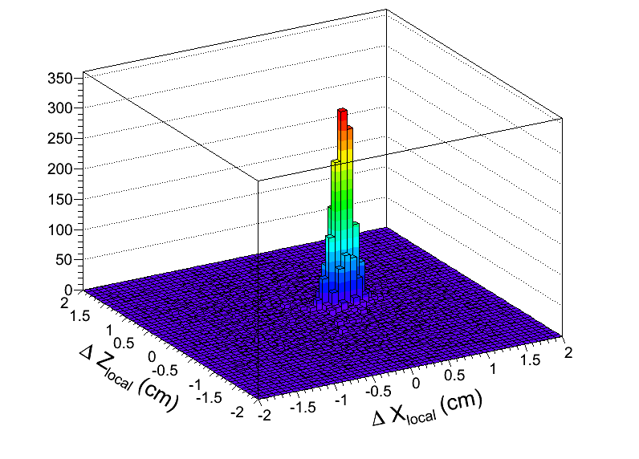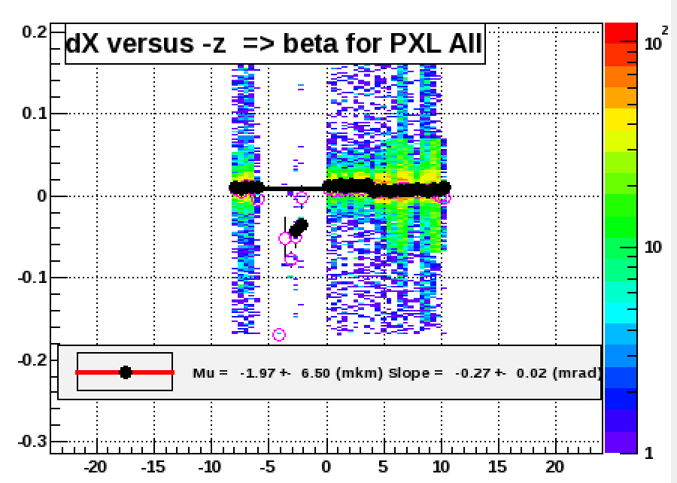

* 1. We begun calibration work that will allow us to include the Pxl hits on the reconstructed tracks.

1. **Geometry modeling**
   1. Several updates were implemented to fine-tune and synchronize the PXL model with the actual geometry.
2. **AOB**
   1. A first implementation of a Slow Pixel simulator, a program that generates raw pixel data, was successfully tested.