**Heavy Flavor Tracker (HFT)**

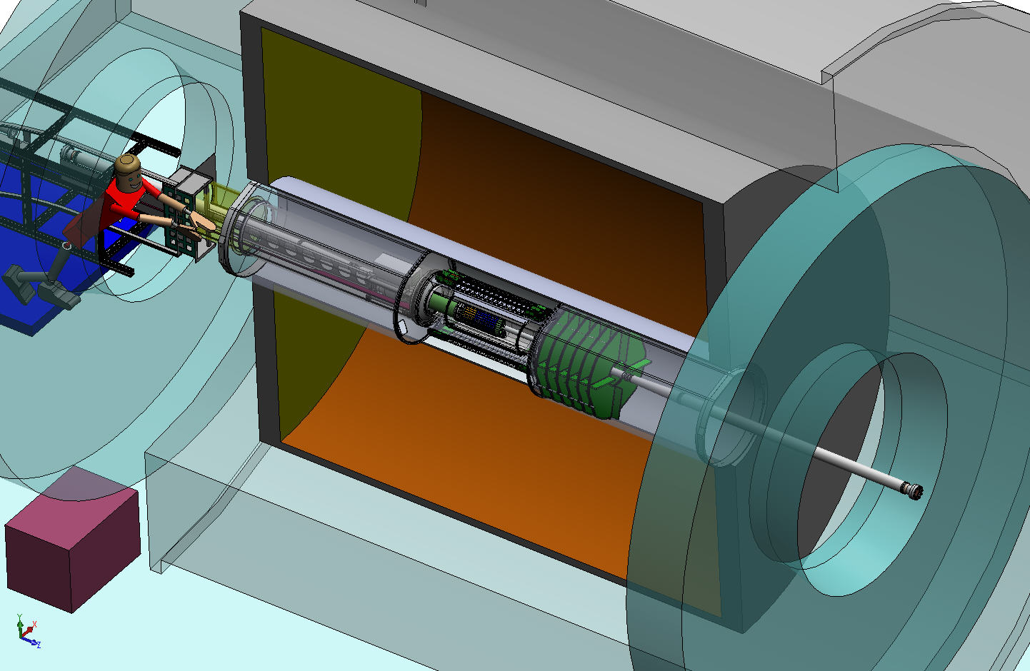

TPC Volume

**Magnet**

**Return Iron**

**Solenoid**

OFC

Outer Field Cage

IFC

Inner Field Cage

SSD

IST

PXL

**EAST**

**WEST**

MONTHLY REPORT

March 2011

|  |  |
| --- | --- |
| Performing Organization | Brookhaven Science Associates |
| Location: | Brookhaven National Laboratory |
|  | Upton, New York 11973-5000 |
|  |  |
| Contract Period of Performance | FY2010-FY2015 |



**HFT MONTHLY PROGRESS REPORT**

**March 2011**

**I. Contractor Project Manager’s Assessment**

The technical schedule and cost status is judged satisfactory.

Technical Progress and Accomplishments

Considerable efforts have been put into the development of the Cost & Schedule baseline, and required CD 2/3 and technical documentation for the Brookhaven pre-review and DOE review. The Cost & Schedule is stable.

The first prototype sensors for the final PXL sensor (Ultimate) were received at LBNL maintaining the schedule for testing of these.

Issues and Concerns

The current schedule that aims for installation with STAR for Q4FY14 is quite tight, in particular for IST and SSD. This was also pointed out at the review on March 28-29. The project is working to identify the means to improve this.

**II Detailed STATUS by WBS**

**WBS 1.1 Project Management**

The monthly teleconference with DOE HQ was held on March 10, 2010.

The HFT Contractor Project Director and project team continue to revise the project documents for the BNL lead pre-CD2/3 review. Each sub-system provided information for each project document deliverable. This includes basis of estimates, and design documentation.

A BNL lead pre-review aw held on March 28 and 29 at BNL. A panel of reviewers was assembled consisting of Rick van Berg, U. Pennsylvania, David Lissauer, BNL, Alex Dress, SUNYSB and Ralph Brown, BNL. In addition the review was lead by Tom Ludlam, Ed O.Brien and Steve Vigdor. The review consisted of talk during Monday, and follow-up the following morning on issues raised by the committee. The report is not yet made available, but the high-level recommendations are clear. The end-schedule should be clarified, in terms of having sufficient float for each sub-detector, toin terms of installation for run-14 the committee felt the cd-4 parameters were too tight, and not precisely described. It also felt that in the roll-up costs the redirect should be included in base costs (TEC) and then acknowledged as a contribution. To follow-up one these and other recommendation the CPD, Jamie Dunlop, Ed O’Brien and Tom Ludlam will meet bi-weekly as oversight on progress to resolve this.

The project has established a working group to revisit, and clarify the cd-4 parameter definition, and the planned verifications.

**WBS 1.2 PXL detector**

The first prototype sensors for the final PXL sensor (Ultimate) were received at LBNL on schedule. The order consisted of two wafers, one a standard resistivity substrate and the other a high resistivity (400 ohm-cm) substrate. Each wafer holds 48 sensor dies. The testing boards for the final sensors were loaded with components in preparation for the sensors to become available. The high resistivity wafer was sent to an outside vendor for dicing and is expected back by the beginning of April.

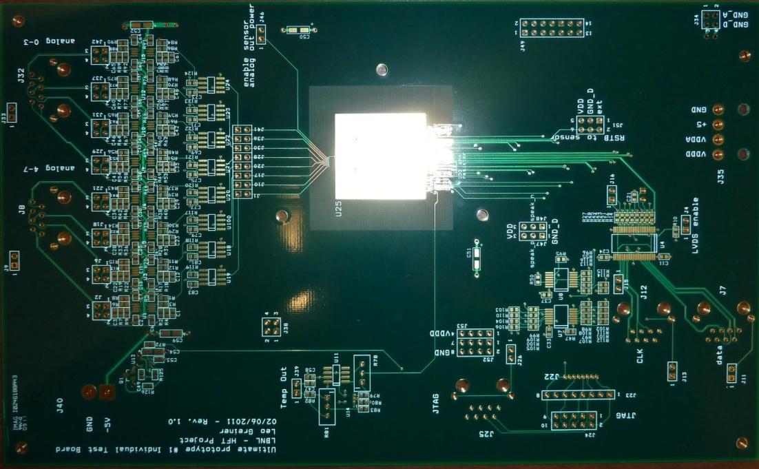

Figure Individual testing board for PXL sensor prototype. Five boards have been loaded with components awaiting the return of the diced sensor dies from the dicing vendor.

The design for the new readout motherboard is underway with the basic structure of a main motherboard and testing interface / capability expansion daughter card. The schematic entry of the design should be completed in April.

The Phase-1 sensor telescope at the Univ. of Texas at Austin lab developed some intermittent problems and was shipped to LBNL for troubleshooting. It is expected that Jo Schambach will visit LBNL and we will fix the telescope setup and make final preparations for staging a beam test at either DESY or SLAC.

The testing boards that will allow us to test the Mimosa-26 sensor on both regular and high-resistivity substrate for latch-up in the STAR environment are complete and in hand. The Mimosa-26 sensors are mounted and wire bonded to the testing boards and the full system assembly is underway. We plan to install this test setup just outside of the endcap magnet iron in the area of the highest measured radiation dose. This is expected to provide a tie between the measurements done at latch-up testing facilities and what can be expected in the STAR environment.

The preparation of a presentation and the cost and schedule documentation was a major effort for the BNL pre-CD2/3 review held at the end of March in preparation for the DOE CD-2/3 review. The PXL technical design support documentation is complete and has been posted. Other documentation including schedule and Basis of Estimate work is complete and part of the posted review package. The PXL subsystem supporting documentation may be found at <http://lbnl.leog.org/cd23/>

Mechanical

Designed and submitted job to LBNL shops for a fixture to fabricate carbon composite insertion rails (see Figure 2).

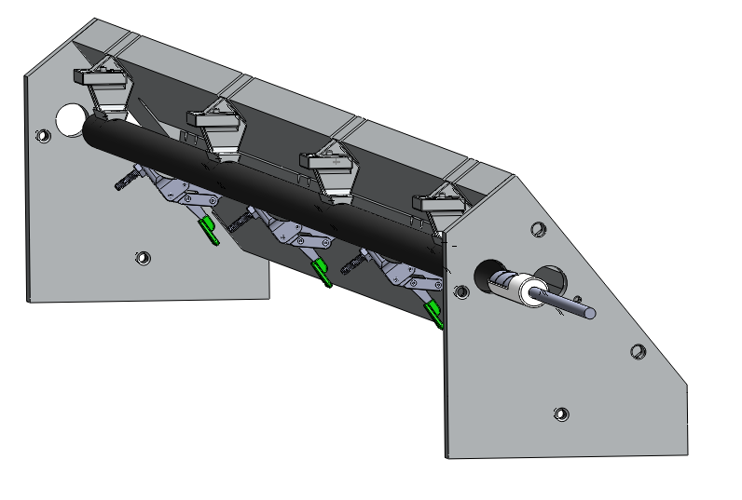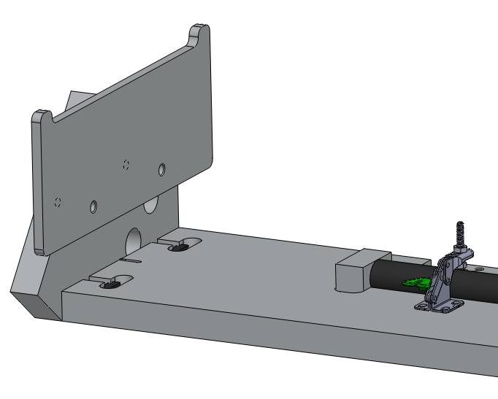

Figure 2 Fixture for cutting and drilling 20 mm diameter carbon composite rails which carry the PXL detector. The fixture is also used for positioning and bonding of the tube support inserts.

Designed and submitted to shops laser holders for the rail alignment tool.

UTA machine shop is continuing work on remaining PXL insertion parts.

Design work is continuing on the support system that will hold the interface/driver cards that ride on the PXL insertion carriage.

Much of the PXL mechanics design efforts this month took second priority to calculation of electric fields related to the shroud design. The shroud will control the electric fields between the IDS and the TPC inner field cage. For a report on this subject see: <http://www-rnc.lbl.gov/~wieman/shroud_hardware_meeting.pptx>.

There is a longer discussion on this under the integration sub-section.

**WBS 1.3 IST detector**

The official quote for 8 silicon pad prototype sensors was received from Hamamatsu on March 2nd. A justification for noncompetitive procurement (Sole Source) was provided to the BNL procurement office. We prefer Hamamatsu as manufacturer = because of their outstanding track record in producing similar devices. Their sensors will arrive fully tested which puts much less strain on our resources and schedule.

On March 18 the BNL procurement office initiated the procurement process with Hamamatsu. After a couple of glitches Hamamatsu is now preparing their offer. Order expected to go out in the week of April 11th.

Work on the kapton hybrid continues, should be finished before April 15th.

Since the ladder design is intimately connected with the hybrid design, we expect the ladder design to be finished at the same time as the hybrid design, i.e. April 15th.

Both the APV Readout Module (ARM) and the APV Readout Controller are working at their basic level. The ARM is able to read out APV chips and digitize their analog signals. The attached picture "data_1_GIF.gif" shows the digitized signals directly extracted from the ADC's on the ARM board.

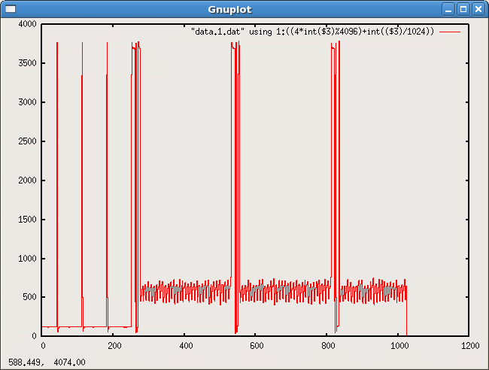

This data has not been sent to the ARC yet because the firmware on the ARC is lacking that capability still.

The current ARC prototype has been reworked and a simple version of the firmware already makes it possible to send simulated data to a STAR DAQ PC.

Next step is to have the ARC communicating with the ARM.

At this moment it looks like the ARM prototype is functioning so well that no modifications are needed and the boards can go in production. The ARC prototype needed to be reworked and there are some issues with the on-board power supplies and clocks that make a re-spin of the board necessary before full production can start. No problems are expected.

The picture below shows ARM and ARC in their readout crate while being tested.

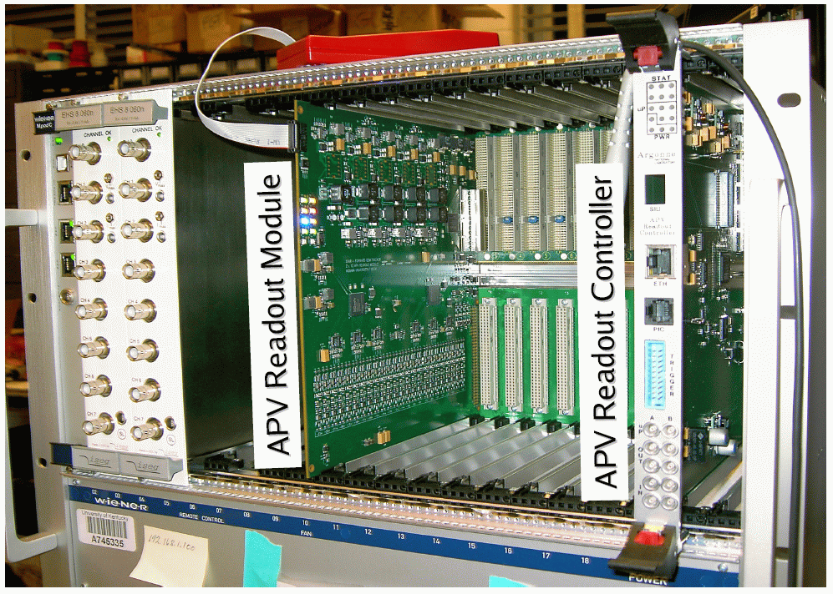

**WBS 1.4 SSD detector**

Ladder Board

During initial testing of the ladder card prototype in February, a major error was discovered in the routing of the traces to the FPGA. It was decided to salvage the investment in time and money in this board by designing an "interposer"  – a small printed circuit card, which reroutes the traces of the FPGA.  During much of March, we were involved in dialogs with several PCB fabricators to evolve a design for the interposer, which can be manufactured with high probability of meeting electrical tests. This effort resulted in a new interposer design. Three bids were received for this design and they have been submitted to procurement.

RDO Board

The firmware design for the VME FPGA on the RDO card has been completed by Subatech and transferred to BNL.  Work is now beginning at Subatech on the design of the Master FPGA firmware. [The Master is responsible for communication with the STAR Trigger and with the DAQ PCs via the DDL link.]

A new board is being designed to test the Ladder Board called the Quick RDO (QRDO). This QDO is a subset of the RDO board with only the bare minimum of components to allow it to be used as a test fixture for the ladder card. The purpose of the QDO is to start testing the ladder board as soon as possible, but not diverge from the ultimate goal of producing a full functional RDO. Modification of the existing Slave FPGA firmware is in process for this board.

Cooling

A prototype cooling system in now in the STAR hall and it is being used for tests.  We have lengths of tube to represent the run from the vacuum source to the face of the magnet, additional tubes to represent the run from the face of the magnet to the SSD ladders, and a dummy prototype to simulate the impedance of each of 20 ladders.

We have not yet made quantitative measurements, but preliminary work suggests that the amount of cooling air drawn through each ladder is less than intuitive calculations. Nevertheless, the performance may in fact be nearly equal to design specifications – 2 l/s through each ladder.    Work is now underway on further understanding the prototype results and producing a final design.

**WBS 1.5 Integration**

Many of the activities for the fabrication of the IDS structures have advanced to a state to prepare for the start of fabrication of the carbon composite structures. This is the culmination of many months of planning, design, engineering, and vendor fabrication. The IDS report below will demonstrate this progress. Work continued to refining the designs and requirements of the infrastructure, beam pipe and assembly needs.

# Inner Detector Support

IDS Design document draft issued late February for internal comment. Missing figures, and detailed ‘composite’ analysis at time of issue. Completed work on full-composite analysis of the Transition Cone—submitted to E-Room for comment. Figures from this document will be integrated into the IDS design document in April for submission to C-AD for formal review.

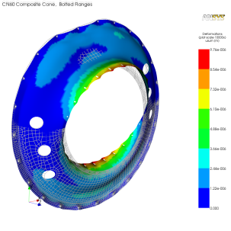

Factors of safety in excess of 50 were noted for various hole configurations with equivalent gravity sag, indicating an acceptably safe design.

Work on Electrostatics of E-Field Shroud was also done in March. Questions arose on placement of cable for Bias Voltage. Design presented in CDR was for a ‘biased’ shroud at up to 6.5kV. Work to date indicates that a shroud at ground potential should meet all requirements. Work will continue on elevated bias shroud options as backup. Some results from analyses are shown.

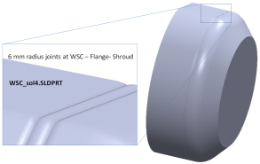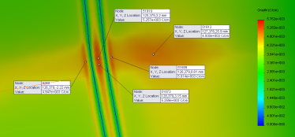

Field strengths at the ‘sharpest corner’ of shroud are shown.

### Integration

Draft Assembly procedure posted to E-Room in early March—includes figures of each assembly step, pulled from a detailed CAD assembly of the process. CAD envelope models of supports required for each stage of the assembly produced, but not detailed. Assembly procedure document template populated with figures and named assembly steps. Place-holders for descriptive text of each assembly step included; will continue work to document this process with text in April—excerpted figures shown below

## ESC/WSC Fabrication

Tooling for ESC/WSC Shells arrived at LBNL Composites shop in early March. Other mechanical components for tooling assembly, e.g. bearings, bolt etc, on hand since February. Composite Material was d elivered. Details for composite lamination developed in March, tooling issued and delivered.

### Cart Preparation

The mandrels for all IDS Shells are designed to spin and be cantilevered for part removal on a custom cart. This cart was previously used to produce the ATLAS Pixel Support Tube. Modifications for the larger ESC/WSC mandrel was required and included in the PO for the production of WSC and OSC mandrels. Primary modification was inclusion of a Tail Support, and welding an adaptor plate on similar centerline to support the new bearing assemblies

Assembly of the cart, including alignment of tail and head support axes is complete. Painting of newly welded plates and adaptors for cleanliness and rust prevention during lamination and cure was also done. Modification of the external autoclave cart to handle the larger WSC tool was done to minimize insertion forces, and better align the external cart to the rails within the autoclave

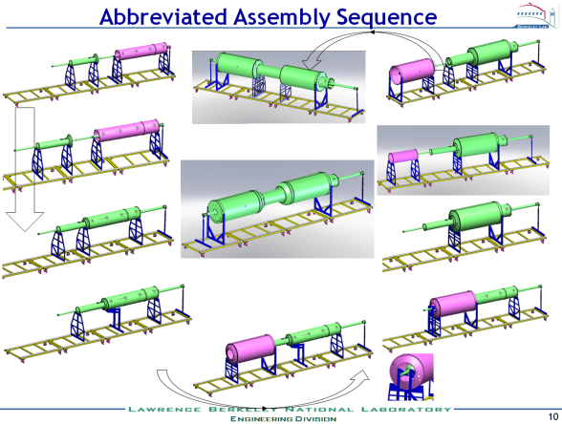

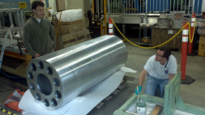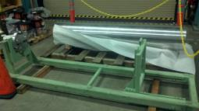

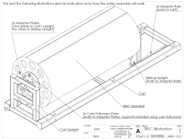

### Mandrel Preparation

The WSC (ESC) mandrel was installed on the cart, in both cantilever mode, and with the tail support installed. The mandrel, though larger than the one used for ATLAS is 800lbs lighter—it is aluminum rather than steel. A brake needs to be installed for safety—the mandrel spins too easily. Working on presently.

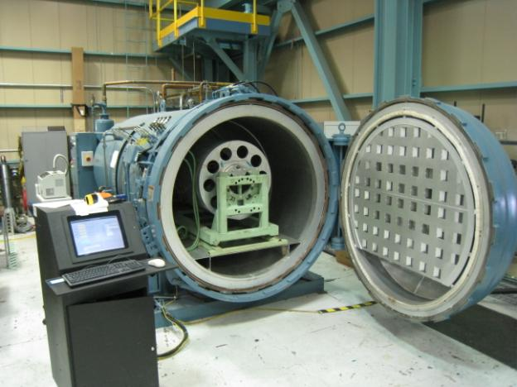

The mandrel was instrumented with 8TC’s and is being run thru full autoclave cure cycles to assess thermal performance. Problem with one lagging TC (#8) below invalidated the first run—it was disabled from the control algorithm for the second run., but still shows on report.

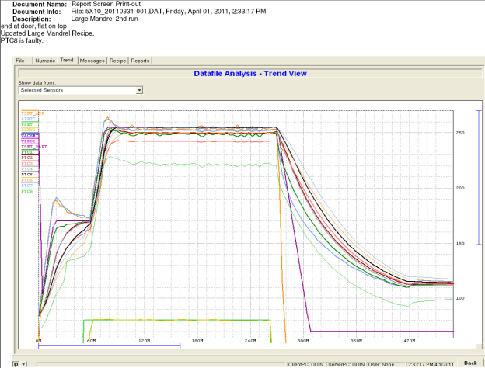

Leading TC (#1) dominates control algorithm—it is near headstock which is at inlet of air circulation. Another cycle with Baffle installed to reduce air velocity in this region will be tried, along with reversing mandrel within autoclave to allow flow to better homogenize. Goal is to get ramp rates for mandrels in the 2-5F/min range—currently ~1.5.

Cost, Schedule, and Documentation

The WBS was frozen by integration early in the month to allow project management to have stable numbers to work with. Additional changes will occur after input is received from the BNL internal review. The PHAD was updated for the BNL review. The TDR chapter was updated for the BNL review and will require additional work after the review.

Beam Pipe

The updated schedule for the testing and delivery of the new beam pipe has not been received from the manufacturer. It is expected at BNL in June. The company did provide a quotation for overseeing the operation of shipping the pipe to CERN for the NEG coating. The manufacturer was notified that this activity would not be done as a change order to the existing contract.

The interfacing of the existing three-inch diameter beam pipe in the IDS and FGT was started. The conditions of inserting the beam pipe through the FGT were agreed upon. Preliminary discussion of air barrier and internal mounts for the pipe were discussed. A C-AD engineering is examining the ability to hold the beam pipe at the TPC wheel with no internal supports. The two FY11 options for installing the beam pipe are assembling the IDS around the beam pipe and inserting the beam pipe through the completed IDS. Discussion of issues related to the existing three-inch diameter beam pipe will continue for several months.

The schedule for the new beam pipe has had further slippage. It is presently estimated to arrive at BNL by June 1, although the company has not sent the proposed adjusted schedule. There is no impact to the planned schedule. The final drawing for the Al beam pipe sections are being prepared for vendor quotes.

Infrastructure

The PXL platform was sent out to a vendor for estimates of cost. The Mezzanine should be ready for cost and delivery quotes in early April.

The specification of needs for the clean room was updated and the STAR technical Support Group (STSG) has begun looking on how to phase in the improvements to meet the needs of the FGT and HFT.

A quotation from a second vendor was obtained for the racks. A rack mount circuit breaker panel, P2 panel, was given to C-AD. C-AD examined the P2 panels for safety and cost. It was suggested that we use a solid metal enclosure on future panels that are fabricated. Additional price quotes were obtained by C-AD. Changing the G10 structure for the buss bars to commercial standoffs will be investigated.

**WBS 1.6 Software**

1) Initial simulation work from Purdue group on D* capabilities of HFT was presented showing good prospects for their reconstruction capabilities as demonstrated by the figures below. Further work on realistic background estimation, PID and cut optimization is in progress.

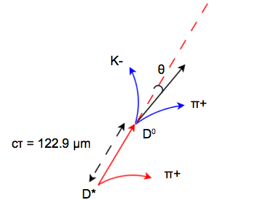

Figure-1: Decay of the D* particle

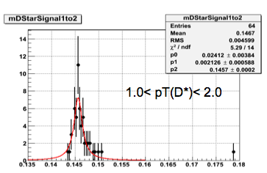

Figure-2: (D*-D0) mass distribution in 1<pT<2 GeV/c

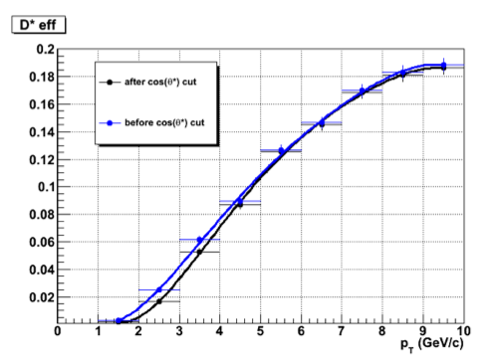

**Figure-3: D* reconstruction efficiency at a function of pT**

**Financial Status**

The SOW for the efforts at MIT is being processed by BNL procurement office. The distributions of cost at completion on other WBS items are to be determined at base lining. A no cost extension to the contract with LBNL has been issued to extend the initial efforts in preparation for CD 2/3 has been issued.

|  |  |  |  |  |  |  |
| --- | --- | --- | --- | --- | --- | --- |
| **WBS** | **Title** | **Monthly Actual** | **FY to Date** | **Project to Date**  **k$** | **Commitments**  **K$** | **Cost at Completion**  **K$** |
| 1.1 | Management | 8.7 | 39.1 | 43.2 | 0 |  |
| 1.2 | PXL | 168.0 | 293.3 | 300.6 | 60.7 |  |
| 1.3 | IST | 0 | 0 | 0 | 0 |  |
| 1.4 | SSD | 0 | 0 | 0 | 0 |  |
| 1.5 | Integration | 94.2 | 171.2 | 178.5 | 19.1 |  |
| 1.6 | Software | 0 | 0 | 0 | 0 |  |
|  | R&D | 0.3 | 14.0 | 273.8 | (14.4) | 280 |
|  | Contingency |  |  |  |  |  |
|  | Total | 271.2 | 517.6 | 796.1 | 65.4 |  |

**Acronyms**

IST Inner Silicon Tracker

IDS Inner Detector Support

OFC Outer Field Cage

FPGA Field Programmable Arrays

WSC West Support Cylinder

ESC East Support Cylinder

OSC Outer Support Cylinder

FGT Forward GEM Tracker

MSC Middle Support Cylinder

ARM APV Readout Module

AMS Austria Micro Systems

JTAG Joint Test Action Group ([IEEE](http://en.wikipedia.org/wiki/Institute_of_Electrical_and_Electronics_Engineers) 1149.1 Standard Test Access Port and Boundary-Scan Architecture)

BNL Brookhaven National Laboratory

MIT Massachusetts Institute of Technology

LBNL Lawrence Berkeley National Laboratory

DESY Deutsches Elektronen-Synchrotron

SLAC Stanford Linear Accelerator Center

STAR Solenoidal Tracker At RHIC

RDO Readout Board

C-AD Collider Accelerator Group

MTD Muon Telescope Detector