HFT
Heavy Flavor Tracker

MONTHLY REPORT

December 13, 2010

Performing Organization | Brookhaven Science Associates
Location: | Brookhaven National Laboratory
 | Upton, New York 11973-5000
Contract Period of Performance | FY2010-FY2014

HFT MONTHLY PROGRESS REPORT
November 2010

I. Contractor Project Manager’s Assessment

Technical Progress and Accomplishments

The PXL electronics and sensor development is progressing well, having completed a latch up test, and preparing for sensor design review in December. The design of the IST kapton hybrid for the ladder has started. The requisition for tooling required to the production of WCS and prototype ESC, OSC has been placed. Optimization of the Carbon fiber material to be used for the Inner Detector Support has begun.

Issues and Concerns

There has been good progress on the development of the integrated cost and schedule WBS, though there was an about 2 weeks delay for the integration sub-system due to other activities at LBNL and BNL. The engineering support from Nantes for the SSD is not as forthcoming as hoped. The project is investigating how the RDO board design can be completed with other resources.

II Detailed STATUS by WBS

WBS 1.1 Project Management

The monthly teleconference with HQ was held on November 16.
The CPM has met with the FPD a number of times in November. The HFT management meeting takes place every Tuesday.

Planning for the December 8-9 meeting was done, including preparing agenda, instruction to sub-system managers to focus on cost & schedule, documentation and planning issues.

There has been good progress on the development of the integrated cost and schedule WBS, though there was an about 2 weeks delay for the integration sub-system due to other activities at LBNL and BNL.

WBS 1.2 PXL detector

Mechanical

Progress was made on the detailed design for the rails in the PXL transport box. This activity included FEA analysis of the rail system. These are the rails that the PXL detector with carriage rides on during storage and transport. At installation the box is adjusted to align the rails in the box with the rails in the STAR experiment so that the PXL can be transferred from the box to the experiment.

The final element in this design is a read out system that accurately determines when the box rails are aligned with the support rails in the STAR experiment. This is necessary to achieve a smooth transfer without binding. A conceptual design has been developed that uses mechanical indicator gauges. This will provide a full quantitative measure of mis-alignment in 6 dimensions, which can then be used to dial in the correct position. A detailed design of this system will be carried out shortly.

A significant amount of time and people effort this last month was spent on working out problems with linking into the Adept database system that we will be using at BNL for a centralized storage of HFT mechanical models and drawings. The difficulty was in finding a way for users outside of BNL to reliably negotiate a path through BNL cyber security. Some of us can now get through, but it remains to be seen how many other STAR users can successfully access STAR mechanical data via this system. The original intent was that Adept would be an interactive tool which would be used throughout the mechanical design stage for version control of models. The very slow speed of interaction/connection between LBNL and BNL it will make it impractical for routine use and it will probably be limited to final design archiving. It is looked into if a duplicate server can be setup at LBNL.
The STAR electric engineer, Ciro d’Agistino, has been instrumental in helping out with proper implementation of Adept coordinating between the multiple parties involved: ITD, STAR ops, HFT users.

Sensors and Electronics

During the month of November we made significant progress on PXL electronics and sensor tasks. We conducted beam testing of the Mimosa-26 sensor, commercial driver and other components and several IPHC designed test structures at the 88” cyclotron. The results are currently under analysis. An initial look indicates that, as expected, the parts of the sensor architecture most susceptible to latch-up are the memory structures. The sensor latch-up cross-sections are in the range expected. We did not encounter any latch-up in the commercial chips that we intend to use on the ladders. A preliminary presentation of the data may be found here http://rnc.lbl.gov/hft/hardware/docs/latchup/latchup_for_IPHC_LBL_phone_meeting.ppt.

The preparations for the sensor design review are well under way. This review will take place on December 6-7 at BNL. Most all predatory material including extensive documentation and design process back up material is now available on the review website at http://rnc.lbl.gov/hft/hardware/docs/sensor_review/

The Phase-1 sensor test boards at the University of Texas, Austin are under test and preparation for configuring into a telescope configuration. We have a tentative test beam time at Fermilab of February 2-16, 2011 where we plan on joining the STAR FGT for a beam run in the test beam facility. Work is progressing on the readout firmware and software in support of this telescope test to measure the sensor efficiency to Minimum Ionizing Particles (MIPs) as a function of various bias settings.

The cost and schedule documentation have been significantly updated in preparation for the next set of reviews. The labor effort for PXL has been mostly leveled and the cost profile is approaching the DOE expected profile. This effort is expected to be ongoing for the next months before the review.

WBS 1.3 IST detector

Mechanical

In January 2011 we will start with producing kapton flex hybrids for the ladder prototyping. It was decided to wait for the real prototype hybrids instead of using dummy hybrids. Since the hybrids have to be laminated to carbon fiber ladders the hybrids have to be as realistic as possible. For cost and schedule reason it was decided to wait until the kapton flex hybrid design is finished.
The design by Ben Buck, MIT/Bates is scheduled to be done by mid January 2011
For multiple reasons the schedule has slipped by 2 months, so an effort will be made to fast track the ladder lamination tests and the ladder prototype production.

Sensors and electronics

What cannot be fast tracked is the prototype silicon sensor production, since the lead time for delivery from the manufacturer is about 6 months. Provided that the funds are available in January, this means that the prototype sensors will be available in July, 2011. However, the ladder/hybrid lamination efforts and the ladder prototype production are independent of the availability of the prototype sensors up to the point that the sensors have to be mounted on the ladders. The ladders will be tested mechanically and electronically before the sensors are mounted. Mounting and bonding of the sensors will take about 2 weeks, so realistically a fully assembled prototype ladder can be expected earliest by the end of July 2011. Characterizing this ladder (source scan and cosmic rays) will take a couple of months and, although tight, this still fits the schedule of starting full production of sensors, hybrids and ladders in the beginning of FY2012.

The testing of the APV readout chips is ongoing with both the IST pre-prototype and the FGT readout boards. It is planned to copy and use the design of the FGT readout system for the IST so progress on this is reported here.

The IST readout system consists of an Wiener MPod crates, APV Readout Modules (ARM's) and APV Readout Controllers (ARC's). The first ARC's, which accept STAR triggers and provide the interface between DAQ and the ARM's, are being tested at Argonne National Laboratory (ANL). Currently the main effort is to send data from the ARC board through the fiber interface (SIU) to the data acquisition computer.
The design of the ARM has still to be finalized. The interfacing with the APV front-ends through a long readout cable has been tested successfully already.
Choices for the clock phase control circuit and on APV on board power supplies have been made. The power supply circuits are being finalized and the ADC chip configuration details are being arranged. The first prototypes for the ARM are still expected before the end of CY2010.
The discussions about mapping, data format and zero suppression are ongoing and have to be brought to an acceptable conclusion to be able to program the ARM FPGA's in the proper way.

The EPICS control and monitoring of the MPOD readout crate, including
LV supplies and ISEG HV modules, has been finalized. It just needs the final graphical user interfaces still.

WBS 1.4 SSD detector

Ladder Board

All of the components for the ladder card are in house. The purchase order to procure the ladder board printed circuit boards has been issued to a French company. This board with the parts will be used to assemble the prototype generation of the ladder board. In December, this company is scheduled to deliver it. Parts have been obtained to make a power cable to the board. Basic test will be carried at BNL, and full testing in Nantes on March-April timescale.

RDO Board

Code for the slave FPGA on the readout board (RDO) is almost complete. As a final effort, an improved version of the code to provide JTAG access to the chips on the ladder is being implemented; this code will allow the existing slow controls software, which currently accesses these chips to be used with no major changes.

Other

Discussions have been made with one manufacturer of power supplies for the Ladder Board. This design has been examined and it seems satisfactory for the project. Later in the project, there will be a search for other manufacturers that can deliver a suitable product.

Project Management

The cost and schedule project worksheet was updated. This effort has led to a good idea on the fastest time that the project can be done. The next step is to incorporate a realistic funding profile to determine the appropriate schedule.

WBS 1.5 Integration

At LBNL, we have translated the generalized materials from their FEM (Finite Element Model) representations in the IDS (Inner Detector Support) model to actual materials that we can order. We optimized the composite materials involved in the various structures to minimize the cost, while meeting the performance requirements. The current FEM of the IDS uses isotropic approximations of composite materials. This is an artifact of the licenses we hold for the analysis software available. The optimizations are based on detailed Matlab/Excel calculations of the micro-mechanics of laminates, which match or exceed the properties of materials required to meet the performance of the IDS FEM. We have recently acquired licenses for another FEM package, which allows us to fully include all aspects of composite materials into a new FEM of the IDS. We will run models of the IDS with this new software package to verify the results of hand calculations, but will proceed with order of materials based on the results of the previous optimization. We expect no surprises.

Based on the results of the hand calculations for sizing, we have ordered the hard tooling (lamination mandrels) for fabrication of the WSC/ESC and OSC. The requisition was placed, the order is still working thru LBNL purchasing--expect vendor to receive order first week of Dec.

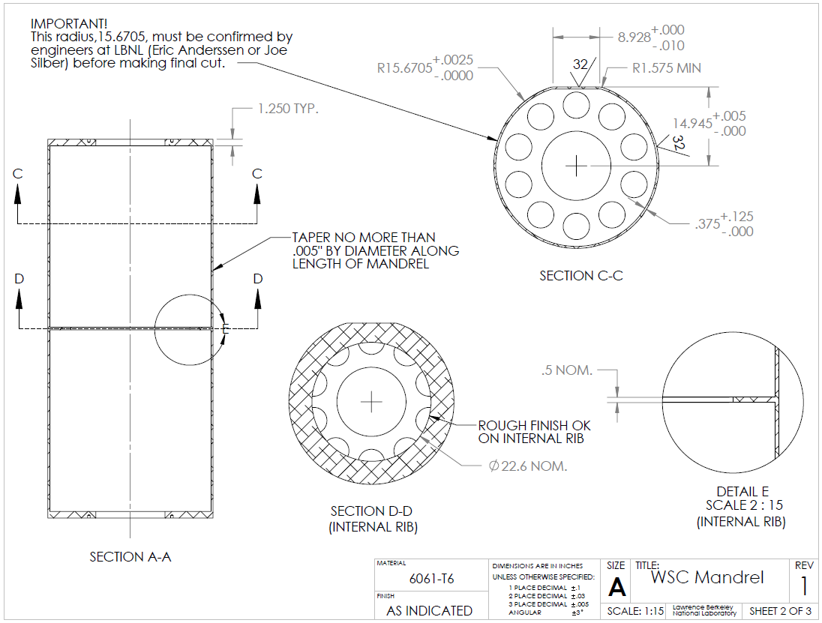

One of several drawings for the WSC/ESC mandrels.

Misc. Integration Support

The Star Ops Electrical Engineer, Ciro D’agostino., agreed to act as the Single Point of Contact (SPOC) to handle ADEPT programs. He has experience working with ADEPT in organizing the electrical systems in STAR and has already worked with BNL support to resolve ADEPT problems. During the month he was able to resolve several issue for the HFT team.

Ciro also gave an introduction to the documentation systems that he has implemented for SATR. The HFT project will use these systems for the documentation of cable route, rack assignments, power distribution etc.

Planning began for initial technology transfer from LBNL to BNL. The Chief Mechanical Technician for STAR, Bob Soja, will travel several times to LBNL to work with the Engineers and technicians to learn as much as possible on the mechanical structures of the IDS. It is believed that this transfer of knowledge will benefit both the FGT installation next summer and the HFT installation in the future.

Initial estimates for efforts to modify systems in the IR and assembly area were discussed with the C-AD Liaison Engineer for STAR. These efforts will be added as needed resources into the WBS.

WBS 1.6 Software

) A presentation was given on the physics capabilities of HFT during the Decadal plan discussion at the STAR Collaboration meeting.

2) The work on D+ reconstruction via its 3-body decay is progressing and it is in the cut optimization step.

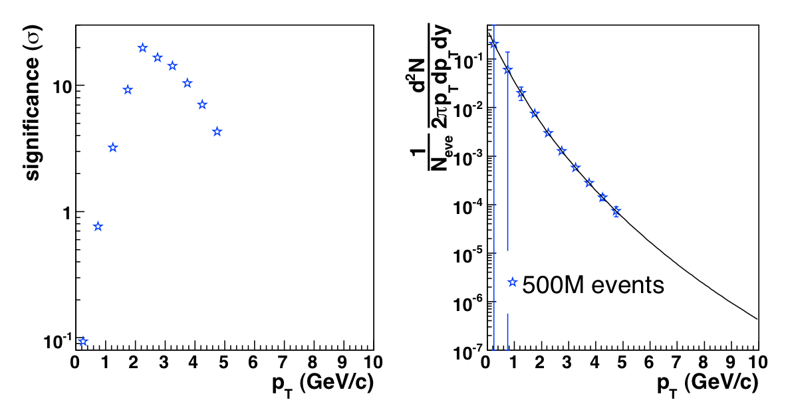

3) The Ds reconstruction via the Φ-meson decay (Ds->Φ+π->K+K+π) has been updated, using some powerful track pointing cuts and the first preliminary estimates on significance and pt spectra is shown in the figure.

4) A template for the Software WBS-tasks timeline was developed.

Financial Status

Project funds have been received for initial efforts in the balance of FY10 through March of FY11. A draft SOW for the efforts at MIT is underway and expected to be in final format in December. The distributions of cost at completion on other WBS items are to be determined at base lining.

There will be significant orders in the comings months. Madrels for IDS, carbon fibber material, as well as for the first production run on the ultimate prototype sensor (Dec-Jan).

WBS | Title | Monthly Actual | FY to Date | Project to Date  k$ | Commitments  K$ | Cost at Completion  K$
1.1 | Management | 3.8 | 9.9 | 13.99 | 0
1.2 | PXL | 21.6 | 49.2 | 56.56 | 31.80
1.3 | IST | 0 | 0 | 0 | 0
1.4 | SSD | 0 | 0 | 0 | 0
1.5 | Integration | 3.0 | 8.2 | 15.50 | .91
1.6 | Software | 0 | 0 | 0 | 0
 | R&D | 4.4 | 11.4 | 271.18 | (14.39) | 280
 | Contingency
 | Total | 32.8 | 78.7 | 357.23 | 18.32

Acronyms

IST Inner Silicon Tracker
IDS Inner Detector Support
OFC Outer Field Cage
FPGA Field Programmable Arrays
WSC West Support Cylinder
ESC East Support Cylinder
OSC Outer Support Cylinder
FGT Forward GEM Tracker
MSC Middle Support Cylinder

