WBS 1.6 Software

- NEW Alignment Tool: An independent PIXEL inter-sector, and halves, alignment method is in development at LBNL correlating event-vertex and track DCA information from tracks crossing different parts of the detector (sectors/halves). It depends minimally on the TPC tracking information as it mostly relies on ‘internal’ Pixel information. This tool will allow us to check, refine and/or monitor the internal alignment between different PXL sub-detectors throughout the run. The algorithm is being tested with simulations and now applied to the data taken in the engineering run, in Run13. The method includes the PXL hit positions in tracking and carries out independent vertex reconstruction using tracks passing through each Pixel sub-detector. The Figure below shows the 3D DCA resolutions between two tracks from the Run13 engineering run data. The solid line depicts the resolution between two tracks from the same sector. The symbols show the same quantity but using tracks from different sectors (sector 4 and 7 in Run13). The open circles show the result with the single sector geometry parameters determined based on the TPC track projection. One can see the resolution is not sufficient enough which points to the limitation of TPC projections. The closed circles show the result with the vertex reconstruction method described above. One can see the resolution between two tracks from different sectors is comparable to that from the same sector, indicating the inter-alignment between these two sectors has been greatly improved. The method has been tested with simulation data and it offers a very promising performance: offsets better than 10 microns and rotation angles better than 0.1 mrad with a sample of about 10K mid-central AuAu-like events. Studies show that this method performs best if one uses straight tracks, i.e. magnet off, thus avoiding some asymmetries from track helix propagation issues. Because of this we are preparing to take a magnet-off calibration sample at the beginning of the next run, Run14.
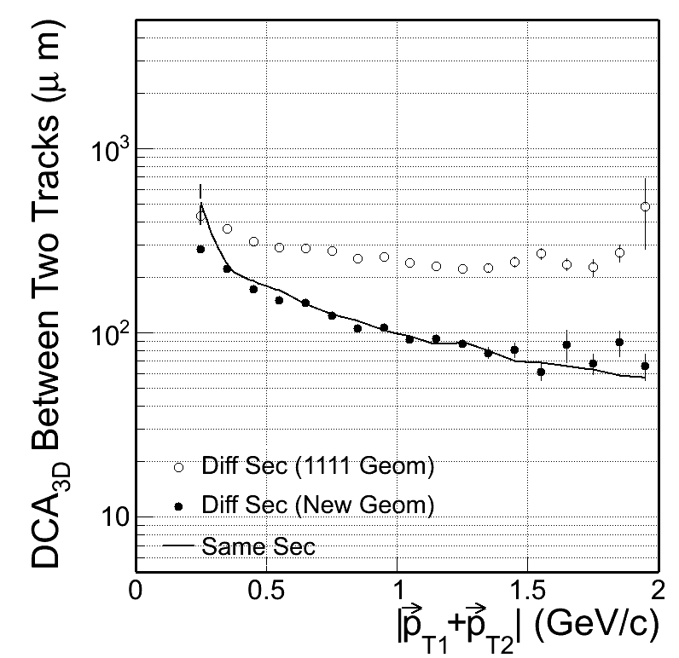
- The HFT group is discussing the calibration plans for the upcoming physics run. To ensure sufficient quality control on the alignment calibration, we should explore all possible directions:
1) Complete the on-going survey measurements for all possible sub-detectors. This is the key to provide the internal alignment between pixels within each sector. We plan to also measure sector positions w.r.t each PXL half before the detector is inserted.
2) Take cosmic-ray data both with and without magnetic field. The first intensive cosmic ray run before the physics run starts will provide a first alignment calculation between two PXL halves and some checks between sectors. We should continue to take as much cosmic-ray data as possible throughout the run whenever possible and another intensive cosmic ray run after the run is ended.
3) Take low luminosity beam data with and without magnetic field. The cosmic data may be limited by statistics, particularly for horizontal sectors. Short low luminosity beam data (can be done by de-steering beams at the end of stores) with and without magnetic field can be taken scattered through the full run too.

- Face-to-Face meeting at BNL: The software group organized a one day meeting at BNL where we discussed progress, the upcoming calibration and alignment needs and strategies, and also identified areas that need near term focused effort.

- Geometry modeling: There was, still is, a lot of activity going on in geometry modeling. There are several fronts in this effort. One is to fine tune/debug the IST geometry. The other is to refine the SSD geometry so that it better reflects the refurbished detector and also model the major mass-contributors like support structures and cables. The third one is the rather detail modeling of the heavy Pixel support structures at large z-positions from the detector center. This latter one is highly asymmetric in phi and is essential to beam calibration work. The figure below shows two views of the current model of pixel support structures [left panel] and some details of the SSD model [right panel].
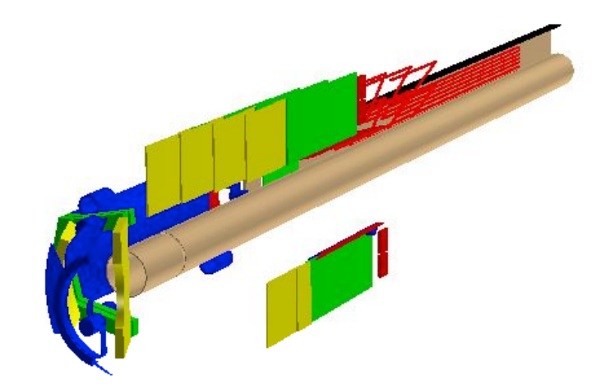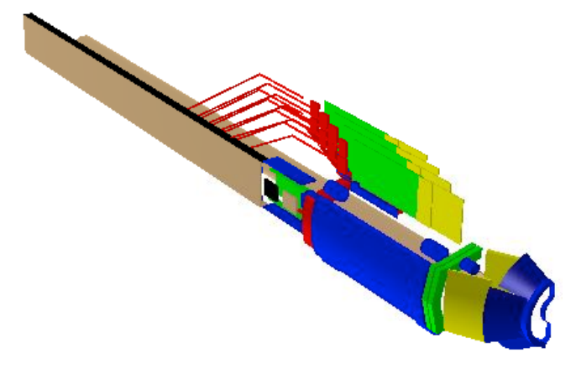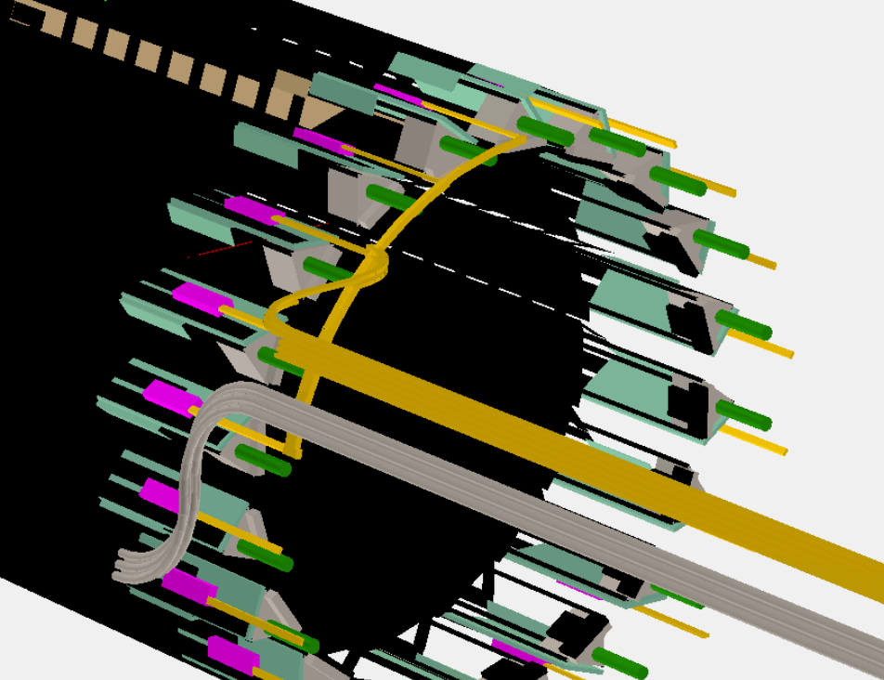

- SSD Software: Important progress toward the establishment of an Offline chain for the SSD was the development of a new DAQ reader for the new system. This was the major missing part of the chain.

