WBS 1.6 Software

Run14 (Au+Au 200 GeV/c) Fast Offline Analysis: During the report period we continue the monitoring, QA-ing, calibrating and analysis of the data. Below we report the focus areas of this effort during this period.

Alignment: [intra-PIXEL]. The fine-tuning of the relative alignment of the PXL detector sectors and halves using the Magnet-Off, Low-luminosity, Au+Au sample is done. This run took place about two months after the dedicated cosmic ray run and the main goals are a) to check the stability of the PXL detector during the run and b) to enhance the statistics in the ‘horizontal’ sectors where the cosmic flow is minimal. The results confirmed that the initial cosmic ray based alignment achieved precisions down to the 10-20 micron level (left panel in fig 1). It also appears (fig 1 right panel) that the residual relative misalignments after this fine-tuning are down to a couple of microns. A similar analysis on the relative rotation angles shows that after the fine-tuning are within 0.1-0.2 mrad (a 0.1 mrad rotation misalignment can introduce, depending on the position of the sensor, a maximum shift of about 10 microns). This PXL alignment result and its apparent time stability give us confidence that our original goals of uncertainties comparable to a pixel size (~20 microns) can be achieved.

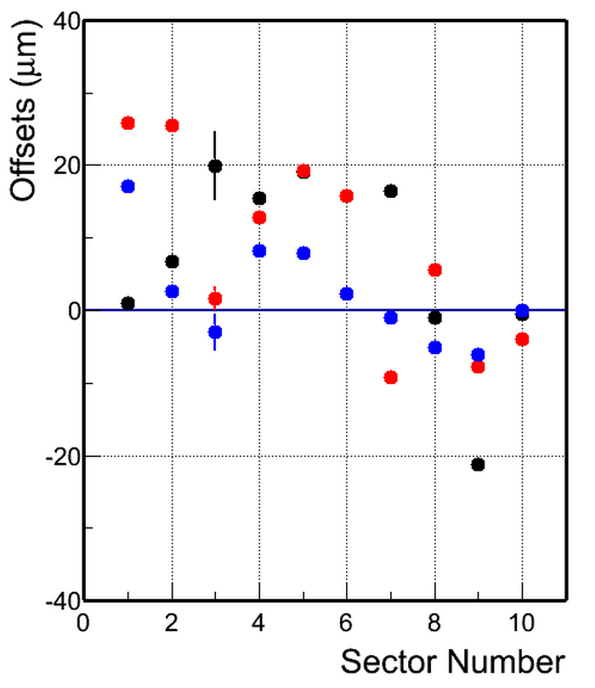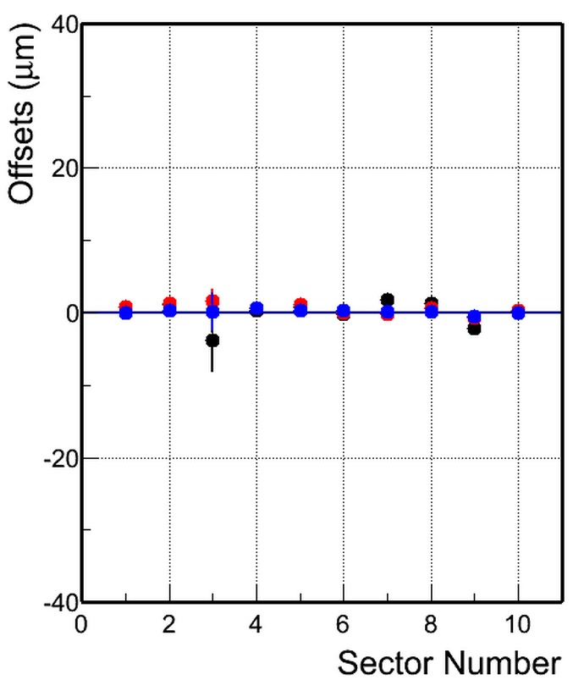

Figure 1: Relative alignment of PXL sectors before (left panel) and after a fine-tuning (right panel). The plots show the relative displacement of Sectors in microns in dX (black), dY (red) and dZ (blue).

Geometry modeling in Tracking: Significant effort has been put in the proper modeling of the HFT material in tracking. This is important for proper accounting of momentum and energy loss of tracks as they cross the various layers of the detector. This modeling needs to be done ‘by hand’ so that simpler shapes equivalent in radiation thickness can replace complex structures. Significant understanding and progress in the modeling was done during the report period.

Gamma ray tomography: We started work that can use the gamma ray conversions in the detector material as a way to estimate/verify the actual detector mass and its position in the STAR coordinate system. One of the goals is to determine the relative position of passive and active elements in an absolute way, for example the position of the beam pipe relative to the PXL/STAR system. The figure below is a geant simulation and it shows the conversion points in STAR. One can easily see (starting from inside) the beam pipe, the PXL trapezoidal sectors, the IST, the SSD and the inner field cage (outer circle) of the TPC. This work is in progress.

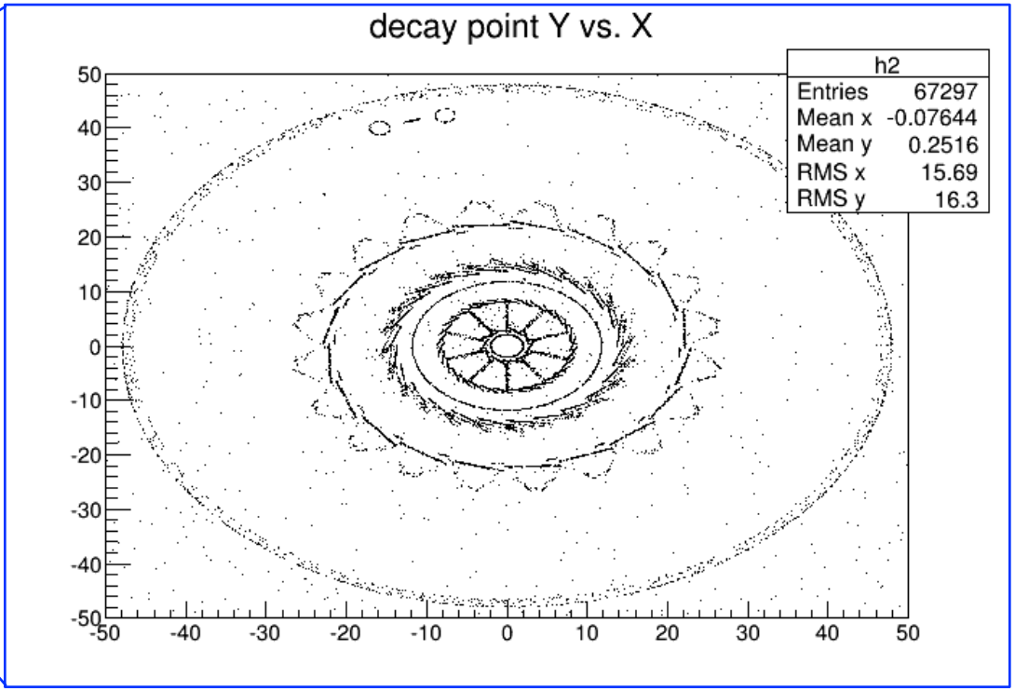

Figure 2 A Geant simulation showing the conversion points of gamma rays in STAR. One sees the outlines of the HFT subsystems inside the inner field cage of the TPC

Simulation: A lot of work is being put in generating the proper simulations for the KPP/CD4 work. More details will be given in next month’s report.
At the same time work is done in modeling the response of the PXL sensors, something that will be used later in detailed, raw signal, simulations for physics. Figure 3 shows a comparison of the simulated PXL signal response (blue solid line) and real data (red points). This work is in progress but one already sees the remarkable agreement between data and simulation.

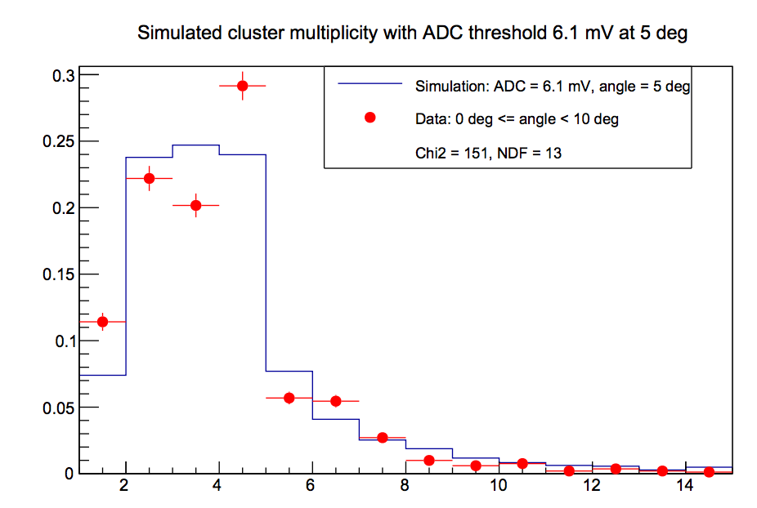
Figure 3 Simulated PXL cluster multiplicity (solid line) comparison with Data (red points).

Two-day workshop in Warsaw: A two-day workshop was organized by our colleagues in Warsaw as an after-Quark Matter 2014 activity. The software needs and the available manpower were discussed in detail and a plan was drafted.

