WBS 1.6 Software

- Alignment Software and Simulations
  - We have successfully extended our work on simulations and the development of a fully functional alignment software package to include all HFT detectors. We can now run the software for PXLs, IST and SSD. Figure 1 shows examples of simulation results for the recently implemented PXL detector.
  - Work has started on developing a VMC (ROOT) environment for detailed, precision tests of the alignment package with simulations.

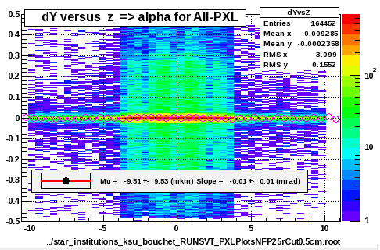
Figure 1 The average alignment result for All-PXL ladders for dY displacements and x-rotations for a small statistics simulation sample. The results (in microns and mrad) are compatible with zero, as they should be for this simulation without geometry modifications.

- Survey
  - PIXEL: further survey work and software development was performed on the prototype sector and issues emerged were addressed. The system is ready for the survey of the prototype PXL sectors used in the upcoming engineering run.

- AOB
  - None

