WBS 1.6 Software

Run14: The group is monitoring, QA-ing, calibrating and analyzing at the Au-Au 200 GeV/c data [about 100 Million events are on tape with the PXL+IST detectors]. An example of such event with tracking is shown in the figure below.

- Alignment [intra-PIXEL, IST relative to PIXEL and PXL-IST relative to TPC]. Significant progress has been made in aligning ALL elements of the HFT detector relative to each other AND relative to TPC. Several independent efforts and techniques are used in this task and several cross checks performed.

- Run QA and Masking of noisy sensors. The offline monitoring of the detector state and overall performance intensified with the advent of the Au-Au collisions at full energy. Semi-automatic tools produce key performance histograms (QA) for the PXL and IST detectors and progress was made for the SSD (even though the SSD in only sporadically included in the physics runs). The QA work is multifaceted and one aspect of it deals with the recording and the time dependence of its noisy or inactive elements (masking). This month work was put to automate the procedure and update and fine-tune the criteria that characterize the various elements.

- Pre-production samples and Analysis: A sample of Au-Au data (about 20K events) was reconstructed with and without the HFT (PXL+IST) hits in the tracking in order to evaluate and debug the reconstruction chain (alignment, tracking, vertex reconstruction and other event characteristics). This work just started.

CD4: We are preparing for the CD4 report and the two KPPs our group is responsible for, i.e. the DCA resolution and overall efficiency. Both simulations and data are to be used.
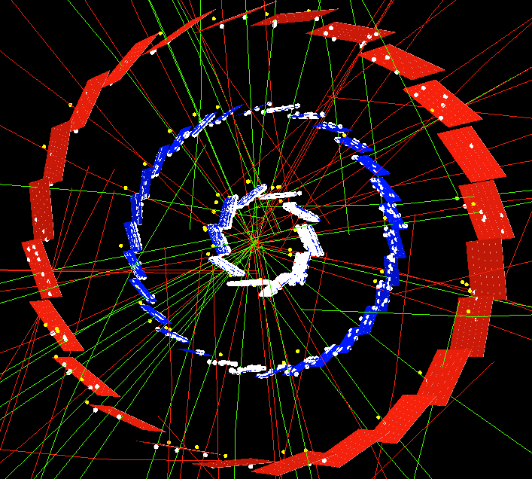

Figure 1 Event display of a peripheral Au+Au 200 GeV/c event with the PIXEL+IST detectors in the run and in the tracking. Lines are extrapolated TPC tracks, white dots on the detector elements are magnified hits and yellow dots are hits picked up by the tracker (displaced off the sensor for clarity).

