WBS 1.6 Software

- Offline Chain
  - A thorough testing and debugging of the geometry and offline chain is ongoing. Several issues have been identified and fixed.
  - The first version of a PXL DAQ reader/Cluster finder/Hit finder has been released.
- Survey
  - The survey of the remaining two sectors (of a total of three for this run13) is done
  - The Db structures are defined. Work to fill them has begun.
- Geometry modeling
  - A precision issue that resulted in an effective misplacement of the PXL hits was tracked down and fixed. This also explained some small but visible effects in alignment software. The figure below shows the effective ‘kink’ this error produced at z=0 (left panel) and its disappearance after the correction.
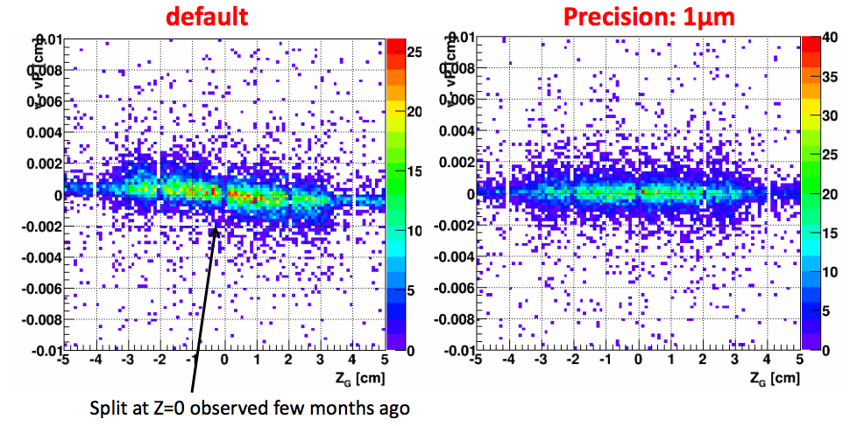
- AOB
  - A first (BUR) draft of the HFT needs for Run14 and Run15 has been circulated and discussed.

