Overview of Silicon Detectors in STAR: Present and Future
Sonia Kabanaª for the SVT, SSD and HFT detector groups of the STAR experiment at RHIC
ªLaboratoire de Physique Subatomique et des technologies associees, SUBATECH,
Ecole des Mines, 4 rue Alfred Kastler, 44307 Nantes cedex 3, France
Abstract. The STAR experiment at RHIC aims to study the QCD phase transition and the origin of the spin of the proton. Its main detector for charged particle track reconstruction is a Time Projction Chamber, which has been supplemented with a Silicon Detector involving two different technologies, in particular double-sided silicon strip and silicon drift technology. STAR is preparing now for a new Silicon Vertex Detector, using double-sided silicon strip, single-sided silicon strip-pads, and CMOS monolithic active pixel sensors technology, planned to take data in 2014. We give an overview of the design, calibration and performances of the silicon detectors used by the STAR experiment in the past and the expected performances of the future silicon detector upgrade.
Keywords: Silicon Detectors for secondary vertex reconstruction, charm and beauty reconstruction, high energy nuclear and particle physics, RHIC.
PACS: 29.40.Wk

Introduction
The STAR experiment at the Relativistic Heavy Ion Collider at the Brookhaven Laboratory studies p+p (polarized), d+Au and A+A collisions at several energies up to sqrt(s)=200 GeV for A+A, and up to sqrt(s)=500 GeV for p+p collisions. STAR aims to reproduce and characterize the QCD phase transition between hadrons and partons, and to measure the partonic contributions to the spin of the proton. STAR started taking data at 2000 with the start of the RHIC collider run.
Hadrons with strange, charm and beauty quarks are important messangers that can be used to study the nature of the dense medium formed in the heavy ion collisions at RHIC. One of the most important discoveries at RHIC is the quenching of jets when passing through the dense medium formed in a heavy ion collision [1]. Furthermore it has been measured that hadrons with light quarks show at high transverse momenta the same amount of suppression with respect to p+p collisions at same energy as hadrons with charm and beauty quarks [2]. This is not expected from theoretical calculations assuming jet quenching through radiative energy loss [3]. To understand this discrepancy charm and beauty must be measured separately, with high precision and up to high transverse momenta.
STAR has used in the past a silicon detector ensemble, consisting of the 3-layer Silicon Vertex Detector (SVT) [4] and the one-layer Silicon Strip Detector (SSD) [5], which has been mainly designed to improve strange particle decay topological reconstruction and extend their acceptance to low transverse momentum. These detectors have been used to study decays of charmed mesons. The future silicon detector upgrade of STAR, the Heavy Flavour Tracker (HFT) [6] aims to improve in significant way the measurement of decays of hadrons with charm and beauty, and to address issues like the mass dependence of jet quenching, the possible collectivity of charm, and allow studies of the transverse momentum dependence of charm baryon to meson ratios.

The star experiment at rhic

The main detector of the STAR experiment [7] for charged particle track reconstruction is a Time Projection Chamber positioned inside a solenoidal magnet of 0.5 T. The STAR detector is shown schematically in figure 1. The TPC is divided into two halves by a Central Membrane and contains 12 sectors in each half. Electrons produced by charged particles drift in Z direction, (Z is the beam direction) from the central membrane to the end caps where they are detected with 45 pad rows. The TPC covers ±1.0 units of pseudorapidity around midrapidity for tracks crossing all layers of pads, and the full azimuth.
The STAR experiment includes many other detector sub-systems, major ones to be mentioned are a Time Of Flight (TOF) detector and an electromagnetic calorimeter, positioned around the TPC, matching the TPC acceptance. Other important upgrades of STAR concern the data acquisition (DAQ1000), and first applications of a new High Level Trigger.

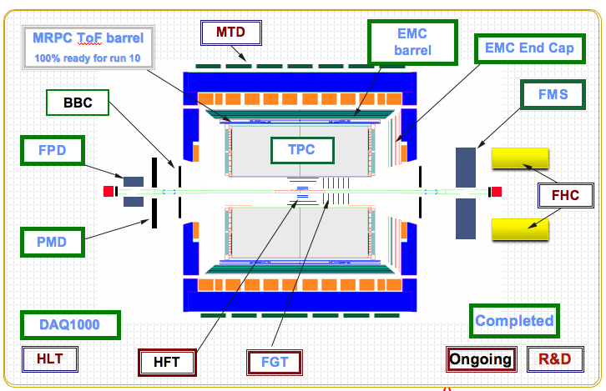

Figure 1. The STAR experiment at RHIC

To improve the STAR track reconstruction accuracy the TPC has been supplemented with a four-layer Silicon Detector involving two different technologies, namely a layer with double-sided silicon strip technology the so called SSD (Silicon Strip Detector), and three layers of a silicon drift technology, the so called Silicon Vertex Tracker (SVT). The ensemble of this Silicon Detector took data mainly in the 2005 run (Cu+Cu at 62 and 200 GeV) and in the 2007 run (Au+Au at 200 GeV). After the 2007 run the silicon detector has been removed from the STAR experiment for reparations and upgrades towards the future Heavy Flavour Tracker (HFT).

the silicon detectors of star

The Silicon Vertex Tracker (SVT)
The Silicon Vertex Tracker [4] consists of three layers of silicon drift detectors with average distances from the primary vertex of 6.85, 10.80 and 14.70 cm, and represent 1.5% of a radiation length X₀ each. The silicon drift wafers are arranged in ladders which are attached to two hemispheres or `clam-shells' that wrap around the beam pipe. Figure 2 shows the SVT detector (left). The detector consists of 216 wafers in total. Electrons drift in the rϕ direction, which is perpendicular to the TPC drift direction. The intrinsic design spatial resolution is σ_{rϕ} ~20 μm and σ_{Z} ~20 μm. The SVT has been taking data since 2003.
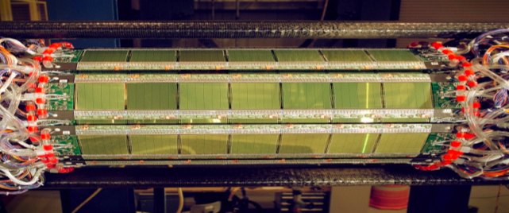

Figure 1. Left: The Silicon Vertex Detector (SVT). Right: The Silicon Strip Detector (SSD).

The Silicon Strip Detector (SSD)

The Silicon Strip Detector of STAR [5] consists of a single layer of 2-side Silicon Strip Detector at 23 cm from the beam, and represents 1.1% of a radiation length X₀ . Figure 2 shows the SSD detector (right). It consists of 20 ladders with 16 wafers each, using double sided silicon strip technology (768 strips per side). The wafers are 75 mm x 42 mm. The strip pitch is 95 μm, and there is a stereo angle of 35 mrad between p- and n-strips. The intrinsic design spatial resolution is σ_{rϕ} ~30 μm and σ_{Z} ~800 μm [5]. The SSD has been fully functional and taking data since 2005.
The SSD offers a non drifting point measurement placed between the TPC and the SVT, which is very important for the TPC to SVT track matching. For example, if only one SVT hit is reconstructed for a particle track and the SSD hit is not reconstructed then the percentage of fakes reaches 50%.

Calibration and performances of the SVT and SSD

The SVT and SSD detectors have taken data together in the 2005 run (Cu+Cu collisions at 62 and 200 GeV) and in the 2007 run (Au+Au collisions at 200 GeV). They have been calibrated and aligned [8,9,10] and have been used for secondary vertex reconstruction of charm meson decays [11-15].

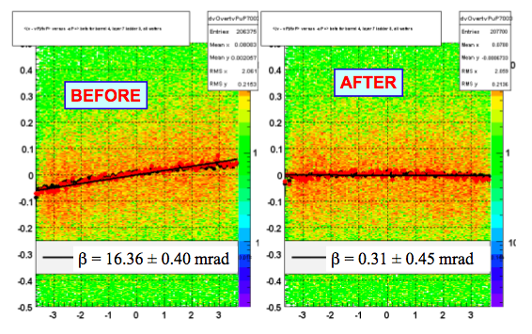

Figure 2. Example of correcting the rotation of an individual SSD ladder around the v-axis. The lines represent the results of linear fits whose slope parameter correspond to the measured misalignment (β). The slopes β measured before and after the alignment are shown in text on the figures [8].

A correction of the Lorentz effect in the SSD, causing a shift in the position of the points of impact in the beam axis of about 200 microns, has been implemented [10].
Several steps have been followed to achieve the alignement of the SVT, SSD and TPC detectors [8,9]. The global alignment of SVT and SSD using ladder survey data and TPC tracks lead to an average alignment of shells and sectors to better than ~50 μm in translations, and a few mrad in rotations. A fine-tuning of individual Laddes of the SSD using TPC tracks has been performed afterwards, after which the majority had translations of less than 20 microns and rotations of less than 0.5 mrad (figure 3). As next step the SVT Ladders have been fine tuned in the Z direction with respect to the system TPC+SSD, leading to translations of less than 20 microns for most ladders. The following step concerned the SVT drift velocity calibration using the TPC+SSD informations, leading to deviations of ~10 microns. An iterative method based on track/vertex fitting has been applied for consistency check.
The SSD detector response has been simulated with Geant and has been compared to the data. The efficiency of the SSD is about 80% for ladders with low level of noice, close to Monte-Carlo estimates, and ~90% if taking into account only active areas of SSD sensors [10].
The quality of the calibration and alignment procedure is reflected in the spatial resolution of the SVT and SSD, which has been estimated from a hit pull analysis in track fit, requiring the pull standard deviation to be equal to 1, and is as follows [8]:
For the SVT : σ_{rϕ} = 49 +- 5 μm and σ_{Z} = 30 +- 7 μm
For the SSD: σ_{rϕ} = 30 μm (set to design value because much smaller than multiple scattering)and σ_{Z} = 742 +- 41 μm.
Therefore the spatial resolution of the SVT and SSD measured in the data after calibration and alignment matches the design resolution of these detectors.

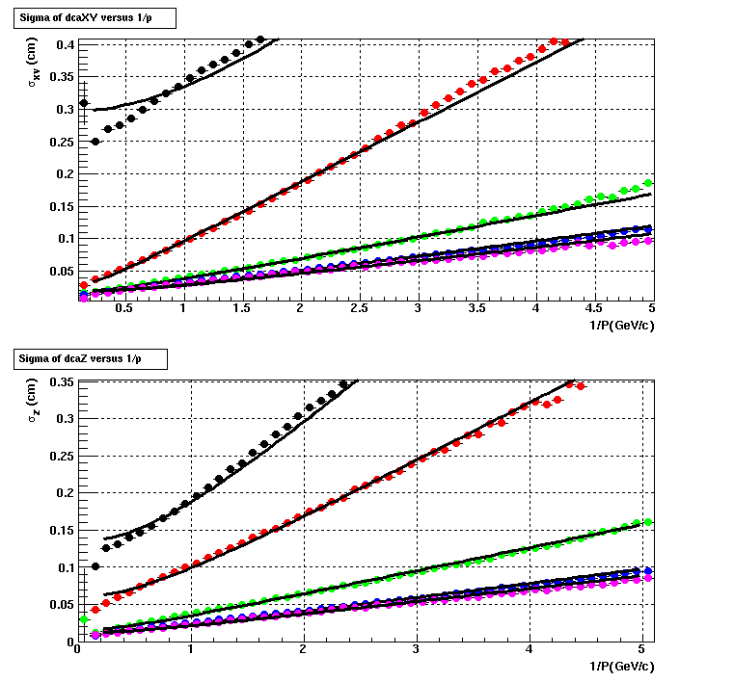
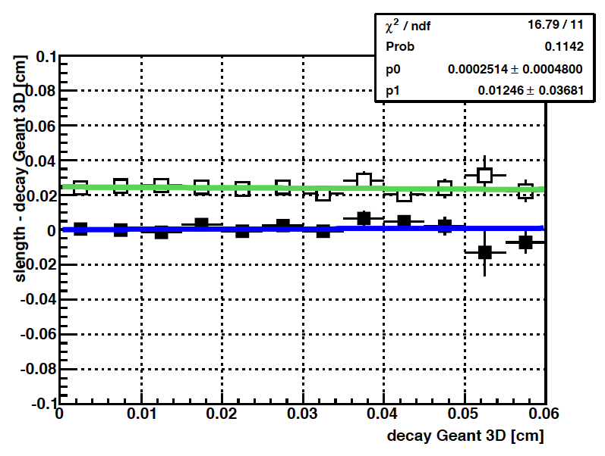

Figure 4. Left: Sigma of the Distance to Closest Approach distribution of charged tracks as a function of the inverse momentum in XY drection (above) and in Z direction (below). From up to down the curves show the case for TPC hits only, TPC+SSD hits, TPC+SSD+1,2 and 3 SVT hits. Right: Closed squares show the difference between the reconstructed and the real decay length as a function of the latter in Geant simulation with SVT and SSD. Open squares show the standart deviation of this distribution [13].

The resulting resolution of the Distance to Closest Approach of charged tracks to the Primary Vertex is shown in figure 4 (left) as a function of inverse momentum. For tracks with momentum 1 GeV it is shown to be improved by an order of magnitude, namely it is reduced from 3350 microns in XY direction, (respectively 1184 microns in Z) when requiring TPC only, down to 281 in XY direction (respectively 212 in Z direction), when requiring 4 hits in the SVT and SSD detectors.
The mean value of the difference of the reconstructed and the real decay length of the D⁰ mesons in the Monte carlo is shown with closed squares in fig. 4 (right) as a function of the latter, while the standard deviation is overlayed with open squares [13]. One observes that there are no systematic shift of the reconstructed quantity and that the standart deviation is flat around ~250 microns, which is of the order of the resolution of the SVT and SSD discussed previously. An example of the D0 meson invariant mass distribution obtained in Au+Au collisions at 200 GeV with the 2007 data of STAR and using the SVT and SSD for secondary vertex reconstruction is shown in figure 5 [14], while also other D mesons have been also reconstructed [14]. Furthermore, the inclusion of the SVT and SSD in the tracking causes an increase in the signal to background ratio for K⁰_{s} of about ~4, namely from 6.22±0.03 to 23.48±0.30 [10].

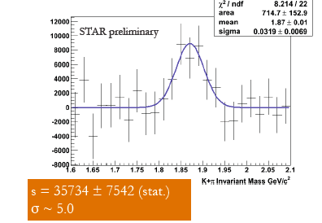
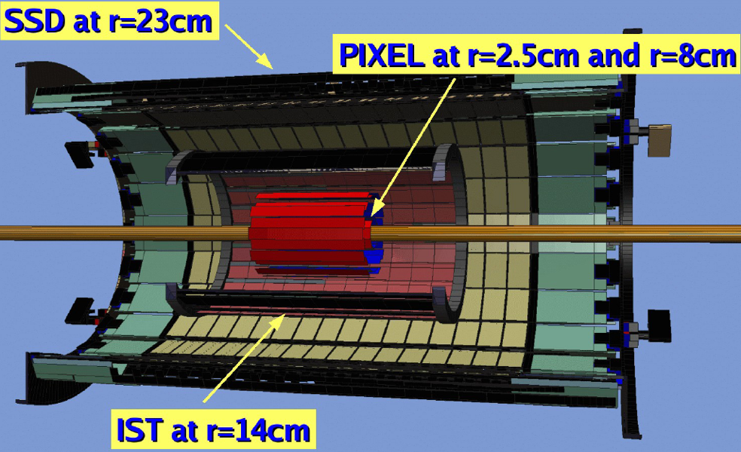

Figure 5. Left: Invariant mass distribution for the D0->K pi decay in Au+Au collisions at 200 GeV using the SVT and SSD detectors for secondary vertex reconstruction [11]. Right: The Heavy Flavour Tracker, the planned future silicon tracker of STAR [6].

The SSD detector is currently prepared for the upgrade of its electronics for its future inclusion in the new Heavy Flavour Tracker with the new data acquisition system of STAR. The SSD upgrade will allow a reduction of the SSD readout time from ~4 milliseconds down to ~154 microseconds.

The Heavy Flavour Tracker (HFT)

The STAR collaboration has proposed a new 4-layer Silicon vertex detector named Heavy Flavour Tracker (HFT) [6], shown shematically in fig. 5 (right). It is composed by the existing SSD at 22 cm from the beam (~1.1% X₀),, a new intermediate layer of single sided strip-pads (IST) at 14 cm from the beam (~1.2% X₀), and two layers of the pixel detector at 8 and 2.5 cm from the beam (0.35% X₀), composed by 18.4 microns x 18.4 microns Monolithic Active Pixel Sensors (MAPS) [6]. The number of pixels is 356 M pixels on ~0.16 m² of Silicon. The mecanical structure foreseen allows for rapid detector replacement within ~1 day. The expected radiation dose for maximal luminosity Au+Au per year of operation is compatible with the MAPS radiation hardness.

The spatial resolution (σ_{rφ},σ_{Z}) is ~ (30, 800) μm for the SSD, (170,1700) μm for the IST, and (10,10) μm for the pixel detector.
The DCA resolution expected for a pion with 1 GeV momentum is ~ 30 microns. Therefore the excellent resolution of the pixel detector, its thinness and the near positioning of the first layer to the beam, lead to an improvement of the DCA resolution of another order of magnitude as compared to the resolution of the SVT and SSD. The HFT resolution is therefore optimal for charm measurements with ctau values of ~100 microns. The integration time of the HFT is less than 200 microseconds.

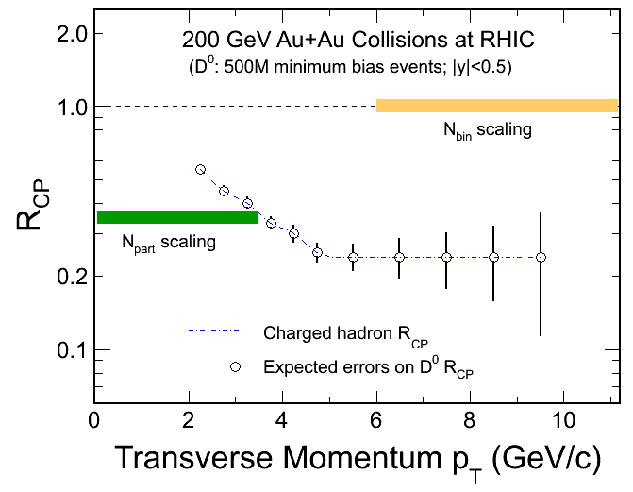
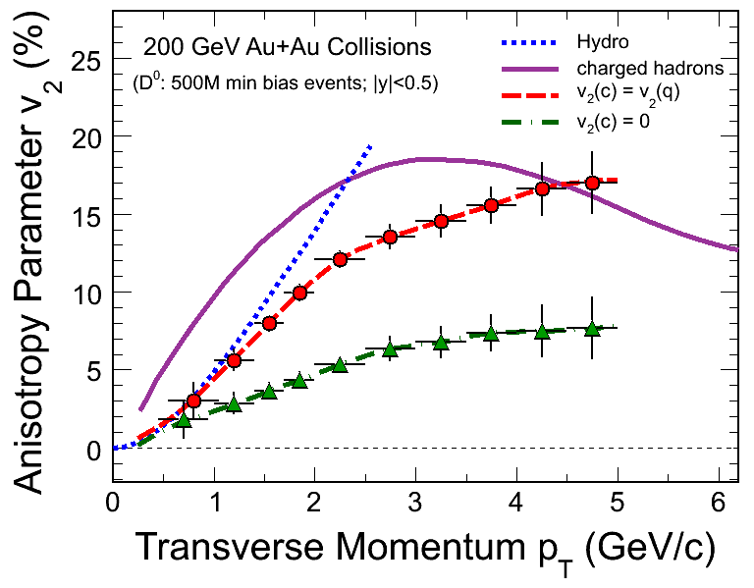

Figure 6. Left: Nuclear modification factor of D0 meson in Au+Au collisions as a function of the D0 transverse momentum, using a simulation with the HFT. Right: Elliptic flow of D0 mesons as a function of their transverse momentum in a simulation with the HFT, assuming charm has same flow as light quarks (points of upper curve), and assuming that charm has zero flow (points of lower curve). The continuous line depicts the measured charged particle flow, while the dashed line show prediction of hydrodynamics [13,16,17].

Figure 6 (left) demonstrates the expected precision of the HFT in measuring the nuclear modification factor R_{CP} of the D0 meson as a function of transverse momentum in 500 M min. bias events assuming heavy quarks have same suppression as light quarks [6,13,16,17].
Figure 6 (right) shows the precision in the measurement of the elliptic flow of D0 mesons with the HFT s a function of their transverse momentum, assuming charm has same flow as light quarks (upper curve) and assuming charm has zero flow (lower curve). These two cases can be clearly distinguished.
The Department Of Energy CD-2/3 review of HFT will take place in july 2011, installation is foreseen for 2013 and first data taking for 2014.

CONCLUSIONS and OUTLOOK

STAR used a 4-layer Silicon Vertex Detector based on Silicon drift (SVT) and Silicon Strip (SSD) technologies in the 2005 and 2007 runs. The performance, calibration and alignment of this detector lead to the reach of its designed resolution. The silicon tracker lead to an improvement by an order of magnitude in the DCA resolution of charged tracks namely from ~3000 down to ~250 microns for pions with momentum of 1 GeV. This improvement is reflected in strange and charm particle reconstruction achieved with these detectors.
STAR prepares now for a new 4-layer silicon tracker, the HFT, to start data taking in 2014. The HFT will lead to the important technological breakthrough of another order of magnitude improvement in the DCA resolution, namely from ~250 down to ~25 microns for pions with momentum of 1 GeV, and will allow for the detailed high precision study of charm and beauty in heavy ion collisions at RHIC.

References

1. J. Adams et al, STAR Collaboration, “Evidence from d + Au measurements for final state suppression of high p(T) hadrons in Au+Au collisions at RHIC”, Phys. Rev. Lett. 91, 2003, 072304.
2. B.I. Abelev et al, STAR Collaboration, “Erratum: Transverse momentum and centrality dependence of high-pt non-photonic electron suppression in Au+Au collisions at sqrt(s)(NN)= 200 GeV”, Phys.Rev.Lett.98, 2007, 192301.
3. M. Djordjevic et al, “The Charm and beauty of RHIC and LHC”, Phys.Rev.Lett.94, 2005, 112301.
4. R. Bellwied et al, STAR Collaboration, “The STAR Silicon Vertex Tracker: A Large Area Silicon Drift Detector”, Nucl. Instrum. And Methods A, 499, 2003, pp. 640.
5. L. Arnold et al, STAR Collaboration, “The STAR Silicon Strip Detector (SSD)”, Nucl. Instrum. And Methods A, 499, 2003, pp. 652.
6. E. Anderssen et al, “A Heavy Flavor Tracker for STAR”, (http://rnc.lbl.gov/hft/docs/hft_final_submission_version.pdf)
7. K. H. Ackermann et al, STAR Collaboration, “STAR Detector Overview”, Nucl. Instrum. And Methods A, 2003, pp. 624.
8. Y. V. Fisyak et al, “Overview of the Inner Silicon detector alignment procedure and techniques in the RHIC/STAR experiment”, J. Phys. Conf. Ser.119, 2008, 032017.
9. S. Margetis et al, “Alignment experience in STAR”, CERN-2007-004, 2007, pp. 23.
10. J Bouchet, PhD Thesis, “Performances du detecteur en silicium a micropistes de l'experience STAR a RHIC”, University of Nantes, France, 2007.
11. S. LaPointe, PhD Thesis, “D meson measurements in STAR using the silicon inner tracker “,Wayne State University, 2010.
12. A. Geromitsos, PhD Thesis, “Open charm measurements in the STAR experiment at RHIC in p+p and A+A collisions at sqrt(s)=200 GeV”, University of Nantes, France, 2010.
13. J Bouchet et al, STAR Collaboration, “Charm reconstruction using a microvertexing technique with the STAR Silicon Vertex Detectors”, 50th Intern. Winter Meeting on Nuclear Physics, Bormio, Italy, Jan. 2011, to appear in the proceedings.
14. S. LaPointe et al, STAR Collaboration, “D Meson Measurements in Au+Au Collisions in STAR using the Silicon Inner Tracker”, Intern. Workshop on Hot Quarks, 2010.
13. W. Borowski et al, STAR Collaboration, “Charm and Beauty searches using electron-D0 azimuthal correlations and microvertexing techniques in the STAR experiment at RHIC”, Intern. Workshop on Hot Quarks, 2010.
14. S. Margetis et al, STAR Collaboration, “Heavy Flavour Tracker: A new silicon detector for the STAR experiment at RHIC”, Acta Phys. Polon. Suppl. 3, 2010, pp. 1009-1014.
17. J. Kapitan et al, STAR Collaboration, “Open charm measurements with HFT at STAR”, Indian J. Phys. 85, 2011, pp. 177-181.

