STAR Heavy Flavor Tracker (HFT)

Response to CD-1 Physics Questions

July 28, 2026

Introduction
This report is written in response to the questions raised in the DOE document “ Report on the Technical, Cost, Schedule and Management Review of the STAR Heavy Flavor Tracker". This review took place at Brookhaven National Laboratory in November 12-13, 2009, and is referred to here as the CD-1 review.
In the first part we describe the simulations that have been performed since the review and then address all the relevant questions.
In the Appendix we present simulations where we compare the significance of D⁰ measurements when using HFT pixel technology versus PHENIX hybrid technology.

New HFT Simulations
The CD-1 questions emphasize the impact on physics of the HFT design parameters, especially in the low p_{T} region that is very sensitive to detector thickness. In this report we study the impact of increasing the mass of the first layer of the PXL detector from a value of 0.32 % of a radiation length (X₀) (thin configuration) to a value of 0.62 % X₀ (thick configuration), and of increasing the internal stability from 20 μm (design value) to 30 μm (CD-4 parameter). The thickness of the “thin” configuration is close to the present design parameter of 0.37% X₀, while the value for the “thick” configuration is close to what could be achieved by using Cu cables for the PXL readout and is also close to the CD-4 parameter for the thickness of the first pixel layer.
All simulations in this report where performed in the same environment as the ones included in the CDR and CD-1 presentations, i.e. the standard STAR simulation and reconstruction chain is used as well as the same HFT detector configuration (geometry). The HFT geometry used in all simulations (slightly different than the latest proposed design) comprises of two layers of PIXEL detectors at 2.5 and 8 cm radius, one IST layer of 600 (r-φ) x 6000 (z) micron strip-lets at a radius of 14 cm and the existing SSD detector at 23 cm radius.
To summarize the additional simulation efforts after the CD-1 review:
- We ran new productions for thin/thick scenarios to more than quadruple our available statistics in the low p_{T} region.
- We performed multi-dimentional, cut-optimization studies for enhanced low p_{T} D⁰ significance, resulting in a gain of efficiency of about a factor of two at low p_{T}.
- We re-evaluated our capability to measure the Λ_{C} /D⁰ ratio.

Answers to CD-1 questions
• Studies should be carried through to the final physics measurement, showing the degradation of the final physics significance if key requirements are not met:
–Give an explicit evaluation of what the loss in low-p_{T} efficiency does regarding the fundamental physics questions relating to flow and energy loss of heavy quarks in the hot-dense medium. Evaluate this loss in terms of current theoretical models and show whether these are well tested by the measurement above ~2 GeV/c or if the loss of statistics at lower p_{T} is a critical loss.

In the following (Figs 1-4) we present new, detailed evaluations of D⁰ signal significance (and its physics impact) as a function of p_{T} and PXL thickness. We begin by discussing the question of ‘the degradation of the final physics significance if key requirements are not met’. There is one item of uncertainty to consider here and that is the increase of PXL thickness due to Cu instead of Al cable traces. The net, ‘physical’ effect is a degradation of the single track DCA resolution by about 10 microns; from 35 (thin) to 45 (thick) microns for kaons of 750 MeV/c momentum. (Note that both values are less than the CD-4 requirement of 50 microns).

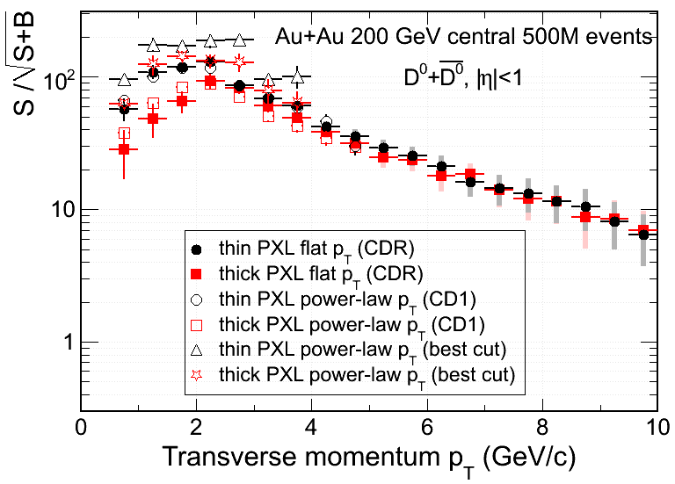
Figure 1: Signal significance as a function of p_{T}. Filled/open circles/squares shows the change in significance due to thickness (thin/thick) for flat/realistic spectral shape. Open triangle/stars show a new result, the signal significance for thin/thick after a careful cut optimization was performed in the lower p_{T} region.

Figure 1 (filled and open circles and squares) shows the change in significance due to thickness. The difference between the open and filled symbols is the generated shape of the spectra (filled symbols represent a flat p_{T} spectrum, while the open symbols correspond to a more realistic power-law p_{T} spectrum). The slight difference between the same (open/filled) symbol is purely statistical. The circles show the signal significance for the standard thin-PXL configuration while the square symbols show the same for the thick-PXL case. The set of background-rejection cuts used to produce these curves is the same as the one used to produce the figures in our CDR and CD1 presentations. We observe (Figure 2) a drop in significance between 1.5 and 2.0 in the important p_{T} region below 2 GeV/c. This result scaled to the actual thickness increase, would imply a required increase in the number of events of about a factor of 2-2.5 in order to keep the signal significance the same [7]. Figure 6

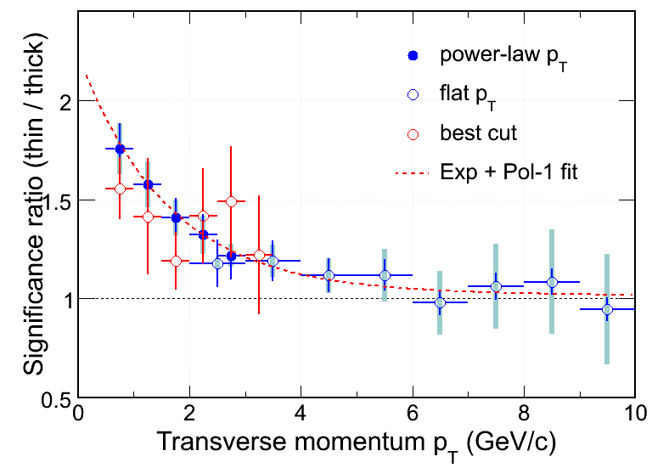
Figure 2: Impact of PXL thickness on signal significance as a function of pT. The different symbols represent different pT shapes and/or optimized cuts, as labeled.
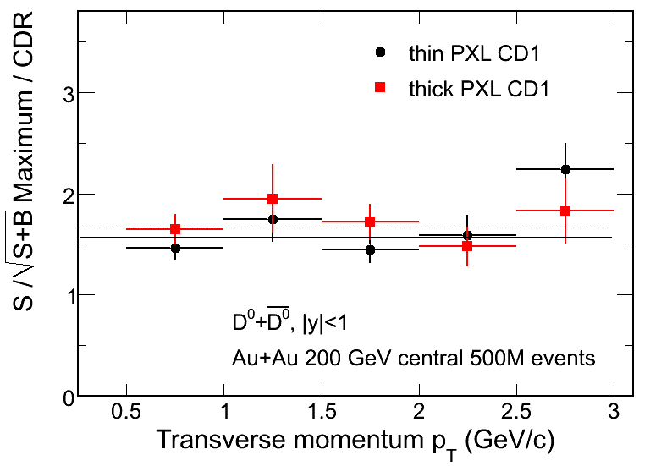
Figure 3: Signal significance gain as a function of p_{T} after cut optimization for thin (black symbols) and thick (red symbols).

Figure 1 also (open triangles and stars) shows a new result, the signal significance for thin/thick but after a careful, multi-dimensional cut optimization was performed in the lower p_{T} region. The net gain from this optimization procedure (a factor of 1.5 – 2.0) is shown in Figure 3Figure 8. We observe that the performance of the optimized cut set for the thick PXL (star symbols in Figure 1) is almost identical to the thin PXL (open/filled circles) if one uses the non-optimized cut set used in the CDR and CD1 so: a potential increase in PXL thickness would not change the precision of low p_{T} values established in the CDR, since the loss in efficiency has been regained by tuning our low p_{T} cut parameters. As our analysis procedure is not yet fully optimized further gains in efficiency might be expected in the future.

Elliptic Flow
The low p_{T} region is important for studies of collectivity. Energy loss is a high p_{T} phenomenon. Here we limit our discussion to v₂, for which the low p_{T} region and PXL thickness is most relevant. It is important to understand that flow is a hydrodynamic phenomenon. Data and hydro predictions agree up to about 1.5 GeV/c p_{T} beyond which point data deviate dramatically from the hydro prediction. In Figure 4 we present the precision of measurement that can be achieved with the thin and the thick PIXEL configuration within the first year of data taking using estimation based on the optimized set of cuts. Also shown in the figure (red and green lines) are two different model calculations based on the coalescence assumption. Coalescence is an empirical observation deduced from v₂ systematics. In the same figure we also show the low p_{T} hydro prediction for the D⁰ mass (blue line), plus our charged hadron results, as an overall reference (purple line).
At low p_{T} we observe the typical hydro mass-scaling/splitting (e.g. the difference between the purple/data line (mostly pions) and the blue/hydro line) and at high p_{T} leveling off and scaling with the number of constituent quarks. The shape of v₂ at high p_{T} is not a hydro effect but is due to quark energy loss. This can be seen in the light hadron data shape. Reference Error: Reference source not found has no predictive power at high p_{T} (above 2 GeV/c) since it only assumes coalescence and does not include the effects of energy loss mechanism. The model uses light quark momentum distributions and for the heavy quark either non-interacting distributions (no flow) or completely thermalized distributions with transverse expansion (flow). In fact, if constituent quark scaling is to hold in the charm sector, the v₂ value at high p_{T} is determined only by the fact that the D⁰ is a meson (not a baryon). In this scenario, the two theoretical curves must merge at high p_{T}. There is no realistic model on the market that would give quantitative guidance for v₂ values at low p_{T} and realistic predictions for v₂ at high p_{T}.

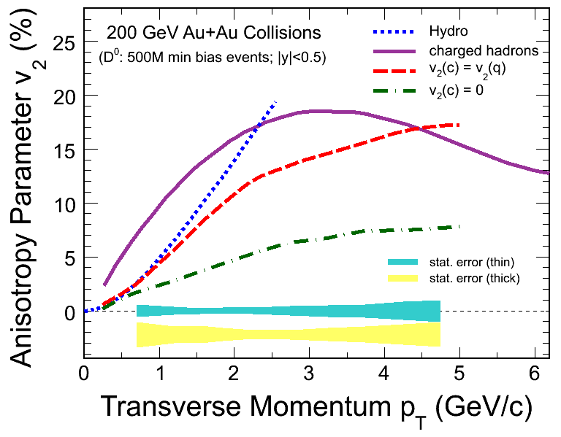
Figure 4: Elliptic flow (v₂) vs p_{T} in Au+Au collisions at 200 GeV. The purple curve shows the measured value for charged hadrons. The red and the green curves show calculations from Ref [Error: Reference source not found] for the limiting cases that the charm quark flows like the light quarks and that the charm quark does not flow. The cyan band indicates the statistical error that can be achieved with 500 M minimum bias events for the thin detector configuration and the yellow band is for the thick configuration. In all error estimations we used the optimized cut set results.
Therefore, a comprehensive comparison with theory predictions will not be possible, unless we see a new description emerge. The comparison has to rely on systematic studies of v₂ scaling at low p_{T} as a function of particle mass. If the heavy quark flows, such systematics will show it.
However, this further emphasizes the importance of testing coalescence in the charm sector.
The impact of thickness on model discrimination is shown as colored error bands in Figure 4. The statistical discrimination is based on 500 Million minbias Au+Au events, which correspond, in a pessimistic scenario of machine/detector duty factors, to a RHIC-year’s run worth of data. We see that both thin and thick configurations will allow for a first year statement about
- The overall, experimentally determined, flow of identified D⁰s as a function of p_{T}, starting at about .5 GeV/c.
- The comparison of the magnitude of D⁰ flow with the two extreme coalescence scenarios (red and green lines).
- Both configurations will be able to discriminate between hydro and coalescence in the case of little flow of D⁰s.
- The thin configuration will allow for some first year discrimination between the hydro and full-flow coalescence scenario (blue and red lines in the figure), but the thick PXL configuration will probably need another year’s run to make this distinction.

Besides v₂ scaling, the Λ_{C} to D⁰ cross-section ratio represents an ideal test. Later in this document (section 3.2) we summarize the capability of the HFT to determine a baryon to meson ratio in the charm sector as well as the thickness impact on this measurement.

• Compare the significance of planned charm and beauty measurement to be done with the HFT to similar measurements expected from the upgraded PHENIX detector. Comment on how significant an advance in theoretical understanding of energy loss and flow for the hot-dense medium the HFT would provide compared to the earlier anticipated PHENIX measurements

It is obvious that PHENIX will perform important charm and beauty measurements before the HFT becomes operational. The emphasis of the PHENIX measurements is on identifying electrons from charm and beauty decays. Such measurements have limitations that can be overcome by topological reconstruction in the case of the HFT. PHENIX has not shown simulations that would establish the capability to do topological reconstruction of D-mesons.^{,5} Therefore we will attempt a qualitative comparison of what can be done with the HFT and PHENIX with respect to the physics extracted from the measurement of the electrons from semi-leptonic D- and B-meson decays. It is beyond the scope of this report to speculate about the PHENIX capability to perform topological reconstruction. In the Appendix we compare the sensitivity for topological reconstruction for HFT pixel technology and for PHENIX hybrid technology.
PHENIX will measure the spectra of non-photonic electrons from charm and beauty decays. The new information that the HYBRID vertex detectors will provide is the electron impact parameter (DCA) from the event vertex. The reconstruction technique is based on applying DCA cuts to reject background and then fit the yields in various p_{T} bins. This will result in a spectrum of the sum of D and B decays. Taking the difference in cτ for charm and bottom into account, D and B separation can be achieved through unfolding. The unfolding process is complicated by the fact that the different D states have quite different cτ values, where for example the D⁺ cτ is very close to the B cτ. Unfolding has to make assumptions about the production ratio for the individual D states. For p+p this is well known. However, in case that the production ratio is modified in heavy ion reactions, unfolding becomes unreliable. This potentially large uncertainty can be mitigated in the STAR non-photonic electron measurement because STAR will directly measure D⁰, D⁺, and D^{s} production.
PHENIX will perform a measurement of the R_{AA} for electrons from D and B decay as a function of p_{T}. Due to momentum smearing from the decay process, the parent p_{T} cannot be determined, thus preventing a precision measurement of R_{AA} for heavy flavor hadrons as a function of p_{T}. This might be very important for a precision comparison with model calculations to determine the mechanism of energy loss.
PHENIX also will determine v₂ of non-photonic electrons. This measurement cannot contribute to the question of thermalization. The parent p_{T} is not determined to better than 3 GeV. We have argued above that only a measurement at low p_{T} (< 2.5 GeV/c) might be able to answer this important question.
We believe the following statements to be correct:
- The theory development in the area of energy loss is progressing rapidly and it is not obvious what it will be in a few years. It is, however, safe to say that quality data are the requirement for theory progress.
- All measurements by STAR based on topological reconstruction are original and without competition at RHIC.
- PHENIX and STAR will both measure charm/beauty production cross sections from the electron spectra.

D and B production can be separated also by multi-particle correlations. Neither PHENIX nor STAR have shown this capability in simulations. Since 2π acceptance is important for two- and multi-particle correlations, it can be assumed that STAR has advantages for this particular measurement.

In summary, a measurement of non-photonic electrons has a very limited reach. The full potential of heavy flavor physics in heavy ion collisions can only be reached through full topologic reconstruction.

Update on Λ_{C} Simulations
Since CDR we have increased statistics of our simulations, to allow for better optimization of cuts also in the Λ_{C} analysis. Despite these improvements, estimated errors in the 2-3 and 3-4 GeV/c p_{T} bins haven't changed significantly, showing robustness of our CDR estimates.
A significant improvement was achieved in the 4-5 GeV/c p_{T} bin, where we didn't require full identification of daughter particles, which resulted in improvements in Λ_{C} reconstruction efficiency and (as background is modest in this higher p_{T} bin) increased the Λ_{C} signal significance.
Note that in the figure, the discrimination should be made between estimated errors and the 2 scenarios of Λ_{C} /D⁰ ratio - not between the two sets of estimated errors. The significance of this discrimination is in the range 2-4 sigma in the case of an enhanced ratio and about 4-6 sigma in the extreme case of no-enhancement.

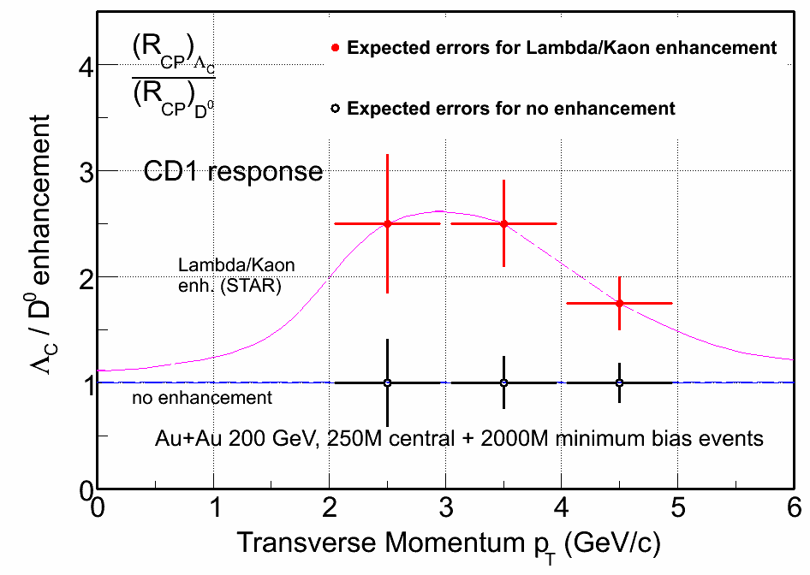
Figure 9: Expected statistical errors of the ratio of Λ_{C} to D⁰ production for different assumptions about the production mechanism.
Similar simulations and analysis of simulated data were conducted for the "thick" detector configuration. However, Λ_{C} /D⁰ measurement with similar errors turned out not to be feasible with reasonable statistics in the "thick" detector configuration.
In summary, we will be able to make a significant measurement of the Λ_{C} /D⁰ ratio only with the thin HFT configuration. This measurement will become much harder with the thick detector configuration.

Appendix:

We have also performed simulations of the significance of D⁰ spectra for the case where we use the PHENIX hybrid technology (ie. pixel dimensions) instead of the HFT pixel technology. We did not change the detector thickness or the geometrical acceptance. Figure 10 shows the ratio of significance for pixel versus hybrid technology as a function of pT. For a given number of events the significance of a HFT measurement is about a factor of 10 better. This means that in order to achieve the same significance as STAR, PHENIX has to acquire a factor of hundred more events. Important factors, like partial (PHENIX) acceptanc, andsbandwidths, have not yet been factored in into this rough estimate.

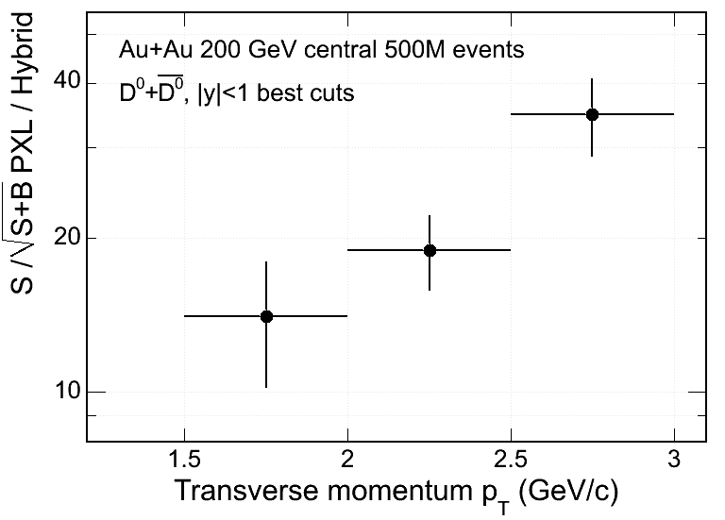
Figure 10: Gain in significance by using HFT PXL technology versus PHENIX hybrid technology.

References:

Reference to CDR
V. Greco, C.M. Ko and R. Rapp, Phys. Lett. B 595 (2004) 202
Coalescence refs
G.D. Moore and D. Teaney, Phys. Rev. C 71, (2005) 064904
W. Zajc, private communication
STAR publication 6 PHENIX Silicon Vertex Upgrade Review, June 2, 2009 7 ‘Answers to Questions’ by H. Wieman, CD1 review

