•Studies should be carried through to the final physics measurement, showing the degradation of the final physics significance if key requirements are not met:
–Give an explicit evaluation of what the loss in low-pT efficiency does regarding the fundamental physics questions relating to flow and energy loss of heavy quarks in the hot-dense medium. Evaluate this loss in terms of current theoretical models and show whether these are well tested by the measurement above ~2 GeV/c or if the loss of statistics at lower pT is a critical loss.

In the following we will study the impact of increasing the mass of the first layer of PXL detector from the design value of .37? (using Al cables) to the value given as a CD-4 parameter of .62?% (Cu cables) and of increasing the internal stability from 20m (design value) to 30m (CD-4 parameter).

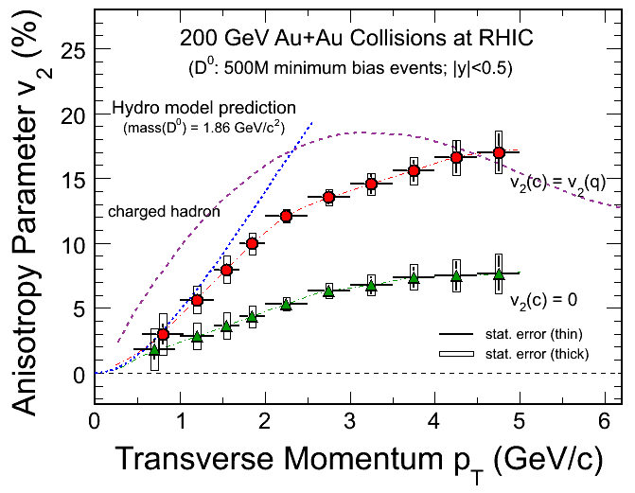
Figure 1 (PLACE HOLDER)Elliptic flow (v2) vs pT in Au+Au collisions at 200 GeV/c

2. figure:
As a function of PT calculate ratio of significance for the three cases
(reference is thin)
Thick/thin
Thin with incr. resolution/thin
Thick with incr. resolution / thin
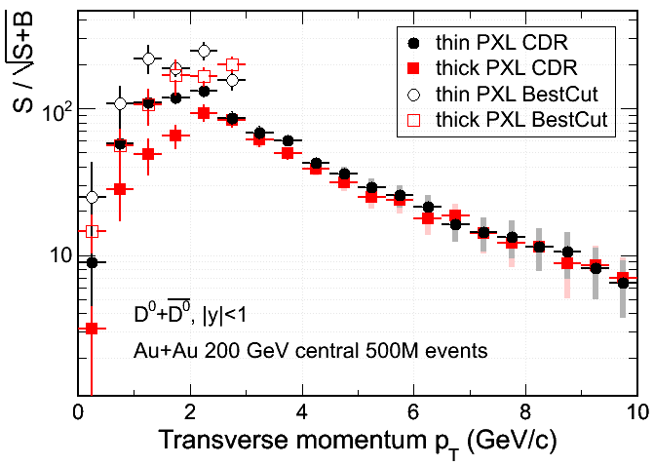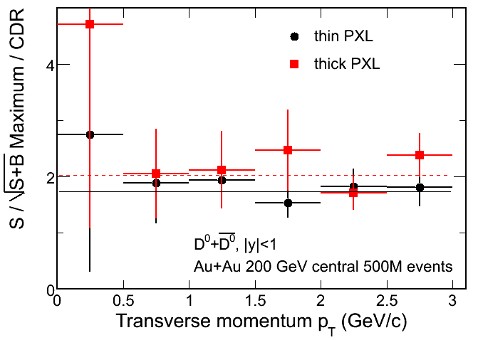
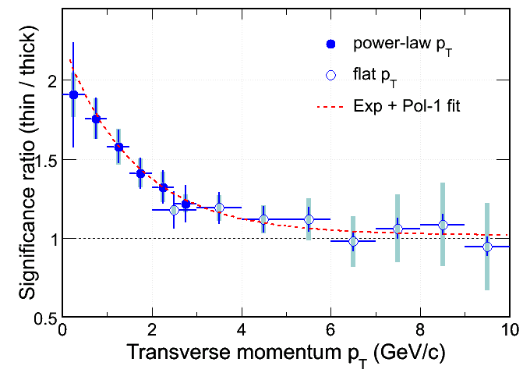
Figure 2 (PLACE HOLDER) Signal significance as a function of pT
The resolution (stability) data will come from fast simulations

Low pt is important for studies of collectivity. Energy loss is a high pt phenomenon. We limit discussion to v2, where low pt is important. The simple argument is that flow is a hydrodynamic phenomenon and data and hydro predictions agree up to 1.5 GeV pt at which point data deviate dramatically from hydro. In Fig. 8 we present precision of measurement that may be achieved by assuming two limiting cases for a model calculation. The model is based on the coalescence assumption. Coalescence is empirical observation deducted from v2 systematics. At low pt mass splitting (hydro) and at high pt leveling of and scaling with number of constituent quarks. V2 at high pt is not hydro effect but is due to quark energy loss. Ref Error: Reference source not found has no predictive power at high pt (above 2 GeV). Energy loss mechanism is not included. It uses light quark momentum distribution and for the heavy quark either non-interacting distributions (no flow) or completely thermalized distributions with transverse expansion (flow). In fact, if constitituent quark scaling is to hold in charm sector, the v2 value at high pt is determined only by the fact that D is meson, thus the two curves are expected to merge. Conclusion: there is no realistic model on the market that would give quantitative guidance for v2 values at low pt and unrealistic predictions for v2 at high pt. Comparison has to be on systematic of v2 scaling as a function of particle mass. If heavy quark flows, the systematics will show.

However, this shows the importance of testing of coalescence in the charm sector. Besides v2 scaling, LC and D0 cross sections are ideal test.

•Compare the significance of planned charm and beauty measurement to be done with the HFT to similar measurements expected from the upgraded PHENIX detector. Comment on how significant an advance in theoretical understanding of energy loss and flow for the hot-dense medium the HFT would provide compared to the earlier anticipated PHENIX measurements

PHENIX has not shown simulations that would establish the capability to do topological reconstruction of D mesons. Therefore we will attempt a qualitative comparison of what can be done with the HFT and PHENIX with respect to the physics extracted from the measurement of the electrons from semileptonic D and B decays. The theory development in the area of energy loss is progressing rapidly and it is not obvious what it will be in a few years. It is, however, safe to say that quality data are the requirement for theory progress. All measurements by STAR based on topological reconstruction are original and without competition at RHIC.

PHENIX and STAR will measure charm production cross sections from electron spectra.

PHENIX will measure the separate spectra for electrons from charm
and electrons from beauty. However, they probably do have to assume something about the
chemistry; i.e. the ratio D+/D0, etc., in order to separate
the D+ from the B contribution. Otherwise the D+ and B are highly
degenerate in the method using a single track displaced from the vertex.
This can be alleviated with the use of multiparticle correlations (since
another thing that distinguishes B from D is the different mass, and
therefore invariant mass distribution from a few particles), but
they have not demonstrated how well that works in Au+Au and
with their acceptance, except for a first look in a poster at QM.

However: there is a loss of information in the B and D R_{AA} vs.
the electron from B and D R_{AA}, since there is momentum smearing.

So, advantages:
Direct reconstruction of momentum, and so possibility to look at
momentum dependence of R_{AA} of mesons directly

Ability to look at chemistry: again, to test coalescence mechanism
at intermediate pt and as a precise test of a necessary input to
the displaced-track method.

Electron v2 cannot contribute to the question of thermalization. In that measurement the parent pt is not determined to better than 3 GeV. We have argued for low pt before.
Also at high pt v2 is pt dependent , to a lesser extend.

Xin and Yifei will try to quantify the losses in precision of D and B separation due to the fact that p+p branching ratios have to be assumed.

Appendix:

Show fast simulation of PHENIX significance. Show that at high pt it is the resolution and not the thickness. And point out that simulation is for 2 pi.

Timescale:
We should have a draft by the collaboration meeting good enough that we can give to Steve, and plan for submission on mid-April at the latest. Any speed-up is important, so one can start discussing a schedule with DOE on CD-2/3.

Key-parameters (reco I)
These were taken to be PXL layer thickness, and internal alignment/stability. This matches our full (and analytical) simulations.

General Considerations:
- we should answer as specific as possible
identify key parameters i) thicjness ii) vibrational 20-30

enclose in app. Howards fast sim that evaluate effect of thick.. of resulting S/B.
1)
The new fig from Yifei gives the diff for v2(pt) in two scenario’s. Comment that improvement in top. Rec. has resulted in *2 over presentation at CDR.

+)Hydro flow of Do can be determined even with thick.

Hydro flow cannot be tested with only data > 2 GeV/c
The development of v2 from low to high is of theoretical interest, (teany with many citing newer articles) Determination od drag coefficients.

-) The lambda-c actually becomes a marginal measurements with thick, Worth to iterate the new result for Lc and plot propeorly with errors i.e.only say for enhancement of Lc/do

-) point out other Charmed mesons that can be reco. Ds..

2) Phenix:..
- give our understanding of Phenix
flow for electrons from Charm above 2 GeV/c
c-b sep from electons, assuming pt shapes?

Again stress that the ambiguity in not knowing the Do directly, and relying on electrons only. Point out that the Do spectraum shape is used in b-c seperation

V. Greco, C.M. Ko and R. Rapp, Phys. Lett. B 595 (2004) 202
Coalescense refs
G.D. Moore and D. Teaney, Phys. Rev. C 71, (2005) 064904
W. Zajc, private communication

